|  |  |
| --- | --- |
| logo ngan.png | MINISTRY OF EDUCATION AND TRAINING |

|  |
| --- |
| **FPT UNIVERSITY** |
| Capstone Project Document |
| Build a Web Application  for manages all activities of  delivery service system by coach |
|  |
| |  |  | | --- | --- | | **Group 18** | | | **Group Members** | Đào Bảo Long – Team Leader – SE60690  Lê Phúc Lữ – Team Member – 60563  Nguyễn Thanh Tùng – Team Member – SE60609  Nguyễn Tấn Đức – Team Member – SE60660 | | **Supervisor** | Nguyễn Trọng Tài | | **Ext Supervisor** | N/A | | **Capstone Project Code** | i-Deliver | |
| Hồ Chí Minh City, April 2014 - |

*Acknowledgement*

After more than three months of intensive researching, working, and having fun, we have finally reached the fundamental objectives of the project *Multi-Hotel Booking*. Apart from our own efforts, the completion of this project depends largely on the encouragement and guidelines of many others. We would like to dedicate this page to expressing our gratitude to the people who have been instrumental in our project.

Firstly and most importantly, we would like to show our greatest respect to Mr. Lâm Hữu Khánh Phương, our supervisor, whose tremendous support and surprising yet innovative ideas contributed a great deal to the completion of our project. Without his encouragement and guidance, this project would probably not have materialized. More than that, we really appreciate the fact that he put us under no pressure whatsoever and always let us having fun while we were working on this project.

Secondly, we would like to thank our fellow men in Group 11, who were also working on a similar project. We will never forget the moments when we were so drawn into arguments that led to nowhere that we even thought we would end up failing to finish our projects. It was an extraordinarily interesting experience having worked together.

Finally, we would like to express our deepest gratitude to our parents and our lecturers for always being there for us. We appreciate that they did a lot to gear us up for all the things we might encounter in our lives. We would not be who we are today if it weren’t for them.

Group 18  
*Nguyễn Phú An,  
Bùi Minh Đức,  
Nguyễn Hiếu Triệu Vỹ*

*This page is intentionally left blank*

# Table of contents

Table of contents 2

Table of figures 2

Terminology 2

1. Introduction 2

1.1. Introduction 2

1.2. The initial idea of group 2

1.3. Overview of existing methods 2

1.1.1. Requests management 2

1.1.2. Packages arrangement 2

1.1.3. Packages management 2

1.4. Limitations of existing system 2

1.1.1. Requests management 2

1.1.2. Packages management and arrangement 2

1.1.3. Schedules and trips management 2

1.5. Benefits of expected system 2

1.6. Business outline 2

1.7. Approaches 2

1.8. Group of functions 2

2. Software Project Management Plan (SPMP) 2

2.1. Problem Definition 2

2.1.1. Name of this Capstone Project 2

2.1.2. Problem Abstract 2

2.1.3. Project Overview 2

2.2.3.1. The Current System 2

2.2.3.2. The Proposed System 2

2.2.3.3. Boundaries of the System 2

2.2.3.4. Development Environment 2

2.2. Project organization 2

2.3.1. Software Process Model 2

2.3.2. Roles and Responsibilities 2

2.3.3. Tools and Techniques 2

2.3. Project management plan 2

2.4.1. Tasks 2

2.2.1.1. Task 1: Initiating 2

2.2.1.2. Task 2: Planning 2

2.2.1.3. Task 3: Specifying requirements 2

2.2.1.4. Task 4: Designing database 2

2.2.1.5. Task 5: Creating Software Design Description 2

2.2.1.6. Task 6: Implementing 2

2.2.1.7. Task 7: Performing Testing 2

2.2.1.8. Task 8: Writing User’s Manual 2

2.2.1.9. Task 9: Deploying the Website 2

2.2.1.10. Task 10: Finalizing and Closing 2

2.4.2. Task sheet 2

2.4. Coding Convention 2

3. Software Requirement Specifications (SRS) 2

3.1. User Requirement Specification 2

3.1.1. Guest Requirements 2

3.1.2. Logged User Requirements 2

3.1.3. Customer Requirements 2

3.1.4. System Admin Requirements 2

3.1.5. Staff Requirements 2

3.2. System Requirement Specification (Specific Requirements) 2

3.2.1. External Interface Requirements 2

3.2.1.1. User Interfaces 2

3.2.1.2. Hardware Interfaces 2

3.2.1.3. Software Interfaces 2

3.2.2. Functional Requirements 2

3.2.2.1. « Customer » Tracking package 2

3.2.2.2. « Customer » View request detail 2

3.2.2.3. « Customer » Payment 2

3.2.2.4. « Customer » Rating 2

3.2.2.5. « Customer » Comment 2

3.2.2.6. « System administrator » Define delivery fee value/calculating formula 2

3.2.2.7. « System administrator » Edit delivery fee value/ calculating formula 2

3.2.2.8. « System administrator » Create new staff account 2

3.2.2.9. « System administrator » Edit account information 2

3.2.2.10. « System administrator » Delete account 2

3.2.2.11. « System administrator » Search information 2

3.2.2.12. « System administrator » Statistic 2

3.2.2.13. « System administrator » Delete comment 2

3.2.2.14. « System administrator » Clear rating 2

3.2.2.15. « Staff » Approve request 2

3.2.2.16. « Staff » Reject request 2

3.2.2.17. « Staff » Assign package 2

3.2.2.18. « Staff » Confirm package in-transit 2

3.2.2.19. « Staff » Confirm package arrived station 2

3.2.2.20. « Staff » Confirm package delivered 2

3.2.2.21. « Staff » Prepare package to return 2

3.2.2.22. « Staff » Search package 2

3.2.2.23. « Staff » Create a schedule 2

3.2.2.24. « Staff » Create a trip 2

3.2.2.25. « Staff » Delete a trip 2

3.2.2.26. « Staff » Add a station 2

3.2.2.27. « Staff » Edit station information 2

3.2.2.28. « Staff » Add a route 2

3.2.2.29. « Staff » Edit route information 2

3.2.2.30. « Staff » Delete a route 2

3.2.2.31. « Staff » Add new coach 2

3.2.2.32. « Staff » Edit coach information 2

3.2.2.33. « Staff » Delete a coach 2

3.2.3. Non-Functional Requirements 2

3.2.2.1. Reliability 2

3.2.2.2. Availability 2

3.2.2.3. Security 2

3.2.2.4. Maintainability 2

3.2.2.5. Portability 2

3.2.2.6. Performance 2

3.3. Entity Relationship Diagram 2

4. Software Design Description (SDD) 2

4.1. Design Overview 2

4.2. System Architectural Design 2

4.3. Component Diagram 2

4.4. Detailed Description of Components 2

4.4.1. Algorithm Processing Classes 2

4.4.1.1. Class diagram 2

4.4.1.2. IRouteChooser 2

4.4.1.3. IAssigning 2

4.4.2. Data Repository Classes 2

4.4.2.1. Class diagram 2

4.4.2.2. IRequestRepository Interface 2

4.4.2.3. IUserRepository Interface 2

4.4.2.4. IJourneyRepository Interface 2

4.4.2.5. IAssigningRepository Interface 2

4.4.2.6. IFeedbackRepository Interface 2

4.4.2.7. IPriceRepository Interface 2

4.4.3. Business Logic Classes 2

4.4.3.1. Class diagram 2

4.4.3.2. IRequestManagement Interface 2

4.4.3.3. IPackageManagement Interface 2

4.4.3.4. IAssigning Interface 2

4.4.3.5. IStationSuggestion Interface 2

4.4.3.6. IJourneyManagement 2

4.4.3.7. IFeedbackManagement 2

4.4.3.8. IPriceManagement Interface 2

4.5. Behavioral Diagrams 2

4.5.1. State Machine Diagram: Request Status Transition 2

4.5.2. State Machine Diagram: Package Status Transition 2

4.5.3. Sequence Diagram: Post Delivery Requests 2

4.5.4. Sequence Diagram: Approve Requests 2

4.5.5. Sequence Diagram: Create a Trip 2

4.5.1. Sequence Diagram: Assign Package 2

4.5.2. Sequence Diagram: Edit a Station 2

4.5.3. Sequence Diagram: Add a Price 2

4.5.4. Sequence Diagram: Create a Staff Account 2

4.6. User Interface Design 2

4.6.1. 2

4.7. Database Design 2

4.8.1. Logical database design 2

4.8.1.1. User 2

4.8.1.2. UserInfo 2

4.8.1.3. Coach 2

4.8.1.4. CoachType 2

4.8.1.5. Route 2

4.8.1.6. Trip 2

4.8.1.7. Station 2

4.8.1.8. Schedule 2

4.8.1.9. Request 2

4.8.1.10. DeliveryStatus 2

4.8.1.11. Invoice 2

4.8.1.12. ManageFee 2

4.8.1.13. Comment 2

4.8.1.14. Rating 2

4.8.1.15. Assigning 2

4.8.1.16. Stage 2

4.8.1.17. RouteStage 2

4.8.1.18. Notification 2

4.8.1.19. Province 2

4.8.2. Physical database design 2

5. Software Test Document 2

5.1. Introduction 2

5.1.1. System Overview 2

5.1.2. Test Approach 2

5.2. Test Plan 2

5.2.1. Features to be tested 2

5.2.2. Features not to be tested 2

5.3. System Test Cases 2

5.3.1. Post new delivery request 2

5.3.2. Online payment 2

5.3.3. Tracking package 2

5.3.4. Feedback 2

5.3.5. Approve delivery requests 2

5.3.6. Assign packages 2

5.3.7. Prepare for packages return 2

5.3.8. Create the trip 2

5.3.9. Create schedules 2

5.3.10. Monitor price/fee 2

5.3.11. Statistics review **Error! Bookmark not defined.**

5.4. Checklists 2

5.4.1. Checklist of Validation 2

5.4.2. Submission Checklist 2

6. Software User’s Manual 2

6.1. Installation Guide 2

6.1.1. Prerequisites 2

6.1.2. Installation procedures 2

Extract the deployment package to a folder on the server, for example, D:\Capstone Project\I-DELIVER. 2

Open the file “DB1.0.sql” in the folder “Database” of the deployment package by Microsoft SQL Server Management Studio (MSSQL). 2

Open the IIS Manager by typing its name into the search box in the start menu in Windows 7 or the charm bar in Windows 8. 2

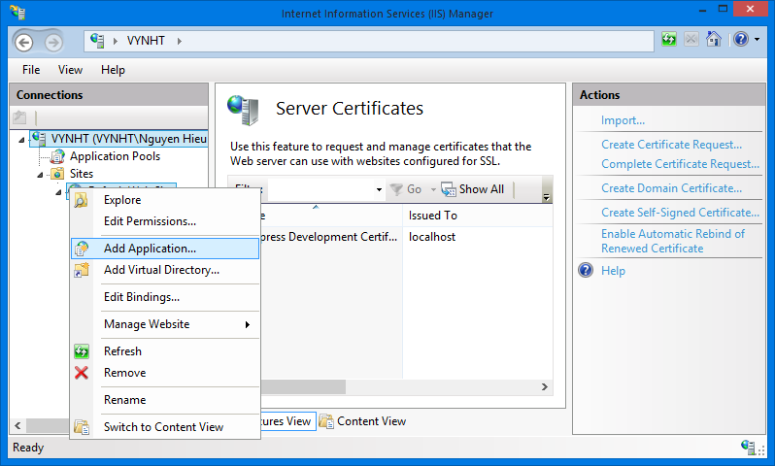 2

Expand the Sites folder and then right click on Default Web Site. Select “Add Application…” to open Add Application window. In the “Add application” window, fill the field “Alias” with the name of the website. 2

Click the “…” button to 2

Verify that 2

6.2. User’s Guide 2

6.2.1. Guides for Customer 2

6.2.1.1. Log in to the system 2

6.2.1.2. Log out of the system 2

6.2.1.3. Register an account with Customer role 2

6.2.1.4. Sent a delivery request 2

6.2.1.5. View station details, rate, and comment 2

6.2.1.6. Online payment 2

6.2.1.7. Tracking package(s) 2

6.2.2. Guides for Staffs and System Admins 2

6.2.2.1. Approve pending requests 2

6.2.2.2. Create a trip 2

6.2.2.3. Assign package(s) 2

6.2.2.4. Confirm package(s) departed from start-station 2

6.2.2.5. Confirm package(s) arrived in end-station 2

6.2.2.6. Confirm package(s) delivered 2

6.2.2.7. Prepare package(s) for return 2

6.2.2.8. Extend due-date for online payment 2

6.2.2.9. Statistics 2

6.2.2.10. Add a price 2

6.2.2.11. Monitor prices 2

Appendix 2

Reference 2

# Table of figures

Figure 1. An overview of the i-Deliver system 2

Figure 2. The waterfall software lifecycle model 2

Figure 3. Model-View-Controller Architecture 2

Diagram 1. Actors overview diagram 2

Diagram 2. Entity Relationship Diagram 2

Diagram 3. Component Diagram 2

Diagram 4. Entities Class Diagram 2

Diagram 5. Algorithm Processing Class Diagram 2

Diagram 6. Data Repository Class Diagram 2

Diagram 7. Business Logic Class Diagram 2

Diagram 8. State machine diagram: Request status transition 2

Diagram 9. State machine diagram: Package status transition 2

Diagram 10. Sequence diagram: Post delivery request 2

Diagram 11. Sequence diagram: Approve Requests 2

Diagram 12. Sequence diagram: Create a trip 2

Diagram 13. Sequence diagram: Assign package 2

Diagram 14. Sequence diagram: Edit a station 2

Diagram 15. Sequence diagram: Add a price 2

Diagram 16. Sequence diagram: Create a Staff Account 2

Diagram 17. Physical database design 2

# Terminology

|  |  |  |
| --- | --- | --- |
| No. | Terminology | Explanation |
| 1. | Customer | A person who needs to book rooms in hotels at their destination |
| 2. | Staff | A person in charge of managing their hotels |
| 3. | System Administrator | A system that provides hotel data including hotel information, room availability, and price changes |
| 4. | Delivery Request | A request sent by a customer to the staff to ask for a delivery request with the I-DELIVER system |

# Introduction

## Introduction

|  |  |  |  |  |  |
| --- | --- | --- | --- | --- | --- |
| **Project Title:** | | *Build a web application for manage the activities of delivery service system by coach* | | | |
| **Start Date:** | | Jan 6, 2014 | | **Finished Date:** |  |
| **No** | **Full name** | | **Role** | **Position** | **Contact** |
| 1. | Nguyễn Trọng Tài | | Supervisor | Lecturer | [TaiNT@fpt.edu.vn](mailto:PhuongLHK@fpt.edu.vn) |
| 2. | Đào Bảo Long | | Developer, Tester | Team Leader | [LongDBSE60690@fpt.edu.vn](mailto:LongDBSE60690@fpt.edu.vn) |
| 3. | Lê Phúc Lữ | | Developer, Tester | Member | [LuLP60563@fpt.edu.vn](mailto:DucBM60324@fpt.edu.vn) |
| 4. | Nguyễn Thanh Tùng | | Developer, Tester | Member | [TungNTSE60609@fpt.edu.vn](mailto:TungNTSE60609@fpt.edu.vn) |
| 5. | Nguyễn Tấn Đức | | Developer, Tester | Member | [DucNTSE60660@fpt.edu.vn](mailto:DucNTSE60660@fpt.edu.vn) |

## The initial idea of group

Nowadays, freight traffic between cities in a day is huge. We have the passenger transportation service providers like Mai Linh or the goods delivery service providers like Tin Thanh, Hop Nhat. And we also have the combination like Phuong Trang. Before working on this project, our team conducted a survey in a passenger transportation service provider. Here are the major findings during the survey:

**Phuong Trang Travel & Transportation Company:**

This company provides passenger transport service using coach. Beside this service, this company also provides goods delivery service. They receive a lot delivery requests per day but all of them still managed by staff manually using papers/books. It makes planning and scheduling for goods delivery become complicated beside passenger transportation arrangement, also makes hard to manage all goods to ensure integrity.

From the problems above, our team decided to develop a delivery service system for passenger transportation service providers which using coach. It operates difference from professional delivery service which using cars specially made for goods delivery.

## Overview of existing methods

### Requests management

The goods delivery service’s staffs have to write down all of delivery requests, monitoring – planning – scheduling manually using papers/books and their memory.

### Packages arrangement

They just simply fill-up empty cargo compartments of each coach as much as possible.

### Packages management

Tracking, searching … is temporary unavailable

## Limitations of existing system

### Requests management

By using papers/books and memory, staffs cannot ensure information accuracy; controllable requests, delivery status of requests.

### Packages management and arrangement

They don’t have any specific fee calculating formula, it’s just estimation.

They don’t have any plan to arrange package on each coach so it’s hard to balance the freight on each route.

### Schedules and trips management

They don’t have detail plans to schedule for each trip, all still managed by demands on real-time.

## Benefits of expected system

The project aims to develop a web-based application that

* Create an easy way for customers to make goods delivery request by allow them to post a new requests on website with registered account then they can tracking their package to ensure delivery.
* Mainly assists service providers’ staff to manage all goods delivery request by using optimized planning and scheduling algorithms, manage the fee of the delivery requests
* Allow customers to comment and rating for the service.

## Business outline

Following the project objectives above, the scope of the project is constrained to the following statements:

* The users of the web-application should interact with the web-application itself through a friendly and attractive user interface.
* *For* ***customers***, this web-application should provide fundamental functions such as register, login then post, edit and cancel goods delivery requests. Through integrated e-payment services, they can pay for their delivery requests. They also can search for posted requested, tracking their package. After using service, customers can comment and rating for the service.
* *For* ***system administrators***, the web-application should allow them to monitor fundamental information about customers, staffs, coaches, routes, and fee.
* *For* ***staffs****,* i-Deliver is a management system allows them to import request, fee calculating, invoice making, planning and scheduling for goods delivery, assign packages for specific coach, specific route.

## Approaches

* Adopt the perspective of a customer during the whole development process, in order to develop a web-based application that promotes usability and interactivity as much as possible.
* Negotiate with web service providers to use their services, and then agree upon how the application communicates with the web services, what information should be retained and what should be eliminated.
* Try to provide staffs the customized tools for manage requests easily.
* Conduct research on how to determine the most appropriate fee based on the average fee of the same service providers in the market.
* Conduct research on how to optimize planning and scheduling for goods delivery.

## Group of functions

|  |  |
| --- | --- |
| Functions for customers | * Allow customers register, login, post/edit/cancel requests, search for, and tracking requests; * Allow customers to rate by different criteria and write comments/reviews on service; |
| Functions for staffs | * Allow staffs to manage fundamental information about requests, fee calculating, invoice making; * Allow staffs to planning and scheduling for goods delivery; * Allow staffs to monitoring and assigning for coaches and routes; |
| Functions for system admins | * Allow system admins to manage all relevant information about the system, customers, staffs, coaches and routes; * Allow system admins to grant access rights to other users of the system; * Allow system admins to decide fee calculating formulas; * Allow system admins to collect and export data to statistic. |

# Software Project Management Plan (SPMP)



## Problem Definition



### Name of this Capstone Project

|  |  |
| --- | --- |
| **Official name** | Building a web-based application that manages the activities of delivery service system by coach |
| **Vietnamese name** | Xây dựng ứng dụng web quản lý các hoạt động cho dịch vụ vận chuyển hàng hóa thông qua hệ thống xe khách đường dài |
| **Abbreviation** | i-Deliver |

### Problem Abstract

The idea of the project is to develop a web-based application that assists delivery service staffs/administrators in manages goods delivery requests, package arrangement, and planning and scheduling, fee management. It also helps customers to make goods delivery request, searching and tracking their package, make a payment online.

### Project Overview



#### The Current System

The idea of this project is developing a delivery service system for passenger transportation service providers which using coach. Before working on this project, we conducted a survey about traditional goods delivery process.

**Traditional goods delivery process:**

Customers will pick their package to delivery service station and provide the name of receiver, destination, and type of goods, weight and size. Then staffs of delivery service will calculate transport fee and give the customer a package invoice which contain provided information and destination station address.

#### The Proposed System

By working on this project, we will develop a service system that assists delivery services providers in Ho Chi Minh City to be closer to their customers. The system has some significant features:

**Create user-oriented interfaces for administrators to simplify management:**

The i-Deliver system support administrators to manage delivery fee like define or edit fee factor. It also helps them to manage related activities of a journey, included trips, stages, stations and routes. Of course the system will provide mechanisms to manage users/staffs.

**Support staffs in delivery requests management, package arrangement, planning and scheduling:**

This system provide easy-to-use interface for requests management like make a new request, edit request information, fee calculating, invoice making, packages arrangement and planning and scheduling, assign packages for specific coach/route.

**Easy-to-use tool for customer to make goods delivery requests, searching and review/edit requests, tracking their package:**

The i-Deliver system is integrated with some technique to help making goods delivery requests online, searching then review or edit requests information, tracking customer’s packages by using request code.

**Optimize arrangement, planning and scheduling for package delivery process**

In traditional way, delivery service staffs have to planning, scheduling and arrange packages for each coaches manually. They just simply fill-up empty cargo compartments as much as possible. This system helps them do their works easily, efficiently by using tools, which optimized by arrangement, planning and scheduling algorithms.

**The i-Deliver system’s users:**

1. **Guests**: non-authorized members can register new account of the i-Deliver website to be granted full access permission or they just can search for routes which delivery service providers operating.
2. **Members:** guests had an authorized account can login to the i-Deliver website to

* Make goods delivery requests;
* Search for posted requests;
* Edit posted requests;
* Cancel posted requests (also have constraints);
* Tracking packages;
* Comment and rating for service;
* Statistics

1. **Administrators**: owners of the i-Deliver website who have highest permission can

* Create new staff account;
* Edit staff account information;
* Delete staff account;
* Define fee calculating formular and fixed value;
* Edit fee calculating formular and fixed value;
* Statistics

1. **Staffs**: users who has account which created by adminstrators have right to

* Manage requests: approve, reject, update status, assign and scheduling;
* Search for packages, routes or members;
* Manage journeys: include add new, edit or delete routes, stations, trips and coaches;
* Manage comments and rates: delete violated/spam comments

Figure 1. An overview of the i-Deliver system

#### Boundaries of the System

There is no previous version of this system. The product will be developed from scratch, independent of any current system.

As said previously, the system under development is not a delivery service management system. It does not provide mechanisms to manage all activities related to goods delivery. In our team’s scope, the i-Deliver is a system that manage related activities of transportation service providers which using coaches. It means that the service provider only working on 2-stations routes (likes Saigon-Nha Trang, Saigon-Vung Tau, Saigon-Hanoi), they don’t provide mechanism to deliver packages to stations between starting point and destination. That is our team’s future plan for this system.

It focuses mainly on providing easy-to-use interfaces and tools, which support both customers and delivery service staffs.

The final product of this Capstone Project includes

* A service portal which helps customers make goods delivery requests;
* A management module for staffs/administrators of delivery service;
* All the documents involved in the development process.

#### Development Environment

Below is the list of hardware and software requirements needed for the development environment of the project.

**Hardware requirements**

* Personal computers for developing with the minimum configuration: 2 Gb of RAM, 100GB of hard disk, Core 2 Duo 2.0 Ghz;
* A server computer for testing with the minimum configuration: 4 Gb of RAM, 100GB of hard disk, Core 2 Duo 2.0 Ghz;
* All computers must be connected to the Internet.

**Software requirements**

* Operating system: Windows 7 or above;
* Web Server: IIS Express 8;
* Framework: .NET Framework 4.5;
* IDE: Visual Studio 2012;
* DBMS: SQL Server 2008 R2;
* Source Control: Tortoise SVN 1.8.4.

## Project organization



### Software Process Model

The waterfall software lifecycle model will be used to guide the development of the system. The waterfall model includes five major phases as in the figure below, enforcing moving to the next phase only after completion of the previous phase.

Requirement Specifications

System and Software Designs

Implementation and Unit Testing

Integration and System Testing

Operation and Maintenance

Figure 2. The waterfall software lifecycle model

### Roles and Responsibilities

|  |  |  |  |
| --- | --- | --- | --- |
| No | Full name | Role in group | Responsibilities |
| 1 | Nguyễn Trọng Tài | Supervisor | * Give advice on business and technical problems; * Review and approve of project documents and product deliverables; * Assess the performance of team members. |
| 2 | Đào Bảo Long | Team Leader,  Developer,  Tester | * Create project management plan and distribute tasks to the other members; * Monitor the development process and review the deliverables; * Work on system architecture and detailed designs; * Implement; * Prepare documents; * Perform unit testing; * Deploy the final product. |
| 3 | Lê Phúc Lữ | Developer, Tester | * Research on; * Design user interfaces; * Work on detailed designs; * Implement; * Prepare documents; * Perform unit testing, system testing, and integration test. |
| 4 | Nguyễn Thanh Tùng | Developer, Tester | * Research on; * Design user interfaces; * Work on detailed designs; * Implement; * Perform unit testing, system testing, and integration test. |
| 5 | Nguyễn Tấn Đức | Developer, Tester | * Research on; * Design user interfaces; * Work on detailed designs; * Implement; * Perform unit testing, system testing, and integration test. |

### Tools and Techniques

The tools that will be used to develop the system include:

* *Developing tools:* Microsoft Visual Studio 2012; Tortoise SVN 1.8.4; Microsoft SQL Server 2008 RC;
* *Modeling tools:* StarUML 5.0.2.1570;
* *Document tools:* Microsoft Office 2010.

## Project management plan



### Tasks

Below are all the major tasks that need to be performed sequentially during the development of the system.



#### Task 1: Initiating

|  |  |
| --- | --- |
| ***Task name*** | Initiating |
| ***Descriptions*** | Perform research/survey on some delivery service providers and pricing model; decide upon the technology that will be used to develop the system. |
| ***Deliverables*** | Report 1 – Project Introduction |
| ***Resources needed*** | All team members; 6 days |
| ***Dependencies and constraints*** | N/A |
| ***Risks*** | Performing survey on the delivery service providers can be difficult because of their business; the chosen technology is new to some members. |

#### Task 2: Planning

|  |  |
| --- | --- |
| ***Task name*** | Planning |
| ***Descriptions*** | Create the project management plan; break the system into modules and assign tasks to each member. |
| ***Deliverables*** | Report 2 – Software Project Management Plan |
| ***Resources needed*** | All team members; 6 days |
| ***Dependencies and constraints*** | Task 1 has finished |
| ***Risks*** | Team leader has no experience in managing software projects; all members are still not acquainted with the new technology. |

#### Task 3: Specifying requirements

|  |  |
| --- | --- |
| ***Task name*** | Specifying requirements |
| ***Descriptions*** | Discuss and agree upon the software requirements, what is to be developed and what is not; generate detailed descriptions of all the functions to be developed. |
| ***Deliverables*** | Report 3 – Software Requirement Specification |
| ***Resources needed*** | All team members; 15 days |
| ***Dependencies and constraints*** | Task 2 has finished |
| ***Risks*** | Many aspects of the problem are still unclear to team members; has no experience of working in a delivery service management project. |

#### Task 4: Designing database

|  |  |
| --- | --- |
| ***Task name*** | Designing database |
| ***Descriptions*** | Design the database based on the requirements collected, through three major steps: Conceptual, Logical, and Physical Design |
| ***Deliverables*** | ERD and the physical database with sample data |
| ***Resources needed*** | All team members; 3 days |
| ***Dependencies and constraints*** | Task 3 has finished |
| ***Risks*** | Some of the requirements specified are not clear and cannot be translated into corresponding entities; little experience in organizing data. |

#### Task 5: Creating Software Design Description

|  |  |
| --- | --- |
| ***Task name*** | Creating Software Design Description |
| ***Descriptions*** | Agree upon the system architecture; work on the detailed design of each module; decide which techniques are appropriate to which modules; design the user interfaces for users to interact with. |
| ***Deliverables*** | Report 4 – Software Design Description |
| ***Resources needed*** | All team members; 12 days |
| ***Dependencies and constraints*** | Task 4 has finished |
| ***Risks*** | Some functions are difficult to find appropriate methods to implement; initial development environment setup is also difficult. |

#### Task 6: Implementing

|  |  |
| --- | --- |
| ***Task name*** | Implementing |
| ***Descriptions*** | Each team member implement all the functions that he or she was assigned and regularly check in the code to the Tortoise SVN; regularly validate that the implementation is consistent with the system and detailed designs. |
| ***Deliverables*** | The implemented website |
| ***Resources needed*** | All team members; 24 days |
| ***Dependencies and constraints*** | Task 5 has finished |
| ***Risks*** | Some design documents contain errors; implementation is not always consistent with the system and detailed designs. |

#### Task 7: Performing Testing

|  |  |
| --- | --- |
| ***Task name*** | Performing Unit Testing |
| ***Descriptions*** | Create and perform appropriate test cases for all main functions; record the test results for later reference; fix all the bugs found during the testing sessions. |
| ***Deliverables*** | Report 5 – Software Test Documentation |
| ***Resources needed*** | All team members; 12 days |
| ***Dependencies and constraints*** | Task 6 has finished |
| ***Risks*** | Lack of test cases for some non-critical functions; not enough time to intensively test all the functions. |

#### Task 8: Writing User’s Manual

|  |  |
| --- | --- |
| ***Task name*** | Writing User’s Manual |
| ***Descriptions*** | Writing a user’s manual to instruct the users, including guest, users, staffs, and system administrators, how to use the system. |
| ***Deliverables*** | Report 6 – User’s Manual |
| ***Resources needed*** | All team members; 5 days |
| ***Dependencies and constraints*** | Task 7 has finished |
| ***Risks*** | Some of the functions are not consistent with the user requirements, causing the user’s manual to be inconsistent with the user requirements. |

#### Task 9: Deploying the Website

|  |  |
| --- | --- |
| ***Task name*** | Deploying the Website |
| ***Descriptions*** | Perform acceptance testing and deploy the website to a host on the Internet |
| ***Deliverables*** | The complete website |
| ***Resources needed*** | All team members; all days left |
| ***Dependencies and constraints*** | Task 8 has finished |
| ***Risks*** | Little experience of deploying a website to a real host |

#### Task 10: Finalizing and Closing

|  |  |
| --- | --- |
| ***Task name*** | Finalizing and Closing |
| ***Descriptions*** | Finalize all related documents and prepare for presentation |
| ***Deliverables*** | The complete website and related documents, presentation |
| ***Resources needed*** | All team members; 4 days |
| ***Dependencies and constraints*** | Task 9 has finished |

### Task sheet

Refer to the next page for the detailed task sheet of the project plan.

|  |  |  |  |  |  |
| --- | --- | --- | --- | --- | --- |
| Task Name | Length | Start | Finish | Predecessor | Resources |
| 1. Initiating | **6 days** | **Mon 06/01/14** | **Sat 11/01/14** |  |  |
| * 1. Identify key stakeholders | 1 day | Mon 06/01/14 | Mon 06/01/14 |  | DucNT,LongDB,LuLP,TungNT |
| * 1. Research & discuss about business and technology | 2 days | Tue 07/01/14 | Wed 08/01/14 | 1.1 | DucNT,LongDB,LuLP,TungNT |
| * 1. Research on similar existing system | 2 days | Thu 09/01/14 | Fri 10/01/14 |  | DucNT,LongDB,LuLP,TungNT |
| * 1. Hold project kick-off meeting | 0.5 days | Sat 11/01/14 | Sat 11/01/14 | 1.2, 1.3 | DucNT,LongDB,LuLP,TungNT |
| * 1. Report 1 – Project Introduction | 0.5 days | Sat 11/01/14 | Sat 11/01/14 | 1.4 | DucNT,LongDB,LuLP,TungNT |
| 1. Planning | **6 days** | **Mon 13/01/14** | **Mon 20/01/14** |  |  |
| * 1. Hold team planning meeting | 0.5 days | Mon 13/01/14 | Mon 13/01/14 | 1.5 | DucNT,LongDB,LuLP,TungNT |
| * 1. Prepare problem abstract, proposed solution, coding convention | 2 days | Mon 13/01/14 | Wed 15/01/14 | 2.1 | TungNT |
| * 1. Prepare major tasks for the whole team | 1.5 days | Wed 15/01/14 | Thu 16/01/14 | 2.1 | LuLP |
| * 1. Prepare management plan and determine task resources, durations, and dependencies | 2 days | Wed 15/01/14 | Thu 16/01/14 | 2.1 | LongDB |
| * 1. Configure Tortoise SVN | 0.5 days | Mon 20/01/14 | Mon 20/01/14 | 2.4 | LongDB |
| * 1. Report 2 – Project Management Plan | 1.5 days | Fri 17/01/14 | Mon 20/01/14 | 2.1-2.5 | DucNT,LongDB,LuLP,TungNT |
| 1. Specifying requirements | **15 days** | **Mon 20/01/14** | **Fri 07/02/14** |  |  |
| * 1. Identify users and users’ requirements | 3 days | Mon 20/01/14 | Thu 23/01/14 | 2.6 | LuLP,TungNT,DucNT |
| * 1. Define system requirements | 1 day | Thu 23/01/14 | Fri 24/01/14 | 3.1 | LongDB |
| * 1. Define non-functional requirements | 1 day | Thu 23/01/14 | Fri 24/01/14 | 3.1 | DucNT |
| * 1. Determine main flows | 3 days | Thu 23/01/14 | Tue 28/01/14 | 3.1 | LuLP,TungNT |
| * 1. Specify functional requirements for users/customers (requests making, searching and reviews posted requests) | 3 days | Tue 28/01/14 | Fri 31/01/14 |  | TungNT |
| * 1. Specify functional requirements for staffs (requests management, package arrangement and scheduling) | 3 days | Tue 28/01/14 | Fri 31/01/14 |  | LuLP |
| * 1. Specify functional requirements for administrators | 3 days | Tue 28/01/14 | Fri 31/01/14 |  | DucNT |
| * 1. Specify functional requirements for coaches, trips, stages, stations, routes management, pricing model, fee calculating | 3 days | Tue 28/01/14 | Fri 31/01/14 |  | LongDB |
| * 1. Specify functional requirements for statistics | 2 days | Fri 31/01/14 | Tue 04/02/14 |  | TungNT |
| * 1. Report 3 – Software Requirement Specification | 2 days | Wed 05/02/14 | Fri 07/02/14 | 3.1-3.9 | LongDB |
| 1. Designing database | **3 days** | **Fri 07/02/14** | **Tue 11/02/14** |  |  |
| * 1. Discuss on conceptual data model | 0.5 days | Fri 07/02/14 | Fri 07/02/14 | 3.11 | DucNT,LuLP |
| * 1. Creating ERD | 0.5 days | Fri 07/02/14 | Fri 07/02/14 | 4.1 | LongDB,TungNT |
| * 1. Validate ERD against software requirements | 1 day | Mon 10/02/14 | Mon 10/02/14 | 4.2 | DucNT,LongDB,LuLP,TungNT |
| * 1. Create logical model and physical database | 1 day | Tue 11/02/14 | Tue 11/02/14 | 4.3 | DucNT,LongDB,LuLP,TungNT |
| 1. Creating Software Design Description | **12 days** | **Wed 12/02/14** | **Thu 27/02/14** |  |  |
| * 1. Discuss on system architecture | 0.5 days | Wed 12/02/14 | Wed 12/02/14 | 3.11 | DucNT,LuLP,TungNT |
| * 1. Configure development environment | 0.5 days | Wed 12/02/14 | Wed 12/02/14 |  | LongDB |
| * 1. Design the master page | 1.5 days | Wed 12/02/14 | Thu 13/02/14 | 3.11 | LongDB |
| * 1. Design the master customer layout | 2.5 days | Wed 12/02/14 | Fri 14/02/14 | 3.11 | TungNT |
| * 1. Design the master staff layout | 2.5 days | Wed 12/02/14 | Fri 14/02/14 |  | LuLP |
| * 1. Design the master admin layout | 1.5 days | Wed 12/02/14 | Thu 13/02/14 |  | DucNT |
| * 1. Design pages for log in, log out, register of customer | 1 day | Fri 14/02/14 | Fri 14/02/14 |  | DucNT |
| * 1. Design pages for posting new request, edit request, view request | 2 days | Mon 17/02/14 | Tue 18/02/14 |  | LuLP |
| * 1. Design pages for customer to view and edit profile | 1.5 days | Mon 17/02/14 | Tue 18/02/14 |  | DucNT |
| * 1. Design page for admin manage fee, stage, route, staff. | 2.5 days | Mon 17/02/14 | Wed 19/02/14 |  | TungNT,LongDB |
| * 1. Design page for staff manage trip, request and invoice. | 2.5 days | Wed 19/02/14 | Fri 21/02/14 |  | LongDB,TungNT |
| * 1. Design page for staff statistic request and trip information. | 1.5 days | Tue 18/02/14 | Wed 19/02/14 |  | DucNT |
| * 1. Design page for staff schedule the package delivery time. | 1 day | Wed 19/02/14 | Wed 19/02/14 |  | LuLP |
| * 1. Design layout for user rate and post comment of routes | 1 day | Mon 24/02/14 | Mon 24/02/14 |  | TungNT |
| * 1. Design page for tracking the package | 1 day | Mon 24/02/14 | Mon 24/02/14 |  | LongDB |
| * 1. Design page for admin manage comment, rating | 1 day | Thu 20/02/14 | Thu 20/02/14 |  | LuLP |
| * 1. Design page for user statistic their request information | 0.5 days | Thu 20/02/14 | Thu 20/02/14 |  | DucNT |
| * 1. Create main sequence diagrams of view, search, edit and delete request | 1.5 days | Thu 20/02/14 | Fri 21/02/14 |  | DucNT |
| * 1. Create main sequence diagrams of manage comment, rating, fee, stage, route, and staff | 1.5 days | Mon 24/02/14 | Tue 25/02/14 |  | DucNT,LuLP |
| * 1. Create main sequence diagrams of posting and rating a route | 0.5 days | Tue 25/02/14 | Tue 25/02/14 |  | DucNT |
| * 1. Create main sequence diagrams of assigning package, edit status of request and manage time (departure/arrival) of coach. | 1 day | Tue 25/02/14 | Tue 25/02/14 |  | TungNT |
| * 1. Draw entity class diagram | 0.5 days | Tue 25/02/14 | Tue 25/02/14 |  | LongDB |
| * 1. Draw model class diagram | 0.5 days | Tue 25/02/14 | Tue 25/02/14 |  | LongDB |
| * 1. Compose physical database description | 1 day | Wed 26/02/14 | Wed 26/02/14 |  | DucNT,LongDB,LuLP,TungNT |
| * 1. Report 4 – Software Design Description | 1 day | Thu 27/02/14 | Thu 27/02/14 |  | DucNT,LongDB,LuLP,TungNT |
| 1. Implementing | **24 days** | **Fri 28/02/14** | **Wed 02/04/14** |  |  |
| * 1. Log in, log out, register | 1 day | Fri 28/02/14 | Fri 28/02/14 | 5.5 | DucNT |
| * 1. Search and view routes | 1 day | Fri 28/02/14 | Fri 28/02/14 | 5.6 | LongDB |
| * 1. Post and view request | 1.5 days | Fri 28/02/14 | Mon 03/03/14 | 5.6 | TungNT |
| * 1. Search, edit, delete request | 1.5 days | Mon 03/03/14 | Tue 04/03/14 | 5.7 | TungNT |
| * 1. Rating for route | 1 day | Fri 28/02/14 | Fri 28/02/14 | 5.7 | LuLP |
| * 1. Comment for route | 1 day | Mon 03/03/14 | Mon 03/03/14 | 5.3 | LuLP |
| * 1. Tracking package | 3 days | Mon 03/03/14 | Wed 05/03/14 | 5.3 | LongDB |
| * 1. Manage all coach and relative information | 4 days | Mon 03/03/14 | Thu 06/03/14 | 5.8 | DucNT |
| * 1. Manage all user and relative information | 4 days | Wed 05/03/14 | Mon 10/03/14 | 5.9 | TungNT |
| * 1. Manage all rating of user | 2 days | Tue 04/03/14 | Wed 05/03/14 | 5.11 | LuLP |
| * 1. Manage all comment user | 2 days | Thu 06/03/14 | Fri 07/03/14 | 5.10 | LuLP |
| * 1. Manage fee of service | 2 days | Mon 10/03/14 | Tue 11/03/14 | 5.10 | DucNT |
| * 1. Statistics of users | 2 days | Thu 06/03/14 | Fri 07/03/14 |  | LongDB |
| * 1. Statistics of staffs | 2 days | Mon 10/03/14 | Tue 11/03/14 |  | LuLP |
| * 1. Statistics of administrators | 2 days | Mon 10/03/14 | Tue 11/03/14 |  | LongDB |
| * 1. Manage all trips | 3 days | Tue 11/03/14 | Thu 13/03/14 |  | TungNT |
| * 1. Manage package | 2 days | Wed 12/03/14 | Thu 13/03/14 |  | DucNT |
| * 1. Scheduling for package | 3 days | Wed 12/03/14 | Fri 14/03/14 |  | LuLP |
| * 1. Integrate all implemented functions | 13 days | Mon 17/03/14 | Wed 02/04/14 |  | DucNT,LongDB,LuLP,TungNT |
| 1. Performing Testing | **12 days** | **Thu 03/04/14** | **Fri 18/04/14** |  |  |
| * 1. Write appropriate unit test cases for the functions each member implemented | 3 days | Thu 03/04/14 | Mon 07/04/14 | 6.14 | DucNT,LongDB,LuLP,TungNT |
| * 1. Perform unit testing and record the results | 2 days | Tue 08/04/14 | Wed 09/04/14 | 7.1 | DucNT,LongDB,LuLP,TungNT |
| * 1. Fix the bugs discovered during unit testing | 3 days | Thu 10/04/14 | Mon 14/04/14 | 7.2 | DucNT,LongDB,LuLP,TungNT |
| * 1. Complete code review checklists | 1 day | Tue 15/04/14 | Tue 15/04/14 | 7.3 | DucNT,LongDB,LuLP,TungNT |
| * 1. Report 5 – Software Test Documentation | 1 day | Wed 16/04/14 | Wed 16/04/14 | 7.4 | DucNT,LongDB,LuLP,TungNT |
| * 1. Perform integration test and fix the bugs discovered | 2 days | Thu 17/04/14 | Fri 18/04/14 | 7.5 | DucNT,LongDB,LuLP,TungNT |
| 1. Writing Users’ Manual | **5 days** | **Mon 21/04/14** | **Fri 25/04/14** |  |  |
| * 1. Write users’ manual for all the functions that each member implemented | 3.5 days | Mon 21/04/14 | Thu 24/04/14 | 7.5 | DucNT,LongDB,LuLP,TungNT |
| * 1. Check if the users’ manual and software requirements are consistent | 1.5 days | Thu 24/04/14 | Fri 25/04/14 | 8.1 | DucNT,LongDB,LuLP,TungNT |
| 1. Deploying the Website | **6 days** | **Sat 26/04/14** | **Fri 02/05/14** |  |  |
| * 1. Add more data to the database | 2 days | Sat 26/04/14 | Mon 28/04/14 |  | DucNT,LuLP,TungNT |
| * 1. Deploy the website the a real host | 0.5 days | Tue 29/04/14 | Tue 29/04/14 | 7.6 | LongDB |
| * 1. Test the website on the real host | 3.5 days | Tue 29/04/14 | Fri 02/05/14 |  | DucNT,LongDB,LuLP,TungNT |
| 1. Finalizing and closing | **4 days** | **Mon 05/05/14** | **Thu 08/05/14** |  |  |
| * 1. Prepare final project report | 3 days | Mon 05/05/14 | Wed 07/05/14 |  | TungNT,LongDB |
| * 1. Prepare final project presentation | 2 days | Mon 05/05/14 | Tue 06/05/14 |  | DucNT,LuLP |
| * 1. Final team meeting | 1 day | Thu 08/05/14 | Thu 08/05/14 |  | DucNT,LongDB,LuLP,TungNT |
| * 1. Close the project | 0 days | Thu 08/05/14 | Thu 08/05/14 |  | DucNT,LongDB,LuLP,TungNT |

## Coding Convention

The implantation of the system must strictly follow all the standard coding and naming convention specified by Microsoft, which can be found at <http://msdn.microsoft.com/en-us/library/ff926074.aspx>.



# Software Requirement Specifications (SRS)



## User Requirement Specification

The system should allow 4 types of actors, namely Guest, Customer, Staff, and System Administrator, and an abstract actor named Logged User, to interact with. Each of these types of user is granted a set of functions as specified below.



Diagram 1. Actors overview diagram



### Guest Requirements

A guest is an unauthenticated user of the website. He or she can:

* Log in with his authorized account;
* Register a new account;
* View, search for, and filter routes by a number of criteria that suit his or her needs;
* View details of an arbitrary routes.

### Logged User Requirements

A logged user is an authenticated user of the website (e.g., a user who logged on to the system with a valid username and password). They can:

* Log out;
* Change their own password;
* View and update their account details.

Note that that this actor is an abstract one and does not represent a real actor in practice.

### Customer Requirements

A Customer is a logged user (see 3.1.2. Logged User Requirement) and is given all the functions of a logged user. In addition, he or she is granted all the functions of a guest (see 3.1.1. Guest Requirement) except for the Log in and Register functions. A Customer also has his or her own set of functions:

* Create and submit the goods delivery requests;
* Cancel unwanted requests if they weren’t paid or approved;
* Edit submitted delivery information in a limit duration;
* Leave reviews about the service;
* Rate hotels by multiple criteria;
* Tracking for package (when the package left station, time left to be delivered, …);
* Make an online payment via third-party service.

### System Admin Requirements

A System Administrator is a logged user (see 3.1.2. Logged User Requirement) and is given all the functions of a logged user. In addition, a system Administrator also has his or her own set of functions:

* Manage Staff accounts;
* Add more System Administrator accounts;
* Manage fee value and calculating formula;
* Statistics: get data about revenue, performance.

### Staff Requirements

A Staff is a logged user (see 3.1.2. Logged User Requirement) and is given all the functions of a logged user. In addition, a system Administrator also has his or her own set of functions:

* Manage all requests: approve, reject online requests, create new, edit and cancel offline requests;
* Manage all related information about routes, stations, trips and coaches;
* Arrange and schedule for packages delivery;
* Searching for information about requests, routes, stations, trips and coaches;
* Manage comments and rating: delete violated comments and clear spam rating;

## System Requirement Specification (Specific Requirements)



### External Interface Requirements

#### User Interfaces

The i-Deliver website should adopt an attractive and user-friendly interface so that the users of the system can get a good experience browsing the site.

The pages should be well linked together to promote seamless navigation between them. The instructions should be specific and suggestive, so that the users will not be confused about what to do next.

Client postbacks should be limited wherever possible, in order to boost performance and ease of use.

Vietnamese should be the official language of the website as its target customers are mainly Vietnamese people. Vietnam Dong should be the official currency. Moreover, all other localizable information, such as date and time, should be Vietnamese-styled.

#### Hardware Interfaces

The i-Deliver website can be reached by personal computers that support Internet connection and web browsers. In order to get the best experience, the following conditions should be satisfied:

* 50 Kbps Internet connection or faster;
* 1 gigahertz (GHz) processor or faster;
* 512 megabytes (MB) RAM or more;

#### Software Interfaces

The software listed below is needed for the system to operate normally:

|  |  |  |  |
| --- | --- | --- | --- |
| **Software Name** | **Version** | **Cost** | **Provider** |
| Web Browser   * Internet Explorer * Google Chrome * Mozilla Firefox * Safari * Opera | 7.0 or higher | Free  Free  Free  Free  Free | Microsoft  Google  Mozilla  Apple  Opera |
| SQL Server Express | 10.0 | Free | Microsoft |
| .NET Framework | 4.5 | Free | Microsoft |

### Functional Requirements

#### « Customer » Tracking package



|  |  |  |  |  |
| --- | --- | --- | --- | --- |
| **– SPECIFICATION** | | | | |
| **Use-case No.** | UC007 | **Use-case Version** | | 1.0 |
| **Use-case Name** | Tracking package | | | |
| **Author** | Nguyễn Tấn Đức | | | |
| **Date** | 11/02/2014 | **Priority** | Normal | |
| **Actor:** Customer  **Summary:**  This use case allows customer can check amount of time that their package was sent.  **Goal:**  Help customer can track their package.  **Triggers:**  N/A  **Preconditions:**  Customer login to the system.  Customer must have previously submitted request and this request is pending.  **Post Conditions:**  *On success:*  *On failure:*  **Main Success Scenario:**   |  |  |  | | --- | --- | --- | | **Step** | **User Action** | **System Response** | | 1. | Click”Quản lí yêu cầu” link in menu bar |  | | 2. |  | Show list of request status on screen(Statusof request: “Chờ xác nhận” and “Đã chuyển đi”) | | 3. | Click status “Đã chuyển đi” button |  | | 4. |  | Show list of request “Đã chuyển đi” | | 5. | Choose request need to tracking |  | | 6. |  | Show result in google map |   **Alternative Scenario:**   |  |  |  |  | | --- | --- | --- | --- | | **No** | **Step** | **User Action** | **System Response** | | 1. | 1. | Click status “Đã chuyển đi” button |  | | 2. |  | Show message “Không tìm thấy kết quả”. |   **Exceptions:**   |  |  |  | | --- | --- | --- | | **No** | **User Action** | **System Response** | | 1. |  |  | | 2. |  |  | | 3. |  |  |   **Relationships:**  “Search request” use case  **Business Rules:**   |  |  | | --- | --- | | **No** | **Business Rule Description** | | 1. |  | | 2. |  | | 3. |  | | | | | |

#### « Customer » View request detail



|  |  |  |  |  |
| --- | --- | --- | --- | --- |
| **– SPECIFICATION** | | | | |
| **Use-case No.** | UC008 | **Use-case Version** | | 1.0 |
| **Use-case Name** | View request detail | | | |
| **Author** | DucNTSE60660 | | | |
| **Date** | 11/02/2014 | **Priority** | Normal | |
| **Actor:** Customer  **Summary:**  This usecase allows customer view all information of their request.  **Goal:**  View information of request.  **Triggers:**  Customer click on a request from list of requests.  **Preconditions:**  Customer must have previously submitted request.  Customer login to the system.  List of request page must be displayed.  **Post Conditions:**  *On success:* Show all information of request.  *On failure:* Show message error.  **Main Success Scenario:**   |  |  |  | | --- | --- | --- | | **Step** | **User Action** | **System Response** | | 1. | Click”Quản lí yêu cầu” link in menu bar |  | | 2. |  | Show list of request status on screen(Statusof request: “Chờ xác nhận” and “Đã chuyển đi”) | | 3. | Click status “Chờ xác nhận” |  | | 4. |  | Show list of request “Chờ xác nhận” with info each of request |   **Alternative Scenario:**   |  |  |  |  | | --- | --- | --- | --- | | **No** | **Step** | **User Action** | **System Response** | | 1. | 1. | Click status “Chờ xác nhận” button |  | | 2. |  | Show message “Không tìm thấy kết quả”. |   **Exceptions:**   |  |  |  | | --- | --- | --- | | **No** | **User Action** | **System Response** | | 1. |  |  | | 2. |  |  | | 3. |  |  |   **Relationships:**  “Search request” use case  **Business Rules:**   |  |  | | --- | --- | | **No** | **Business Rule Description** | | 1. | Customer must have previously submitted request. | | 2. |  | | 3. |  | | | | | |

#### « Customer » Payment



|  |  |  |  |  |
| --- | --- | --- | --- | --- |
| **– SPECIFICATION** | | | | |
| **Use-case No.** | UC0010 | **Use-case Version** | | <1.0> |
| **Use-case Name** | Payment | | | |
| **Author** | Nguyễn Tấn Đức | | | |
| **Date** | 11/02/2014 | **Priority** | Normal | |
| **Actor:** Customer  **Summary:**  This use case allows customer can choose a way to payment (direct or online payment).  **Goal:**  Pay to use the service. Customer can pay directly with staff or paying online through paypal.  **Triggers:**  Customer click on “Thanh toán” button.  **Preconditions:**  Customer must login to the system.  Customer have unpaid request.  **Post Conditions:**  *On success:*  *On failure:*  **Main Success Scenario:**   |  |  |  | | --- | --- | --- | | **Step** | **User Action** | **System Response** | | 1. | Click “Thanh toán” link in menu bar |  | | 2. |  | Show list of requests required payment. | | 3. | Choose request to payment |  | | 4. |  | Show informationof request before payment. | | 5. | Click “Check out with Paypal” button |  | | 6. |  | Redirect paypal page | | 7. | Customer enters some required fields and click “Pay” button. |  | | 8. |  | Redirect success payment page. |   **Alternative Scenario:**   |  |  |  |  | | --- | --- | --- | --- | | **No** | **Step** | **User Action** | **System Response** | | 1. | 1. | Clicks on the button “Pay”. |  | | 2. |  | Redirect cancel payment page. |   **Exceptions:**   |  |  |  | | --- | --- | --- | | **No** | **User Action** | **System Response** | | 1. |  |  | | 2. |  |  | | 3. |  |  |   **Relationships:**  “Post request” use case  **Business Rules:**   |  |  | | --- | --- | | **No** | **Business Rule Description** | | 1. |  | | 2. |  | | 3. |  | | | | | |

#### « Customer » Rating



|  |  |  |  |  |
| --- | --- | --- | --- | --- |
| **RATING – SPECIFICATION** | | | | |
| **Use-case No.** | UC011 | **Use-case Version** | | 1.0 |
| **Use-case Name** | Rating | | | |
| **Author** | Lê Phúc Lữ | | | |
| **Date** | 09/02/2014 | **Priority** | Normal | |
| **Actor:** Customer.  **Summary:**  This use case allows customer can make a small feedback to center by rating the service of a specific route. When rating, he/she clicks to the star and the number of marked stars is the level of rating for this route.  **Goal:**  To rate the quality of the service of route of the center.  **Triggers:**  Customer clicks to the stars to rate after he/she used the service of this route.  **Preconditions:**  The customer enters to the page contains the list of route and for each route; there is a rating level corresponding.  **Post Conditions:**  *On success:* The star from the leftmost to the star that user clicked to are all marked. Then, there is a sentence notices the level of customer rated lies beside the list of stars, i.e., “Bạn đã đánh giá 4/5 điểm cho dịch vụ này”.  *On failure:* There is nothing changed and the star is not marked.  **Main Success Scenario:**   |  |  |  | | --- | --- | --- | | **Step** | **User Action** | **System Response** | | 1. | User click to one of five stars corresponding route to select the value that they think it should be. |  | | 2. |  | Display the information that user rated for the route: “Bạn đã đánh giá x/5 điểm cho tuyến đường này” with x is the rating level.  Saves the rating point for the route and updates the overall rating average point and rating average point for the currently rated route. |   **Alternative Scenario:**  N/A.  **Exceptions:**   |  |  |  | | --- | --- | --- | | **No** | **User Action** | **System Response** | | 1. | Customer clicks on the star but system encounters an exception when saving the rating point for the route. | Shows the popup to notice about the error “Không thể lưu đánh giá này do hệ thống có vấn đề”. |   **Relationships:**  “Clear rating” use case.  **Business Rules:**   |  |  | | --- | --- | | **No** | **Business Rule Description** | | 1. | This use case only for customer that logged in to the system so when guest rating, the i-Deliver check authentication and don’t perform the rating level. | | 2. | When user re-rates for the route, the old rate level will be updated by new rating. | | 3 | The rating level is the integer in interval [0; 5] inclusively but the average point maybe is a floating point number. | | | | | |

#### « Customer » Comment



|  |  |  |  |  |
| --- | --- | --- | --- | --- |
| **COMMENT – SPECIFICATION** | | | | |
| **Use-case No.** | UC012 | **Use-case Version** | | 1.0 |
| **Use-case Name** | Comment | | | |
| **Author** | Lê Phúc Lữ | | | |
| **Date** | 09/02/2014 | **Priority** | Normal | |
| **Actor:** Customer.  **Summary:**  This use case allows customer can make a small feedback to center by comment to the service of a specific route. When comment, he/she type the content of comment to the text box in the comment section of each route. After that, he/she click button “Gửi” or click “Enter” to submit the comment to system and this content will be display on the page of route. As long as submit the comment, he/she can edit or delete their own comment when they want.  **Goal:**  Comment the quality of the service of route of the center.  **Triggers:**  Customer can comment to route after he/she used the service of this route.  **Preconditions:**  The customer enter to the page contains the list of route and for each route, there is text box to input the content of comment corresponding.  **Post Conditions:**  *On success:* The content of comment display on the page of route that customer concerned.  *On failure:* User can input the comment to text box but cannot submit this content to system  **Main Success Scenario:**   |  |  |  | | --- | --- | --- | | **Step** | **User Action** | **System Response** | | 1. | Customer inputs the content of comment to the text box then clicks to button “Gửi”. |  | | 2. |  | Displays the content of comment that user input. Name of button “Gửi” will be changed to “Chỉnh sửa” so when user want to modify their comment, he/she can click to his button, modify and resubmit. |   **Alternative Scenario:**   |  |  |  |  | | --- | --- | --- | --- | | **No** | **Step** | **User Action** | **System Response** | | 1. | 1. | Customer doesn’t input anything to the text box and clicks to button “Gửi” |  | | 2. |  | Displays the popup notice that they want to input the text at least 3 characters, i.e., “Nhận xét của bạn phải có ít nhất 3 kí tự, mời bạn nhập lại”. | | 2. | 1. | Customer inputs the content of comment to the text box and he/she doesn’t click to button “Gửi”, then they click to Back on browse or close the window. |  | | 2. |  | Display the opup notice that they still not submit the comment to system and can be lost it by exit the window. |   **Exceptions:**   |  |  |  | | --- | --- | --- | | **No** | **User Action** | **System Response** | | 1. | Customer inputs the content of comment to the text box then clicks to button “Gửi”. | Shows the popup to notice about the error “Không thể hiện nhận xét này do hệ thống có vấn đề”. | | 2. | After customer submits the comment, he/she want to modify the content, they clicks to button “Chỉnh sửa”. | Shows the popup to notice about the error “Không thể chỉnh sửa nhận xét này do hệ thống có vấn đề”. |   **Relationships:**  “Delete comment” use case.  **Business Rules:**   |  |  | | --- | --- | | **No** | **Business Rule Description** | | 1. | When customer comments to the route, they can modify the content but cannot delete it. The comment is point to quality of the service not for reply the other comment so can be delete if illegal. | | 2. | The content of comment is at least 3 characters differ to “space” character. | | | | | |

#### « System administrator » Define delivery fee value/calculating formula



|  |  |  |  |  |
| --- | --- | --- | --- | --- |
| **DEFINE DELIVERY FEE VALUE – SPECIFICATION** | | | | |
| **Use-case No.** | UC013 | **Use-case Version** | | 1.0 |
| **Use-case Name** | Define delivery fee value/calculating formula | | | |
| **Author** | Lê Phúc Lữ | | | |
| **Date** | 10/02/2014 | **Priority** | Normal | |
| **Actor:** System administrator (admin).  **Summary:**  This use case allows admin can create the fee of delivery service base on the weight and volume of package. In detail, he/she can define the range of weight including max and min value of package’s weight; then, for each range, define the range of volume that also including max and min value of package’s volume. For a specific range, create the fee for deliver this corresponding package.  **Goal:**  To create the fee for deliver package base on its weight and volume.  **Triggers:**  N/A.  **Preconditions:**  Admin logged in to the system and enter to the fee setting page and he/she doesn’t setting anything about the fee before.  **Post Conditions:**  *On success:* The information of fee value will be inserted successfully.  *On failure:* The information of fee value not inserted or insert incorrectly.  **Main Success Scenario:**   |  |  |  | | --- | --- | --- | | **Step** | **User Action** | **System Response** | | 1. | Admin click “Tạo mới phí mới” link button in menu bar |  | | 2. |  | Display form “Tạo mới phí mới ” on screen | | 3. | Admin enter all fields required. Click “Tạo mới” button. |  | | 4. |  | If some fields wrong, system ask admin enter again. | | 5. | Admin enter all fields required. Click “Tạo mới” button. |  | | 6. |  | New fee is created. Redirect list of fee page. |   **Alternative Scenario:**  N/A.  **Exceptions:**   |  |  |  | | --- | --- | --- | | **No** | **User Action** | **System Response** | | 1. |  |  |   **Relationships:**  “Edit fee value” use case.  **Business Rules:**   |  |  | | --- | --- | | **No** | **Business Rule Description** | | 1. |  | | 2. |  | | 3 |  | | | | | |

#### « System administrator » Edit delivery fee value/ calculating formula



|  |  |  |  |  |
| --- | --- | --- | --- | --- |
| **EDIT DELIVERY FEE VALUE – SPECIFICATION** | | | | |
| **Use-case No.** | UC014 | **Use-case Version** | | 1.0 |
| **Use-case Name** | Edit delivery fee value / calculating formula | | | |
| **Author** | Lê Phúc Lữ | | | |
| **Date** | 10/02/2014 | **Priority** | Normal | |
| **Actor:** System administrator (admin).  **Summary:**  This use case allows admin can modify the fee of delivery service base on the weight and volume of package. After he/she define information before, he/she can update the range of weight including max and min value of package’s weight; the range of volume that also including max and min value of package’s volume and also the fee for each range of weight and volume.  **Goal:**  To edit the fee for deliver package base on its weight and volume.  **Triggers:**  Admin define the fee value before.  **Preconditions:**  Admin logged in to the system and enter to the fee setting page.  **Post Conditions:**  *On success:* The information of fee value updated successfully.  *On failure:* The information of fee value not updated or updated incorrectly.  **Main Success Scenario:**   |  |  |  | | --- | --- | --- | | **Step** | **User Action** | **System Response** | | 1. | Click “Danh sách các mức phí” link button in menu bar. |  | | 2. |  | Display list of fees. | | 3. | Choose the fee want to change value and click “Chỉnh sửa” button. |  | | 4. |  | Display form edit fee for admin can change value of fee. | | 5. | Admin change some field value and click “Lưu” button. |  | | 6. |  | Save change new value in database and redirect list of fees page. |   **Alternative Scenario:**  N/A.  **Exceptions:**   |  |  |  | | --- | --- | --- | | **No** | **User Action** | **System Response** | | 1. |  |  | | 2. |  |  | | 3. |  |  |   **Relationships:**  “Add fee value” use case.  **Business Rules:**   |  |  | | --- | --- | | **No** | **Business Rule Description** | | 1. |  | | 2. |  | | 3 |  | | | | | |

#### « System administrator » Create new staff account



|  |  |  |  |  |
| --- | --- | --- | --- | --- |
| **CREATE NEW STAFF ACCOUNT – SPECIFICATION** | | | | |
| **Use-case No.** | UC015 | **Use-case Version** | | 1.0 |
| **Use-case Name** | Create new staff account | | | |
| **Author** | Lê Phúc Lữ | | | |
| **Date** | 10/02/2014 | **Priority** | Normal | |
| **Actor:** System administrator (admin).  **Summary:**  The staffs have an important role in the system when they manage almost the action of system. Admin can create new staff account with username and password but without the basic information as the customer (it is no need on the system). The staff role is authorized to access some specific pages to manage.  **Goal:**  Create new staff account.  **Triggers:**  N/A.  **Preconditions:**  Admin logged in to the system and enter to the manage account page.  **Post Conditions:**  *On success:* New account with correct account and password insert successfully.  *On failure:* No new account added or wrong information added.  **Main Success Scenario:**   |  |  |  | | --- | --- | --- | | **Step** | **User Action** | **System Response** | | 1. | Admin click “Tạo tài khoản mới” link button in menu bar |  | | 2. |  | Display form “Tạo tài khoản mới” on screen | | 3. | Admin enter all fields required. Click “Tạo mới” button. |  | | 4. |  | If some fields wrong, system ask admin enter again. | | 5. | Admin enter all fields required. Click “Tạo mới” button. |  | | 6. |  | New account is created. Redirect list of account page. |   **Alternative Scenario:**  N/A.  **Exceptions:**   |  |  |  | | --- | --- | --- | | **No** | **User Action** | **System Response** | | 1. |  |  |   **Relationships:**  “Add fee value” use case.  **Business Rules:**   |  |  | | --- | --- | | **No** | **Business Rule Description** | | 1. | Login into the system with admin role. | | 2. |  | | 3 |  | | | | | |

#### « System administrator » Edit account information



|  |  |  |  |  |
| --- | --- | --- | --- | --- |
| **EDIT ACCOUNT INFORMATION – SPECIFICATION** | | | | |
| **Use-case No.** | UC016 | **Use-case Version** | | 1.0 |
| **Use-case Name** | Edit account information | | | |
| **Author** | Lê Phúc Lữ | | | |
| **Date** | 10/02/2014 | **Priority** | Normal | |
| **Actor:** System administrator (admin).  **Summary:**  This use case allows admin can update the information of staff or user account due to some special reason.  **Goal:**  Edit the account (including staff and customer) information.  **Triggers:**  N/A.  **Preconditions:**  Admin logged in to the system and enter to the manage account page.  **Post Conditions:**  *On success:* The updated information is saved successfully.  *On failure:* No new update information are saved or information incorrect.  **Main Success Scenario:**   |  |  |  | | --- | --- | --- | | **Step** | **User Action** | **System Response** | | 1. | Click “Danh sách nhân viên” link button in menu bar. |  | | 2. |  | Display list of accounts. | | 3. | Choose the account want to change information and click “Chỉnh sửa” button. |  | | 4. |  | Display form edit account for admin can change information. | | 5. | Admin change information of account and click “Lưu” button. |  | | 6. |  | Save change in database and redirect list of account page. |   **Alternative Scenario:**  N/A.  **Exceptions:**   |  |  |  | | --- | --- | --- | | **No** | **User Action** | **System Response** | | 1. |  |  |   **Relationships:**  N/A  **Business Rules:**   |  |  | | --- | --- | | **No** | **Business Rule Description** | | 1. | User login into the system with admin role. | | 2. |  | | 3 |  | | | | | |

#### « System administrator » Delete account



|  |  |  |  |  |
| --- | --- | --- | --- | --- |
| **DELETE ACCOUNT – SPECIFICATION** | | | | |
| **Use-case No.** | UC017 | **Use-case Version** | | 1.0 |
| **Use-case Name** | Delete account | | | |
| **Author** | Lê Phúc Lữ | | | |
| **Date** | 10/02/2014 | **Priority** | Normal | |
| **Actor:** System administrator (admin).  **Summary:**  This use case allows admin can delete account of staff or customer. When some staff don’t work for the center anymore so he/she cannot access to the manage page of system. And in the other, if some customer has registered an account at the page for the bad objective, then admin can delete their account.  **Goal:**  Delete the account of staff or customer.  **Triggers:**  N/A.  **Preconditions:**  Admin logged in to the system and enter to the manage account page.  **Post Conditions:**  *On success:* The account delete successfully.  *On failure:* The account still not is deleted.  **Main Success Scenario:**   |  |  |  | | --- | --- | --- | | **Step** | **User Action** | **System Response** | | 1. | Click “Danh sách nhân viên” link button in menu bar. |  | | 2. |  | Display list of accounts. | | 3. | Choose the account want to change information and click “Xoá” button. |  | | 4. |  | Display form confirms to delete account. | | 5. | Admin click “Xác nhận” button |  | | 6. |  | Account will be delete, redirect list of accounts page |   **Alternative Scenario:**   |  |  |  |  | | --- | --- | --- | --- | | **No** | **Step** | **User Action** | **System Response** | | 1. | 1. | Click status “Huỷ” button |  | | 2. |  | Redirect list of accounts page. |   **Exceptions:**   |  |  |  | | --- | --- | --- | | **No** | **User Action** | **System Response** | | 1. |  |  |   **Relationships:**  N/A.  **Business Rules:**   |  |  | | --- | --- | | **No** | **Business Rule Description** | | 1. |  | | 2. |  | | 3 |  | | | | | |

#### « System administrator » Search information

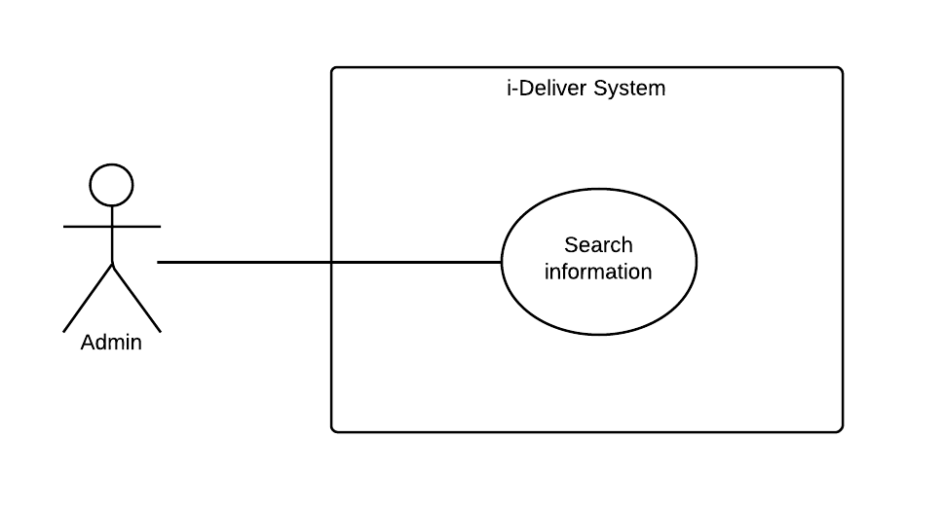

|  |  |  |  |  |
| --- | --- | --- | --- | --- |
| **SEARCH INFORMATION – SPECIFICATION** | | | | |
| **Use-case No.** | UC019 | **Use-case Version** | | 1.0 |
| **Use-case Name** | Search information | | | |
| **Author** | Lê Phúc Lữ | | | |
| **Date** | 10/02/2014 | **Priority** | Normal | |
| **Actor:** System administrator (admin).  **Summary:**  This use case allows admin search some specific information for management, especially search account.  **Goal:**  Search information of account with the key word.  **Triggers:**  N/A.  **Preconditions:**  Admin logged in to the system and enter to the manage account page.  **Post Conditions:**  *On success:* The account match with the searching criteria will be found and display on the page result of search process.  *On failure:* Wrong account display on the page result.  **Main Success Scenario:**   |  |  |  | | --- | --- | --- | | **Step** | **User Action** | **System Response** | | 1. |  |  | | 2. |  |  |   **Alternative Scenario:**  N/A.  **Exceptions:**   |  |  |  | | --- | --- | --- | | **No** | **User Action** | **System Response** | | 1. |  |  |   **Relationships:**  N/A.  **Business Rules:**   |  |  | | --- | --- | | **No** | **Business Rule Description** | | 1. |  | | 2. |  | | 3 |  | | | | | |

#### « System administrator » Statistic



|  |  |  |  |  |
| --- | --- | --- | --- | --- |
| **STATISTIC – SPECIFICATION** | | | | |
| **Use-case No.** | UC019 | **Use-case Version** | | 1.0 |
| **Use-case Name** | Statistic | | | |
| **Author** | Lê Phúc Lữ | | | |
| **Date** | 10/02/2014 | **Priority** | Normal | |
| **Actor:** System administrator (admin).  **Summary:**  This use case allows admin statistic information of system, especially statistic on customer account.  **Goal:**  Statistic the information of account.  **Triggers:**  N/A.  **Preconditions:**  Admin logged in to the system and enter to the statistic page.  **Post Conditions:**  *On success:* The result of statistic information will be displayed.  *On failure:* The statistic information is not displayed.  **Main Success Scenario:**   |  |  |  | | --- | --- | --- | | **Step** | **User Action** | **System Response** | | 1. | Click “Thống kê” button in menu bar. |  | | 2. |  | Display statistic information of account by pie chart. |   **Alternative Scenario:**  N/A.  **Exceptions:**   |  |  |  | | --- | --- | --- | | **No** | **User Action** | **System Response** | | 1. |  |  |   **Relationships:**  N/A.  **Business Rules:**   |  |  | | --- | --- | | **No** | **Business Rule Description** | | 1. | User login into the system with admi role. | | 2. |  | | 3 |  | | | | | |

#### « System administrator » Delete comment



|  |  |  |  |  |
| --- | --- | --- | --- | --- |
| **DELETE COMMENT – SPECIFICATION** | | | | |
| **Use-case No.** | UC020 | **Use-case Version** | | 1.0 |
| **Use-case Name** | Delete comment | | | |
| **Author** | Lê Phúc Lữ | | | |
| **Date** | 09/02/2014 | **Priority** | Normal | |
| **Actor:** Admin  **Summary:**  This use case allows admin physical delete the illegal comment for the route, i.e., use the word are not bright meaning, advertise for external service, …  **Goal:**  Delete the specific comment of customer for route.  **Triggers:**  The admin can delete the comment that violates the rule.  **Preconditions:**  Staff enters to the manage feedback page of the system and choose the comment of route for delete.  **Post Conditions:**  *On success:* The comment will be deleted successfully.  *On failure:* The comment won’t be deleted as expected.  **Main Success Scenario:**   |  |  |  | | --- | --- | --- | | **Step** | **User Action** | **System Response** | | 1. | Admin chooses the comment of route and clicks the button “Xóa nhận xét”. |  | | 2. |  | Shows a popup to confirm the action that the staff really wants to delete the comment. “Bạn có thực sự muốn xóa nhận xét này không?” | | 3. | If admin clicks to “Yes” button. |  | | 4. |  | The comment will be deleted. | | 5. | If admin clicks to “No” button. |  | | 6. |  | Closes the popup and doesn’t do anything. |   **Alternative Scenario:**  N/A.  **Exceptions:**   |  |  |  | | --- | --- | --- | | **No** | **User Action** | **System Response** | | 1. | Admin chooses the comment of route and clicks the button “Xóa nhận xét”. When the popup showed, he/she clicks to “Yes” button to confirm. | The comment is not deleted. | | 2. | Admin chooses the list of route that he/she want to reset the rating, then click to button “Clear”. When the popup showed, he/she clicks to “No” button to confirm. | The comment is deleted or the content of it changed. | | 3. | Admin chooses the comment of route and clicks the button “Xóa nhận xét”. | The popup is not showed. |   **Relationships:**  “Comment” usecase.  **Business Rules:**   |  |  | | --- | --- | | **No** | **Business Rule Description** | | 1. | The comment is legal if its content is clear and point to the quality of service, not chat, advertise, … The staff has to read the content of comment carefully to make sure not delete legal comment. | | | | | |

#### « System administrator » Clear rating



|  |  |  |  |  |
| --- | --- | --- | --- | --- |
| **CLEAR RATING – SPECIFICATION** | | | | |
| **Use-case No.** | UC021 | **Use-case Version** | | 1.0 |
| **Use-case Name** | Clear rating | | | |
| **Author** | Lê Phúc Lữ | | | |
| **Date** | 09/02/2014 | **Priority** | Normal | |
| **Actor:** Admin.  **Summary:**  This use case allows admin clear the rating of the route due to some reasons. After a period run the system, each route maybe receive a lot of rating for the service, so these rating and the average point of rate stand for the quality of a specific period of time. So to make sure the rating is up-to-date, staff have to reset (or clear) the rating for route.  **Goal:**  Clear the rating of customer for the route after a period run the system.  **Triggers:**  Admin can clear the rating after it has been saved or statistic after a long enough period.  **Preconditions:**  Admin enters to the manage feedback page of the system and choose one or multiple route for clear the rating.  **Post Conditions:**  *On success:* The ratings of selected routes will be reset to null.  *On failure:* The ratings of selected routes are not set to null exactly.  **Main Success Scenario:**   |  |  |  | | --- | --- | --- | | **Step** | **User Action** | **System Response** | | 1. | Admin chooses the list of route that he/she want to reset the rating, then click to button “Clear”. |  | | 2. |  | Shows a popup to confirm the action that the staff really wants to clear the rating or not. “Bạn có thực sự muốn reset các đánh giá cũ hay không?” | | 3. | If admin clicks to “Yes” button. |  | | 4. |  | All the rating of user rate for this route, also the average rating will be set to null. | | 5. | If admin clicks to “No” button. |  | | 6. |  | Closes the popup and doesn’t do anything. |   **Alternative Scenario:**  N/A.  **Exceptions:**   |  |  |  | | --- | --- | --- | | **No** | **User Action** | **System Response** | | 1. | Admin chooses the list of route that he/she want to reset the rating, then click to button “Clear”. When the popup showed, he/she clicks to “Yes” button to confirm. | The ratings of selected routes are not set to null exactly. | | 2. | Amin chooses the list of route that he/she want to reset the rating, then click to button “Clear”. When the popup showed, he/she clicks to “No” button to confirm. | Some ratings of selected routes are reset while user don’t expect. | | 3. | Amin chooses the list of route that he/she want to reset the rating, then click to button “Clear”. | The popup is not showed. |   **Relationships:**  “Rating” usecase.  **Business Rules:**   |  |  | | --- | --- | | **No** | **Business Rule Description** | | 1. | The rating of route after clear will become NULL (means there is not any user rate), not become 0. | | | | | |

#### « Staff » Approve request

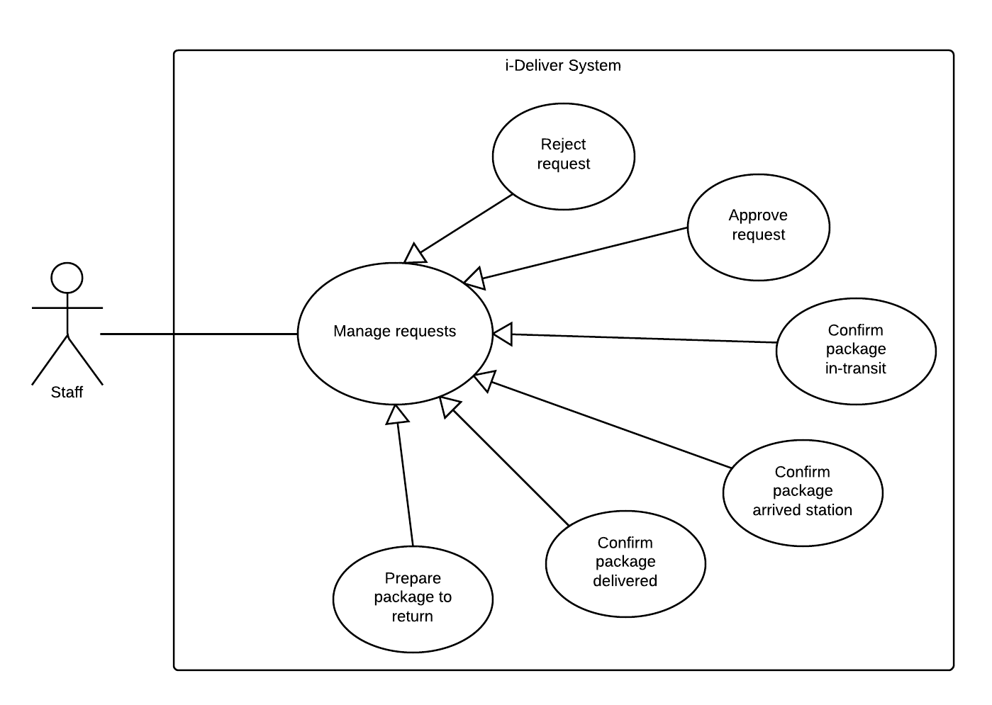

|  |  |  |  |  |
| --- | --- | --- | --- | --- |
| **– SPECIFICATION** | | | | |
| **Use-case No.** | UC0022 | **Use-case Version** | | 1.0 |
| **Use-case Name** | Approve request | | | |
| **Author** | Nguyễn Thanh Tùng | | | |
| **Date** | 10/2/2014 | **Priority** | High | |
| **Actor:**  *Staffs*  **Summary:**  This use case allows staffs to approve a request from customers or in other words the staffs will change the status of request.  **Goal:**  To confirm a request is valid and that request will be processed.  **Triggers:**  .The staffs click on button “Chấp thuận” on the staff page.  **Preconditions:**  .The staff page is being displayed.  **Post Conditions:**  *On success:* The request’s status will be changed  *On failure:* An error message is displayed. The content of the error message will be based on the type of failure.  **Main Success Scenario:**   |  |  |  | | --- | --- | --- | | **Step** | **User Action** | **System Response** | | 1. | Click “Tiếp nhận yêu cầu” link button in menu bar. |  | | 2. |  | Display list of requests that customer request. | | 3. | Select the request want to approve and click “Xác nhận” button. |  | | 4. |  | Request is accepted and system redirect list of requests page. |   **Alternative Scenario:**  N/A  **Exceptions:**   |  |  |  | | --- | --- | --- | | **No** | **User Action** | **System Response** | | 1. |  |  | | 2. |  |  | | 3. |  |  |   **Relationships:**  “Post request” usecase.  **Business Rules:**   |  |  | | --- | --- | | **No** | **Business Rule Description** | | 1. | User login into the system with staff role | | 2. | Only staff at this station has the right to accept requests on this station. | | 3. |  | | | | | |

#### « Staff » Reject request



|  |  |  |  |  |
| --- | --- | --- | --- | --- |
| **– SPECIFICATION** | | | | |
| **Use-case No.** | UC0023 | **Use-case Version** | | 1.0 |
| **Use-case Name** | Reject request | | | |
| **Author** | Nguyễn Thanh Tùng | | | |
| **Date** | 10/2/2014 | **Priority** | High | |
| **Actor:**  Staffs  **Summary:**  This use case allows staffs to delete a request from manager page.  **Goal:**  .To reject a request because it’s may be not valid or in a period time, don’t have any response from customers.  **Triggers:**  .The staffs click on button “Xóa” on the staff pages.  **Preconditions:**  . The staff page is being displayed.  **Post Conditions:**  *On success:* The request will be removed.  *On failure:* An error message is displayed. The content of the error message will be based on the type of failure.  **Main Success Scenario:**   |  |  |  | | --- | --- | --- | | **Step** | **User Action** | **System Response** | | 1. |  |  | | 2. |  |  | | 3. |  |  | | 4. |  |  | | 5. |  |  | | 6. |  |  |   **Alternative Scenario:**   |  |  |  |  | | --- | --- | --- | --- | | **No** | **Step** | **User Action** | **System Response** | | 1. | 1. |  |  | | 2. |  |  | | 2. | 1. |  |  | | 2. |  |  | | 3. | 1. |  |  | | 2. |  |  | | 3. | 1. |  |  | | 2. |  |  | | 4. | 1. |  |  | | 2. |  |  |   **Exceptions:**   |  |  |  | | --- | --- | --- | | **No** | **User Action** | **System Response** | | 1. |  |  | | 2. |  |  | | 3. |  |  | | 4. |  |  | | 5. |  |  | | 6. |  |  | | 7. |  |  | | 8. |  |  |   **Relationships:**  “Check room prices and availability” use case  **Business Rules:**   |  |  | | --- | --- | | **No** | **Business Rule Description** | | 1. |  | | 2. |  | | 3. |  | | | | | |

#### « Staff » Assign package



|  |  |  |  |  |
| --- | --- | --- | --- | --- |
| **– SPECIFICATION** | | | | |
| **Use-case No.** | UC001 | **Use-case Version** | | 1.0 |
| **Use-case Name** | Assign package | | | |
| **Author** | Nguyễn Thanh Tùng | | | |
| **Date** | 10/02/2014 | **Priority** | High | |
| **Actor:**  *Staffs*  **Summary:**  This use case allows staffs assign a request to which car, route…follow the content of request, and request will be become a package.  **Goal:**  .To transport package according to customer requirements  **Triggers:**  .  **Preconditions:**  .The request must be approved.  **Post Conditions:**  *On success:* Package will be assigned.  *On failure:* An error message is displayed. The content of the error message will be based on the type of failure.  **Main Success Scenario:**   |  |  |  | | --- | --- | --- | | **Step** | **User Action** | **System Response** | | 1. | Click “Xếp lịch vận chuyển” link button in menu bar. |  | | 2. |  | Display list of request have been paid on screen. | | 3. | Staff can choose one or more requests to assign and click “Xếp lịch”. |  | | 4. |  |  | | 5. |  |  | | 6. |  |  |   **Alternative Scenario:**   |  |  |  |  | | --- | --- | --- | --- | | **No** | **Step** | **User Action** | **System Response** | | 1. | 1. |  |  | | 2. |  |  | | 2. | 1. |  |  | | 2. |  |  | | 3. | 1. |  |  | | 2. |  |  | | 3. | 1. |  |  | | 2. |  |  | | 4. | 1. |  |  | | 2. |  |  |   **Exceptions:**   |  |  |  | | --- | --- | --- | | **No** | **User Action** | **System Response** | | 1. |  |  | | 2. |  |  | | 3. |  |  | | 4. |  |  | | 5. |  |  | | 6. |  |  | | 7. |  |  | | 8. |  |  |   **Relationships:**  **Business Rules:**   |  |  | | --- | --- | | **No** | **Business Rule Description** | | 1. |  | | 2. |  | | 3. |  | | | | | |

#### « Staff » Confirm package in-transit



|  |  |  |  |  |
| --- | --- | --- | --- | --- |
| **– SPECIFICATION** | | | | |
| **Use-case No.** | UC001 | **Use-case Version** | | 1.0 |
| **Use-case Name** | Update request status | | | |
| **Author** | Nguyễn Thanh Tùng | | | |
| **Date** | 10/02/2014 | **Priority** | High | |
| **Actor:**  *Staffs*  **Summary:**  The use case allows staffs update status of a package when it’s assigned.  **Goal:**  .To notifies to customers about their package through the status of package: on way or waiting.., help their tracking package.  **Triggers:**  .Staffs click on button”Thay đổi trạng thái” on staff’s page.  **Preconditions:**  .Package must be assigned.  **Post Conditions:**  *On success:* Status of package will be changed.  *On failure:* An error message is displayed. The content of the error message will be based on the type of failure.  **Main Success Scenario:**   |  |  |  | | --- | --- | --- | | **Step** | **User Action** | **System Response** | | 1. |  |  | | 2. |  |  | | 3. |  |  | | 4. |  |  | | 5. |  |  | | 6. |  |  |   **Alternative Scenario:**   |  |  |  |  | | --- | --- | --- | --- | | **No** | **Step** | **User Action** | **System Response** | | 1. | 1. |  |  | | 2. |  |  | | 2. | 1. |  |  | | 2. |  |  | | 3. | 1. |  |  | | 2. |  |  | | 3. | 1. |  |  | | 2. |  |  | | 4. | 1. |  |  | | 2. |  |  |   **Exceptions:**   |  |  |  | | --- | --- | --- | | **No** | **User Action** | **System Response** | | 1. |  |  | | 2. |  |  | | 3. |  |  | | 4. |  |  | | 5. |  |  | | 6. |  |  | | 7. |  |  | | 8. |  |  |   **Relationships:**  **Business Rules:**   |  |  | | --- | --- | | **No** | **Business Rule Description** | | 1. |  | | 2. |  | | 3. |  | | | | | |

#### « Staff » Confirm package arrived station



|  |  |  |  |  |
| --- | --- | --- | --- | --- |
| **– SPECIFICATION** | | | | |
| **Use-case No.** | UC001 | **Use-case Version** | | 1.0 |
| **Use-case Name** | Update request status | | | |
| **Author** | Nguyễn Thanh Tùng | | | |
| **Date** | 10/02/2014 | **Priority** | High | |
| **Actor:**  *Staffs*  **Summary:**  The use case allows staffs update status of a package when it’s assigned.  **Goal:**  .To notifies to customers about their package through the status of package: on way or waiting.., help their tracking package.  **Triggers:**  .Staffs click on button”Thay đổi trạng thái” on staff’s page.  **Preconditions:**  .Package must be assigned.  **Post Conditions:**  *On success:* Status of package will be changed.  *On failure:* An error message is displayed. The content of the error message will be based on the type of failure.  **Main Success Scenario:**   |  |  |  | | --- | --- | --- | | **Step** | **User Action** | **System Response** | | 1. |  |  | | 2. |  |  | | 3. |  |  | | 4. |  |  | | 5. |  |  | | 6. |  |  |   **Alternative Scenario:**   |  |  |  |  | | --- | --- | --- | --- | | **No** | **Step** | **User Action** | **System Response** | | 1. | 1. |  |  | | 2. |  |  | | 2. | 1. |  |  | | 2. |  |  | | 3. | 1. |  |  | | 2. |  |  | | 3. | 1. |  |  | | 2. |  |  | | 4. | 1. |  |  | | 2. |  |  |   **Exceptions:**   |  |  |  | | --- | --- | --- | | **No** | **User Action** | **System Response** | | 1. |  |  | | 2. |  |  | | 3. |  |  | | 4. |  |  | | 5. |  |  | | 6. |  |  | | 7. |  |  | | 8. |  |  |   **Relationships:**  **Business Rules:**   |  |  | | --- | --- | | **No** | **Business Rule Description** | | 1. |  | | 2. |  | | 3. |  | | | | | |

#### « Staff » Confirm package delivered



|  |  |  |  |  |
| --- | --- | --- | --- | --- |
| **– SPECIFICATION** | | | | |
| **Use-case No.** | UC001 | **Use-case Version** | | 1.0 |
| **Use-case Name** | Update request status | | | |
| **Author** | Nguyễn Thanh Tùng | | | |
| **Date** | 10/02/2014 | **Priority** | High | |
| **Actor:**  *Staffs*  **Summary:**  The use case allows staffs update status of a package when it’s assigned.  **Goal:**  .To notifies to customers about their package through the status of package: on way or waiting.., help their tracking package.  **Triggers:**  .Staffs click on button”Thay đổi trạng thái” on staff’s page.  **Preconditions:**  .Package must be assigned.  **Post Conditions:**  *On success:* Status of package will be changed.  *On failure:* An error message is displayed. The content of the error message will be based on the type of failure.  **Main Success Scenario:**   |  |  |  | | --- | --- | --- | | **Step** | **User Action** | **System Response** | | 1. |  |  | | 2. |  |  | | 3. |  |  | | 4. |  |  | | 5. |  |  | | 6. |  |  |   **Alternative Scenario:**   |  |  |  |  | | --- | --- | --- | --- | | **No** | **Step** | **User Action** | **System Response** | | 1. | 1. |  |  | | 2. |  |  | | 2. | 1. |  |  | | 2. |  |  | | 3. | 1. |  |  | | 2. |  |  | | 3. | 1. |  |  | | 2. |  |  | | 4. | 1. |  |  | | 2. |  |  |   **Exceptions:**   |  |  |  | | --- | --- | --- | | **No** | **User Action** | **System Response** | | 1. |  |  | | 2. |  |  | | 3. |  |  | | 4. |  |  | | 5. |  |  | | 6. |  |  | | 7. |  |  | | 8. |  |  |   **Relationships:**  **Business Rules:**   |  |  | | --- | --- | | **No** | **Business Rule Description** | | 1. |  | | 2. |  | | 3. |  | | | | | |

#### « Staff » Prepare package to return



|  |  |  |  |  |
| --- | --- | --- | --- | --- |
| **– SPECIFICATION** | | | | |
| **Use-case No.** | UC001 | **Use-case Version** | | 1.0 |
| **Use-case Name** | Update request status | | | |
| **Author** | Nguyễn Thanh Tùng | | | |
| **Date** | 10/02/2014 | **Priority** | High | |
| **Actor:**  *Staffs*  **Summary:**  The use case allows staffs update status of a package when it’s assigned.  **Goal:**  .To notifies to customers about their package through the status of package: on way or waiting.., help their tracking package.  **Triggers:**  .Staffs click on button”Thay đổi trạng thái” on staff’s page.  **Preconditions:**  .Package must be assigned.  **Post Conditions:**  *On success:* Status of package will be changed.  *On failure:* An error message is displayed. The content of the error message will be based on the type of failure.  **Main Success Scenario:**   |  |  |  | | --- | --- | --- | | **Step** | **User Action** | **System Response** | | 1. |  |  | | 2. |  |  | | 3. |  |  | | 4. |  |  | | 5. |  |  | | 6. |  |  |   **Alternative Scenario:**   |  |  |  |  | | --- | --- | --- | --- | | **No** | **Step** | **User Action** | **System Response** | | 1. | 1. |  |  | | 2. |  |  | | 2. | 1. |  |  | | 2. |  |  | | 3. | 1. |  |  | | 2. |  |  | | 3. | 1. |  |  | | 2. |  |  | | 4. | 1. |  |  | | 2. |  |  |   **Exceptions:**   |  |  |  | | --- | --- | --- | | **No** | **User Action** | **System Response** | | 1. |  |  | | 2. |  |  | | 3. |  |  | | 4. |  |  | | 5. |  |  | | 6. |  |  | | 7. |  |  | | 8. |  |  |   **Relationships:**  **Business Rules:**   |  |  | | --- | --- | | **No** | **Business Rule Description** | | 1. |  | | 2. |  | | 3. |  | | | | | |

#### « Staff » Search package



|  |  |  |  |  |
| --- | --- | --- | --- | --- |
| **– SPECIFICATION** | | | | |
| **Use-case No.** | UC001 | **Use-case Version** | | 1.0 |
| **Use-case Name** | Search Package | | | |
| **Author** | Nguyễn Thanh Tùng | | | |
| **Date** | 10/02/2014 | **Priority** | High | |
| **Actor:**  *Staffs*  **Summary:**  This use case allows staffs search information of package such as package name, assign to which coach…  **Goal:**  .To search package for tracking and checking information.  **Triggers:**  .Staffs click on button “Tìm kiếm”  **Preconditions:**  .Staffs page being displayed.  **Post Conditions:**  *On success:* A list of packages is displayed.  *On failure:* An error message is displayed. The content of the error message will be based on the type of failure.  **Main Success Scenario:**   |  |  |  | | --- | --- | --- | | **Step** | **User Action** | **System Response** | | 1. |  |  | | 2. |  |  | | 3. |  |  | | 4. |  |  | | 5. |  |  | | 6. |  |  |   **Alternative Scenario:**   |  |  |  |  | | --- | --- | --- | --- | | **No** | **Step** | **User Action** | **System Response** | | 1. | 1. |  |  | | 2. |  |  | | 2. | 1. |  |  | | 2. |  |  | | 3. | 1. |  |  | | 2. |  |  | | 3. | 1. |  |  | | 2. |  |  | | 4. | 1. |  |  | | 2. |  |  |   **Exceptions:**   |  |  |  | | --- | --- | --- | | **No** | **User Action** | **System Response** | | 1. |  |  | | 2. |  |  | | 3. |  |  | | 4. |  |  | | 5. |  |  | | 6. |  |  | | 7. |  |  | | 8. |  |  |   **Relationships:**  “Check room prices and availability” use case  **Business Rules:**   |  |  | | --- | --- | | **No** | **Business Rule Description** | | 1. |  | | 2. |  | | 3. |  | | | | | |

#### « Staff » Create a schedule



|  |  |  |  |  |
| --- | --- | --- | --- | --- |
| **CREATE A SCHEDULE – SPECIFICATION** | | | | |
| **Use-case No.** | UC029 | **Use-case Version** | | 1.0 |
| **Use-case Name** | Create new schedule | | | |
| **Author** | LongDB | | | |
| **Date** | 10/02/2014 | **Priority** | Normal | |
| **Actor:**  *Staff*  **Summary:**  This use case allows a staff to create a schedule for specify coach and route.  **Goal:**  To manually define a new schedule in the i-Deliver system.  **Triggers:**  The user clicks on the button “Tạo lịch chạy” on the schedule management page.  **Preconditions:**  The user is already logged in with an account of Staff role.  **Post Conditions:**  *On success:* A new schedule was added to system’s database. The user is redirected to schedule list page which is now has a section that describes the currently added schedule.  *On failure:* An error message is displayed. Please refer to the Exception Scenario section the see what the content of the error message is.  **Main Success Scenario:**   |  |  |  | | --- | --- | --- | | **Step** | **User Action** | **System Response** | | 1. | Clicks on the button “Tạo lịch chạy”. |  | | 2. | Fills out the form with relevant values.  [See Exception No. 1, 2, 3, 4] |  | | 3. | Clicks the button “Tạo mới”  [See Alternative No. 1, 2, 3] |  | | 4. |  | Saves the schedule to the database and redirects the user to the schedule list page which now has a new section that describes the newly added schedule. |   **Alternative Scenario:**   |  |  |  |  | | --- | --- | --- | --- | | **No** | **Step** | **User Action** | **System Response** | | 1. | 1. | Clicks on the button “Hủy”. |  | | 2. |  | Shows a popup to ask the user to confirm the action. | | 2. | 1. | The user chooses “OK”. |  | | 2. |  | If the user confirms to go back, redirects the user to the list page, otherwise, just hide the popup. | | 3. | 1. | Clicks on the button “Tạo mới”. |  | | 2. |  | Saves the schedule to the database and redirects the user to the schedule list page. |   **Exceptions:**   |  |  |  | | --- | --- | --- | | **No** | **User Action** | **System Response** | | 1. | Does not select an item in the select list “Tuyến”. | Shows the message “Vui lòng chọn một tuyến” next to the field. | | 2. | Does not select an item in the select list “Xe”. | Shows the message “Vui lòng chọn một xe” next to the field. | | 3. | Leaves the field “Thời gian đi dự kiến” empty. | Shows the message “Vui lòng nhập thời gian” next to the field. | | 4. | Leaves the field “Thời gian đến dự kiến” empty. | Shows the message “Vui lòng nhập thời gian” next to the field. |   **Relationships:**  N/A  **Business Rules:**   |  |  | | --- | --- | | **No** | **Business Rule Description** | | 1. | A new schedule can be created for a route if only that route had specified coaches run on. | | | | | |

#### « Staff » Create a trip



|  |  |  |  |  |
| --- | --- | --- | --- | --- |
| **ADD A TRIP – SPECIFICATION** | | | | |
| **Use-case No.** | UC029 | **Use-case Version** | | 1.0 |
| **Use-case Name** | Create new trip | | | |
| **Author** | LongDB | | | |
| **Date** | 10/02/2014 | **Priority** | Normal | |
| **Actor:**  *Staff*  **Summary:**  …  **Goal:**  To manually open a new trip in the i-Deliver system  **Triggers:**  The user clicks on the button “Tạo một chuyến mới” on the trip management page.  **Preconditions:**  The user is already logged in with an account of Staff role.  **Post Conditions:**  *On success:* A new trip was added to system’s database. The user is redirected to trip list page which is now has a section that describes the currently added trip.  *On failure:* An error message is displayed. Please refer to the Exception Scenario section the see what the content of the error message is.  **Main Success Scenario:**   |  |  |  | | --- | --- | --- | | **Step** | **User Action** | **System Response** | | 1. | Clicks on the button “Tạo một chuyến mới”. |  | | 2. | Fills out the form with relevant values.  [See Exception No. 1, 2] |  | | 3. | Clicks the button “Tạo mới”  [See Alternative No. 1, 2, 3] |  | | 4. |  | Saves the trip to the database and redirects the user to the trip list page which now has a new section that describes the newly added trip. |   **Alternative Scenario:**   |  |  |  |  | | --- | --- | --- | --- | | **No** | **Step** | **User Action** | **System Response** | | 1. | 1. | Clicks on the button “Hủy”. |  | | 2. |  | Shows a popup to ask the user to confirm the action. | | 2. | 1. | The user chooses “OK”. |  | | 2. |  | If the user confirms to go back, redirects the user to the list page, otherwise, just hide the popup. | | 3. | 1. | Clicks on the button “Tạo mới”. |  | | 2. |  | Saves the trip to the database and redirects the user to the trip list page. |   **Exceptions:**   |  |  |  | | --- | --- | --- | | **No** | **User Action** | **System Response** | | 1. | Does not select a date in the datepicker “Ngày chạy”. | Shows the message “Vui lòng chọn ngày” next to the field. | | 2. | Does not select an item in the select list “Tuyến”. | Shows the message “Vui lòng chọn tuyến” next to the field. |   **Relationships:**  N/A  **Business Rules:**   |  |  | | --- | --- | | **No** | **Business Rule Description** | | 1. | A new trip can be created for a route if only that route had defined schedule. | | 2. | Before create a new trip, user must select a date to review all trip created in that day in order to avoid duplicate. | | 3. | Once time user pick a date to create new trip, the i-Deliver system will create trip for 7 days continuous automatically | | | | | |

#### « Staff » Delete a trip



|  |  |  |  |  |
| --- | --- | --- | --- | --- |
| **DELETE A TRIP – SPECIFICATION** | | | | |
| **Use-case No.** | UC031 | **Use-case Version** | | 1.0 |
| **Use-case Name** | Delete a trip | | | |
| **Author** | LongDB | | | |
| **Date** | 10/02/2014 | **Priority** | Normal | |
| **Actor:**  *Staff*  **Summary:**  This use case allows a staff to remove an existing trip from the system.  **Goal:**  To manually remove an existing trip from the system.  **Triggers:**  The staff clicks on the button “Xóa chuyến” on the section that contains the trip to be deleted in the trip management page.  **Preconditions:**  The user is already logged in with an account of Staff role.  The trip management page is being displayed.  The trip to be deleted is being selected.  **Post Conditions:**  *On success:* The selected trip is deleted from the system databse. The row that contains the selected trip is removed from the trip list page.  *On failure:* An error message is displayed. The content of the error message will be specified in the Exception Scenario section based on the type of failure.  **Main Success Scenario:**   |  |  |  | | --- | --- | --- | | **Step** | **User Action** | **System Response** | | 1. | Clicks on the button “Xóa” on the row that contains the trip to be deleted. |  | | 2. |  | Shows a popup to ask the staff to confirm the action. | | 3. | Chooses “OK” to continue to delete the trip.  [See Alternative No. 1] | Marks the selected trip as deleted in the database.  Removes the row that contains the selected trip from the trip list page. |   **Alternative Scenario:**   |  |  |  |  | | --- | --- | --- | --- | | **No** | **Step** | **User Action** | **System Response** | | 1. | 1. | Clicks on the button “Hủy bỏ”. |  | | 2. |  | Hides the popup message box. |   **Exceptions:**  N/A  **Relationships:**  “Add a trip” use case  **Business Rules:**   |  |  | | --- | --- | | **No** | **Business Rule Description** | | 1. | Staff will be notified by requests list which assigned to selected trip before delete that trip. | | 2. | All of requests has assigned to selected trip will be re-assigned | | | | | |

#### « Staff » Add a station



|  |  |  |  |  |
| --- | --- | --- | --- | --- |
| **ADD A STATION – SPECIFICATION** | | | | |
| **Use-case No.** | UC032 | **Use-case Version** | | 1.0 |
| **Use-case Name** | Add new station | | | |
| **Author** | LongDB | | | |
| **Date** | 10/02/2014 | **Priority** | Normal | |
| **Actor:**  *Staff*  **Summary:**  …  **Goal:**  To manually open a new station in the i-Deliver system  **Triggers:**  The user clicks on the button “Thêm một trạm mới” on the station management page.  **Preconditions:**  The user is already logged in with an account of Staff role.  **Post Conditions:**  *On success:* A new station was added to system’s database. The user is redirected to trip station page which is now has a section that describes the currently added station.  *On failure:* An error message is displayed. Please refer to the Exception Scenario section the see what the content of the error message is.  **Main Success Scenario:**   |  |  |  | | --- | --- | --- | | **Step** | **User Action** | **System Response** | | 1. | Clicks on the button “Tạo trạm chuyến mới”. |  | | 2. | Fills out the form with relevant values.  [See Exception No. 1, 2, 3, 4, 5] |  | | 3. | Clicks the button “Tạo mới”.  [See Alternative No. 1, 2, 3] |  | | 4. |  | Saves the stations to the database and redirects the user to the station list page which now has a new section that describes the newly added station. |   **Alternative Scenario:**   |  |  |  |  | | --- | --- | --- | --- | | **No** | **Step** | **User Action** | **System Response** | | 1. | 1. | Clicks on the button “Quay về trang quản lý”. |  | | 2. |  | Shows a popup to ask the user to confirm the action. | | 2. | 1. | The user chooses “OK”. |  | | 2. |  | If the user confirms to go back, redirects the user to the list page, otherwise, just hide the popup. | | 3. | 1. | Clicks on the button “Lưu và tiếp tục”. |  | | 2. |  | Saves the station to the database and redirects the user to the station list page. |   **Exceptions:**   |  |  |  | | --- | --- | --- | | **No** | **User Action** | **System Response** | | 1. | Leaves the field “Tên trạm” empty. | Shows the message “Vui lòng nhập tên trạm” next to the field. | | 2. | Leaves the field “Địa chỉ” empty. | Shows the message “Vui lòng nhập địa chỉ trạm” next to the field. | | 3. | Does not select an item in the select list “Tỉnh thành”. | Shows the message “Vui lòng chọn tỉnh, thành phố” next to the select list. | | 4. | Fills the field “Số điện thoại” with a value that cannot be recognized as a phone number. | Shows the message “Vui lòng nhập số điện thoại hợp lệ” next to the field. | | 5. | Leaves the field “Địa chỉ” empty. | Shows the message “Vui lòng nhập địa chỉ” next to the field. |   **Relationships:**  N/A  **Business Rules:** | | | | |

#### « Staff » Edit station information



|  |  |  |  |  |
| --- | --- | --- | --- | --- |
| **EDIT STATION INFORMATION – SPECIFICATION** | | | | |
| **Use-case No.** | UC033 | **Use-case Version** | | 1.0 |
| **Use-case Name** | Edit station information | | | |
| **Author** | LongDB | | | |
| **Date** | 10/02/2014 | **Priority** | Normal | |
| **Actor:**  *Staff*  **Summary:**  This use case allows a staff to view and manually change information about an existing station in the database.  **Goal:**  To manually edit information of a station in the system.  **Triggers:**  The user clicks on the button “Thông tin trạm” on station management page.  **Preconditions:**  The user is already logged in with an account of Staff role.  The station management page is being displayed.  **Post Conditions:**  *On success:* The information of selected station is updated in the system. The user is redirect to the station management page where information is currently updated.  *On failure:* An error message is displayed. The content of the error message will be specified in the Exception Scenario section based on the type of failure.  **Main Success Scenario:**   |  |  |  | | --- | --- | --- | | **Step** | **User Action** | **System Response** | | 1. | Clicks on the button “Chỉnh sửa thông tin trạm”. |  | | 2. | Fills out the form with relevant values.  [See Exception No. 1, 2, 3, 4, 5] |  | | 3. | Clicks the button “Lưu thay đổi”.  [See Alternative No. 1, 2, 3] |  | | 4. |  | Saves new station information to the database and redirects the staff to the station list page. |   **Alternative Scenario:**   |  |  |  |  | | --- | --- | --- | --- | | **No** | **Step** | **User Action** | **System Response** | | 1. | 1. | Clicks on the button “Quay về trang quản lý”. |  | | 2. |  | Shows a popup to ask the user to confirm the action. | | 2. | 1. | The user chooses “OK”. |  | | 2. |  | If the user confirms to go back, redirects the user to the list page, otherwise, just hide the popup. | | 3. | 1. | Clicks on the button “Lưu thay đổi”. |  | | 2. |  | Saves new station information to the database and redirects the staff to the station list page. |   **Exceptions:**   |  |  |  | | --- | --- | --- | | **No** | **User Action** | **System Response** | | 1. |  |  | | 2. |  |  | | 3. |  |  | | 4. |  |  | | 5. |  |  | | 6. |  |  | | 7. |  |  | | 8. |  |  |   **Relationships:**  “Add a station” use case  **Business Rules:**   |  |  | | --- | --- | | **No** | **Business Rule Description** | | 1. |  | | 2. |  | | 3. |  | | | | | |

#### « Staff » Add a route



|  |  |  |  |  |
| --- | --- | --- | --- | --- |
| **ADD A ROUTE – SPECIFICATION** | | | | |
| **Use-case No.** | UC035 | **Use-case Version** | | 1.0 |
| **Use-case Name** | Add new route | | | |
| **Author** | LongDB | | | |
| **Date** | 10/02/2014 | **Priority** | Normal | |
| **Actor:**  *Staff*  **Summary:**  …  **Goal:**  To manually open a new route in the i-Deliver system  **Triggers:**  The user clicks on the button “Thêm một tuyến mới” on the routes management page.  **Preconditions:**  The user is already logged in with an account of Staff role.  **Post Conditions:**  *On success:* A new route was added to system’s database. The user is redirected to route station page which is now has a section that describes the currently added station.  *On failure:* An error message is displayed. Please refer to the Exception Scenario section the see what the content of the error message is.  **Main Success Scenario:**   |  |  |  | | --- | --- | --- | | **Step** | **User Action** | **System Response** | | 1. | Clicks on the button “Tạo một tuyến mới”. |  | | 2. |  |  | | 3. | Fills out the form with relevant values.  [See Exception No. 1, 2, 3, 4, 5, 6, 7, 8, 9, 10, 11, 12, 13] |  | | 4. | Clicks the button “Lưu và quản về trang quản lý”.  [See Alternative No. 1, 2] |  | | 5. |  | Saves the routes to the database and redirects the user to the route list page which now has a new section that describes the newly added route. |   **Alternative Scenario:**   |  |  |  |  | | --- | --- | --- | --- | | **No** | **Step** | **User Action** | **System Response** | | 1. | 1. | Clicks on the button “Quay về trang quản lý”. |  | | 2. |  | Shows a popup to ask the user to confirm the action. | | 2. | 1. | The user chooses “OK”. |  | | 2. |  | If the user confirms to go back, redirects the user to the list page, otherwise, just hide the popup. | | 3. | 1. | Clicks on the button “Lưu và tiếp tục”. |  | | 2. |  | Saves the route to the database and redirects the user to the route list page. |   **Exceptions:**   |  |  |  | | --- | --- | --- | | **No** | **User Action** | **System Response** | | 1. |  |  | | 2. |  |  | | 3. |  |  | | 4. |  |  | | 5. |  |  | | 6. |  |  | | 7. |  |  | | 8. |  |  |   **Relationships:**  “…” use case  **Business Rules:**   |  |  | | --- | --- | | **No** | **Business Rule Description** | | 1. |  | | 2. |  | | 3. |  | | | | | |

#### « Staff » Edit route information



|  |  |  |  |  |
| --- | --- | --- | --- | --- |
| **EDIT ROUTE INFORMATION – SPECIFICATION** | | | | |
| **Use-case No.** | UC036 | **Use-case Version** | | 1.0 |
| **Use-case Name** | Edit route information | | | |
| **Author** | LongDB | | | |
| **Date** | 10/02/2014 | **Priority** | Normal | |
| **Actor:**  *Staff*  **Summary:**  This use case allows a staff to view and manually change information about an existing route in the database.  **Goal:**  To manually edit information of an existing route in the system.  **Triggers:**  The user clicks on the button “Thông tin tuyến” on route management page.  **Preconditions:**  The user is already logged in with an account of Staff role.  The route management page is being displayed.  **Post Conditions:**  *On success:* The information of selected route is updated in the system. The user is redirect to the route management page where information is currently updated.  *On failure:* An error message is displayed. The content of the error message will be specified in the Exception Scenario section based on the type of failure.  **Main Success Scenario:**   |  |  |  | | --- | --- | --- | | **Step** | **User Action** | **System Response** | | 1. |  |  | | 2. |  |  | | 3. |  |  | | 4. |  |  | | 5. |  |  | | 6. |  |  |   **Alternative Scenario:**   |  |  |  |  | | --- | --- | --- | --- | | **No** | **Step** | **User Action** | **System Response** | | 1. | 1. |  |  | | 2. |  |  | | 2. | 1. |  |  | | 2. |  |  | | 3. | 1. |  |  | | 2. |  |  | | 3. | 1. |  |  | | 2. |  |  | | 4. | 1. |  |  | | 2. |  |  |   **Exceptions:**   |  |  |  | | --- | --- | --- | | **No** | **User Action** | **System Response** | | 1. |  |  | | 2. |  |  | | 3. |  |  | | 4. |  |  | | 5. |  |  | | 6. |  |  | | 7. |  |  | | 8. |  |  |   **Relationships:**  “Add a route” use case  **Business Rules:**   |  |  | | --- | --- | | **No** | **Business Rule Description** | | 1. |  | | 2. |  | | 3. |  | | | | | |

#### « Staff » Delete a route



|  |  |  |  |  |
| --- | --- | --- | --- | --- |
| **DELETE A ROUTE – SPECIFICATION** | | | | |
| **Use-case No.** | UC037 | **Use-case Version** | | 1.0 |
| **Use-case Name** | Delete a route | | | |
| **Author** | LongDB | | | |
| **Date** | 10/02/2014 | **Priority** | Normal | |
| **Actor:**  *Staff*  **Summary:**  This use case allows a staff to remove an existing route from the system.  **Goal:**  To manually remove an existing route from the system.  **Triggers:**  The staff clicks on the button “Xóa tuyến” on the section that contains the route to be deleted in the route management page.  **Preconditions:**  The user is already logged in with an account of Staff role.  The route management page is being displayed.  The route to be deleted is being selected.  **Post Conditions:**  *On success:* The selected route is deleted from the system databse. The row that contains the selected route is removed from the route list page.  *On failure:* An error message is displayed. The content of the error message will be specified in the Exception Scenario section based on the type of failure.  **Main Success Scenario:**   |  |  |  | | --- | --- | --- | | **Step** | **User Action** | **System Response** | | 1. | Clicks on the button “Xóa” on the row that contains the trip to be deleted. |  | | 2. |  | [See Exception No. 1]  Shows a popup to ask the staff to confirm the action. | | 3. | Chooses “OK” to continue to delete the route.  [See Alternative No. 1] | Marks the selected route as deleted in the database.  Removes the row that contains the selected route from the route page.  [See Exception No. 2, 3] |   **Alternative Scenario:**   |  |  |  |  | | --- | --- | --- | --- | | **No** | **Step** | **User Action** | **System Response** | | 1. | 1. | Clicks on the button “Hủy bỏ”. |  | | 2. |  | Hides the popup message box. |   **Exceptions:**   |  |  |  | | --- | --- | --- | | **No** | **User Action** | **System Response** | | 1. |  |  | | 2. |  |  | | 3. |  |  | | 4. |  |  | | 5. |  |  | | 6. |  |  | | 7. |  |  | | 8. |  |  |   **Relationships:**  “Add a route” use case  **Business Rules:**   |  |  | | --- | --- | | **No** | **Business Rule Description** | | 1. |  | | 2. |  | | 3. |  | | | | | |

#### « Staff » Add new coach



|  |  |  |  |  |
| --- | --- | --- | --- | --- |
| **ADD A COACH – SPECIFICATION** | | | | |
| **Use-case No.** | UC038 | **Use-case Version** | | 1.0 |
| **Use-case Name** | Add new coach | | | |
| **Author** | LongDB | | | |
| **Date** | 10/02/2014 | **Priority** | Normal | |
| **Actor:**  *Staff*  **Summary:**  …  **Goal:**  To manually add a new coach to the i-Deliver system  **Triggers:**  The user clicks on the button “Thêm một xe mới” on the coach management page.  **Preconditions:**  The user is already logged in with an account of Staff role.  **Post Conditions:**  *On success:* A new coach was added to system’s database. The user is redirected to coach station page which is now has a section that describes the currently added coach.  *On failure:* An error message is displayed. Please refer to the Exception Scenario section the see what the content of the error message is.  **Main Success Scenario:**   |  |  |  | | --- | --- | --- | | **Step** | **User Action** | **System Response** | | 1. | Clicks on the button “Thêm một xe mới”. |  | | 2. |  |  | | 3. | Fills out the form with relevant values.  [See Exception No. 1, 2, 3, 4, 5, 6, 7, 8, 9, 10, 11, 12, 13] |  | | 4. | Clicks the button “Lưu và quản về trang quản lý”.  [See Alternative No. 1, 2] |  | | 5. |  | Saves the coach s to the database and redirects the user to the coach list page which now has a new section that describes the newly added coach. |   **Alternative Scenario:**   |  |  |  |  | | --- | --- | --- | --- | | **No** | **Step** | **User Action** | **System Response** | | 1. | 1. | Clicks on the button “Quay về trang quản lý”. |  | | 2. |  | Shows a popup to ask the user to confirm the action. | | 2. | 1. | The user chooses “OK”. |  | | 2. |  | If the user confirms to go back, redirects the user to the list page, otherwise, just hide the popup. | | 3. | 1. | Clicks on the button “Lưu và tiếp tục”. |  | | 2. |  | Saves the coach to the database and redirects the user to the coach list page. |   **Exceptions:**   |  |  |  | | --- | --- | --- | | **No** | **User Action** | **System Response** | | 1. |  |  | | 2. |  |  | | 3. |  |  | | 4. |  |  | | 5. |  |  | | 6. |  |  | | 7. |  |  | | 8. |  |  |   **Relationships:**  “…” use case  **Business Rules:**   |  |  | | --- | --- | | **No** | **Business Rule Description** | | 1. |  | | 2. |  | | 3. |  | | | | | |

#### « Staff » Edit coach information



|  |  |  |  |  |
| --- | --- | --- | --- | --- |
| **EDIT COACH INFORMATION – SPECIFICATION** | | | | |
| **Use-case No.** | UC039 | **Use-case Version** | | 1.0 |
| **Use-case Name** | Edit coach information | | | |
| **Author** | LongDB | | | |
| **Date** | 10/02/2014 | **Priority** | Normal | |
| **Actor:**  *Staff*  **Summary:**  This use case allows a staff to view and manually change information about an existing coach in the database.  **Goal:**  To manually edit information of an existing coach in the system.  **Triggers:**  The user clicks on the button “Thông tin xe” on coach management page.  **Preconditions:**  The user is already logged in with an account of Staff role.  The coach management page is being displayed.  **Post Conditions:**  *On success:* The information of selected coach is updated in the system. The user is redirect to the coach management page where information is currently updated.  *On failure:* An error message is displayed. The content of the error message will be specified in the Exception Scenario section based on the type of failure.  **Main Success Scenario:**   |  |  |  | | --- | --- | --- | | **Step** | **User Action** | **System Response** | | 1. |  |  | | 2. |  |  | | 3. |  |  | | 4. |  |  | | 5. |  |  | | 6. |  |  |   **Alternative Scenario:**   |  |  |  |  | | --- | --- | --- | --- | | **No** | **Step** | **User Action** | **System Response** | | 1. | 1. |  |  | | 2. |  |  | | 2. | 1. |  |  | | 2. |  |  | | 3. | 1. |  |  | | 2. |  |  | | 3. | 1. |  |  | | 2. |  |  | | 4. | 1. |  |  | | 2. |  |  |   **Exceptions:**   |  |  |  | | --- | --- | --- | | **No** | **User Action** | **System Response** | | 1. |  |  | | 2. |  |  | | 3. |  |  | | 4. |  |  | | 5. |  |  | | 6. |  |  | | 7. |  |  | | 8. |  |  |   **Relationships:**  “Add a coach” use case  **Business Rules:**   |  |  | | --- | --- | | **No** | **Business Rule Description** | | 1. |  | | 2. |  | | 3. |  | | | | | |

#### « Staff » Delete a coach



|  |  |  |  |  |
| --- | --- | --- | --- | --- |
| **DELETE A COACH – SPECIFICATION** | | | | |
| **Use-case No.** | UC040 | **Use-case Version** | | 1.0 |
| **Use-case Name** | Delete a coach | | | |
| **Author** | LongDB | | | |
| **Date** | 10/02/2014 | **Priority** | Normal | |
| **Actor:**  *Staff*  **Summary:**  This use case allows a staff to remove an existing coach from the system.  **Goal:**  To manually remove an existing coach from the system.  **Triggers:**  The staff clicks on the button “Xóa xe này” on the section that contains the coach to be deleted in the coach management page.  **Preconditions:**  The user is already logged in with an account of Staff role.  The coach management page is being displayed.  The coach to be deleted is being selected.  **Post Conditions:**  *On success:* The selected coach is deleted from the system databse. The row that contains the selected coach is removed from the coach list page.  *On failure:* An error message is displayed. The content of the error message will be specified in the Exception Scenario section based on the type of failure.  **Main Success Scenario:**   |  |  |  | | --- | --- | --- | | **Step** | **User Action** | **System Response** | | 1. | Clicks on the button “Xóa” on the row that contains the trip to be deleted. |  | | 2. |  | Shows a popup to ask the staff to confirm the action. | | 3. | Chooses “OK” to continue to delete the coach.  [See Alternative No. 1] | Marks the selected coach as deleted in the database.  Removes the row that contains the selected coach from the coach list page. |   **Alternative Scenario:**   |  |  |  |  | | --- | --- | --- | --- | | **No** | **Step** | **User Action** | **System Response** | | 1. | 1. | Clicks on the button “Hủy bỏ”. |  | | 2. |  | Hides the popup message box. |   **Exceptions:**   |  |  |  | | --- | --- | --- | | **No** | **User Action** | **System Response** | | 1. |  |  | | 2. |  |  | | 3. |  |  |   **Relationships:**  “Add a coach” use case  **Business Rules:**   |  |  | | --- | --- | | **No** | **Business Rule Description** | | 1. |  | | 2. |  | | 3. |  | | | | | |

### Non-Functional Requirements



#### Reliability

Information about hotels are collected via web services in such a way that preserves the most accurate and up-to-date data. There should be a mechanism that helps prevent violating referential constraints and data integrity when the system synchronizes the data from the web services.

#### Availability

N/A

#### Security

Authentication is required when the user utilizes certain functions in the system. Passwords must be encrypted so the even they are unrecognizable to even system admins and database admins. The system should also require authorization when the user tries to access an unauthorized function.

#### Maintainability

In the architecture design of the system, the responsibilities of all components should be clear and do no overlap each other.

The communications with a web service provider should be packaged in a single module independent from the rest of the system. The module should support plug-and-play, so that, when the web service provider change the structure of the web service results, or when the system must work with another web service provider, minimal changes to the rest of the system are required.

#### Portability

On the client side, the website should be accessible to anyone with a personal computer that connects to the Internet and has a browser.

#### Performance

N/A

## Entity Relationship Diagram

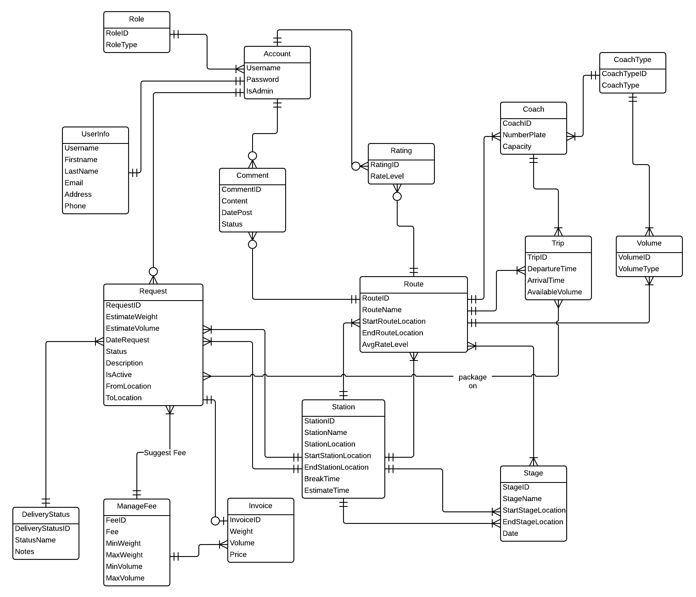

Diagram 2. Entity Relationship Diagram

# Software Design Description (SDD)



## Design Overview

The SDD describes the system architectural design and the detailed designs, including the user interfaces, of the system.

The components should communicate through interfaces. The detailed implementation of each component should be transparent to other components. The passive MVC III pattern is the preferable architecture for the website.

The detailed designs of the system should adopt the basic principles of software design, including “high cohesion, low coupling” and “open to extension, closed to modification” principles.

Each of the following sections is summarized below:

* Section 4.2: Gives a specification of the system architecture design, describing the overall architecture of the system and subsystems.
* Section 4.3: Specifies all the components that should be included in the system, and the communications between them.
* Section 4.4: Describes the class and package diagrams, as well as their descriptions in details, to provide a static view of the system.
* Section 4.4: Describes the sequence diagrams for the use cases specified in the SRS, to provide a dynamic view of the system.
* Section 4.5: Describes the user interfaces, to specify what will be seen by the users of the system.
* Section 4.5: Describes the Database Design, including the relations and the relationships between them.

## System Architectural Design

The MVC III (Model – View – Controller) pattern is used as the overall system architecture, because it specifies a clear distinction between the responsibilities of the components and is appropriate for developing web applications.

3. Exchange data

4. Results

**CONTROLLER**

* Intercepts user input;
* Coordinates the view and model;
* Handles communication between the model and data layer.

**VIEW**

* Binds to the model;
* Renders the UIs (HTML, CSS, JavaScript);
* Allows navigating between controllers.

**MODEL**

* Communicates with data source;
* Exposes functionalities, business logics, and data validation.

Database   
Server

Application Server

1. Request

8. Response

5. Select views

7. Changes made

2. Invoke methods

6. Query states

Method invocations

Change notifications

Figure 3. Model-View-Controller Architecture

## Component Diagram



Diagram 3. Component Diagram

The i-Deliver system includes the following major components:

* **Entity Framework 5.0:** An object-relational mapper that enables working with relational data persistence using domain-specific objects;
* **Data Repository:** A data store that provides data access functionality, using the Entity Framework to communicates with the database;
* **Business Logic:** A module that uses interfaces exposed by the Data Repository to encapsulate important businesses of in the i-Deliver system;
* **Ninject Dependency Injection 3.0:** A lightweight dependency injection framework for .NET applications which helps split the application into a collection of loosely-coupled, highly-cohesive pieces, and then glue them back together in a flexible manner.
* **Website:** A web-application that helps exposes all the functionalities to end-users.

From the point of view of the MVC-II pattern, the components Entity Framework 5.0, Data Repository, Business Logic, and Ninject Dependency Injection 3.0 all belong to the Model part. The Controller and the View parts are wrapped in the component Website.

## Detailed Description of Components



### Entities Classes

Diagram 4. Entities Class Diagram

### Algorithm Processing Classes

#### Class diagram

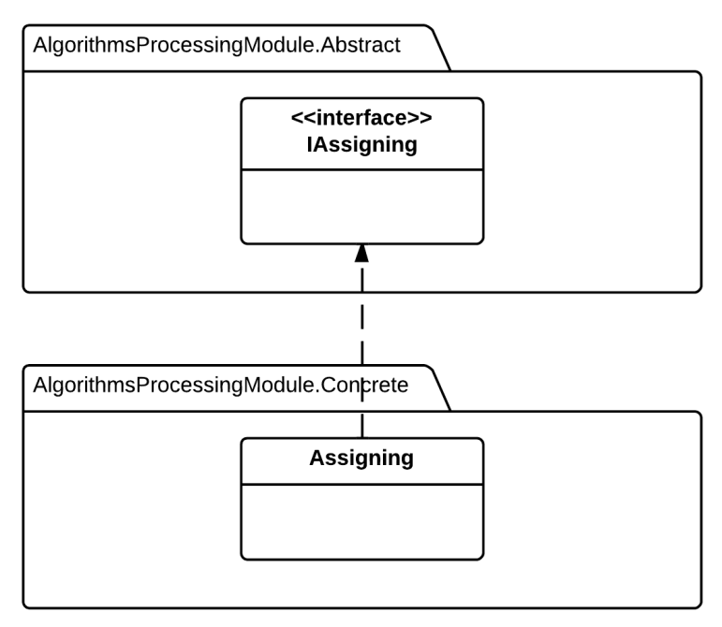

Diagram 5. Algorithm Processing Class Diagram

#### IRouteChooser



**Properties:** N/A

**Operations**

|  |  |  |
| --- | --- | --- |
| **Signature:** int ChooseOneRouteSolution(int StartStation, int EndStation)  **Description:** return one suitable route to deliver from the start station to the end station, if the route not exsit, return -1. | | |
| **Parameter** | **Type** | **Description** |
| StartStation | int | The ID of the start station of the request |
| EndStation | int | The ID of the end station of the request |

|  |  |  |
| --- | --- | --- |
| **Signature:** List <int> ChooseMultipleRouteSolution(int StartStation, int EndStation)  **Description:** return the list of suitable route to deliver from the start station to the end station. | | |
| **Parameter** | **Type** | **Description** |
| StartStation | int | The ID of the start station of the request |
| EndStation | int | The ID of the end station of the request |

|  |  |  |
| --- | --- | --- |
| **Signature:** List<int> SuggestRoute(int StartStation, int EndStation)  **Description:** Suggest for staff the best suitable route or list of routes base on the input start and end station of request. | | |
| **Parameter** | **Type** | **Description** |
| StartStation | int | The ID of the start station of the request |
| EndStation | int | The ID of the end station of the request |

|  |  |  |
| --- | --- | --- |
| **Signature:** bool RouteChosenSave (List<int> RouteList)  **Description:** Retrieves the list of route and save them to the table with exactly indicate order. | | |
| **Parameter** | **Type** | **Description** |
| RouteList | List<int> | List of route that staff choose or system suggest |

|  |  |  |
| --- | --- | --- |
| **Signature:** float EstimateTimeDeliver (List<int> RouteList)  **Description:** Find the estimate time to deliver the package base on the input route list and their relative information. | | |
| **Parameter** | **Type** | **Description** |
| RouteList | List<int> | List of route that staff choose or system suggest |

#### IAssigning



**Properties:** N/A

**Operations**

|  |  |  |
| --- | --- | --- |
| **Signature:** float FindRemaingVolume (int TripID)  **Description:** Return the remaining volume that the coach on input trip can be serve. | | |
| **Parameter** | **Type** | **Description** |
| TripID | int | The ID of trip that staff want to estimate. |

|  |  |  |
| --- | --- | --- |
| **Signature:** List <int> AssigningPackage (int RequestID)  **Description:** Automatically find the list of trip suitable for deliver the package. | | |
| **Parameter** | **Type** | **Description** |
| RequestID | int | The ID of request that staff processing. |

### Data Repository Classes

#### Class diagram



Diagram 6. Data Repository Class Diagram

#### IRequestRepository Interface



Properties: N/A

Operations:

|  |  |  |
| --- | --- | --- |
| Signature: IEnumerable<Request> Get Requests()  Description: Retrieves all the requests from the database | | |
| N/A | N/A | N/A |

|  |  |  |
| --- | --- | --- |
| Signature: Request GetRequestById(int requestId)  Description: Retrieves a request from the database given its id | | |
| Parameter | **Type** | **Description** |
| *requestId* | int | Id of the request to be retrieved |

|  |  |  |
| --- | --- | --- |
| Signature: IEnumerable<Request> GetRequestByStatus(int status)  Description: Retrieves all the request from the database given its status | | |
| Parameter | **Type** | **Description** |
| *Status* | Int | Status of the request to be retrived |

|  |  |  |
| --- | --- | --- |
| Signature: bool postRequest(Request request)  Description: post new delivery request to system and save to database | | |
| Parameter | **Type** | **Description** |
| *request* | Request | New request to be saved |

|  |  |  |
| --- | --- | --- |
| Signature: bool updateRequest(int requestId)  Description: Update existing request to the database given its id | | |
| Parameter | **Type** | **Description** |
| *requestId* | int | Id of the request to be updated |

|  |  |  |
| --- | --- | --- |
| Signature: bool cancelRequest(int requestId)  Description: Cancel/Remove existing request from the database given its id | | |
| Parameter | **Type** | **Description** |
| *requestId* | int | Id of the request to be updated |

|  |  |  |
| --- | --- | --- |
| Signature: IEnumerable<Request> serchRequest(string query)  Description: Retrieves all the request from the database given by query string | | |
| Parameter | **Type** | **Description** |
| *query* | String | Query string to find matching request |

|  |  |  |
| --- | --- | --- |
| Signature:  Description: | | |
| Parameter | **Type** | **Description** |
| *provinceId* | int | Id of the hotel to be checked |

#### IUserRepository Interface



Properties: N/A

|  |  |  |
| --- | --- | --- |
| Signature: User GetUserByUsername(String username)  Description: Retrieves a user given its username from the database | | |
| Parameter | **Type** | **Description** |
| *username* | String | Username of user to be retrieved |

|  |  |  |
| --- | --- | --- |
| Signature: User GetUserByRole(String role)  Description: Retrieves a user given its role from the database | | |
| Parameter | **Type** | **Description** |
| *role* | String | Role of user to be retrieved |

|  |  |  |
| --- | --- | --- |
| Signature: bool addUser(User user)  Description: Add new user to the database | | |
| Parameter | **Type** | **Description** |
| *user* | UserProfile | The user to be saved |

|  |  |  |
| --- | --- | --- |
| Signature: bool updateUser(int username)  Description: Update/Save user information to the database | | |
| Parameter | **Type** | **Description** |
| *username* | String | Username of user to be updated |

|  |  |  |
| --- | --- | --- |
| Signature: bool GrantAccess(String username, int roleId)  Description: Grants the selected role the the user with the user id | | |
| Parameter | **Type** | **Description** |
| *username* | String | Username of the user to be granted access |
| *roleId* | Role | Role that will be granted to the user |

|  |  |  |
| --- | --- | --- |
| Signature: bool DeactivateUser(String username)  Description: Marks the the user as deactivated in the database | | |
| Parameter | **Type** | **Description** |
| *username* | String | Username of the user to be marked as deactivated |

#### IJourneyRepository Interface



**Properties:** N/A

**Operations**

|  |  |  |
| --- | --- | --- |
| Signature: IEnumerable<Station> GetStations()  Description: Retrieves all the stations from the database | | |
| Parameter | **Type** | **Description** |
| N/A | N/A | N/A |

|  |  |  |
| --- | --- | --- |
| Signature: Station GetStationByStationId(int stationId)  Description: Retrieves the station given its station id from the database | | |
| Parameter | **Type** | **Description** |
| *stationId* | int | Id of the station to be retrieved |

|  |  |  |
| --- | --- | --- |
| Signature: Station AddStation(Station station)  Description: Add new station to the database | | |
| Parameter | **Type** | **Description** |
| *station* | Station | The new station to be added to database |

|  |  |  |
| --- | --- | --- |
| Signature: bool UpdateStation(int stationId)  Description: Update station information from given its id from the database | | |
| Parameter | **Type** | **Description** |
| *stationId* | int | Id of the station to be updated |

|  |  |  |
| --- | --- | --- |
| Signature: bool DeleteStation(int stationId)  Description: Delete the station given its it from the database | | |
| Parameter | **Type** | **Description** |
| *stationId* | int | Id of the station to be deleted |

|  |  |  |
| --- | --- | --- |
| Signature: IEnumerable<Trip> GetTrips()  Description: Retrieves all the trips from the database | | |
| Parameter | **Type** | **Description** |
| N/A | N/A | N/A |

|  |  |  |
| --- | --- | --- |
| Signature: Station GetTripByTripId(int tripId)  Description: Retrieves the station given its station id from the database | | |
| Parameter | **Type** | **Description** |
| *tripId* | int | Id of the trip to be retrieved |

|  |  |  |
| --- | --- | --- |
| Signature: Station AddTrip(Trip trip)  Description: Add new trip to the database | | |
| Parameter | **Type** | **Description** |
| *trip* | Trip | The new trip to be added to database |

|  |  |  |
| --- | --- | --- |
| Signature: bool UpdateTrip(int tripId)  Description: Update trip information from given its id from the database | | |
| Parameter | **Type** | **Description** |
| *tripId* | int | Id of the trip to be updated |

|  |  |  |
| --- | --- | --- |
| Signature: bool DeleteTrip(int tripId)  Description: Delete the trip given its it from the database | | |
| Parameter | **Type** | **Description** |
| *tripId* | int | Id of the trip to be deleted |

#### IAssigningRepository Interface



**Properties:** N/A

**Operations**

|  |  |  |
| --- | --- | --- |
| Signature: bool approveRequest(int requestId)  Description: Approve pending requests | | |
| Parameter | **Type** | **Description** |
| *requestId* | int | Id of the request to be approved |

|  |  |  |
| --- | --- | --- |
| Signature: bool rejectRequest(int requestId)  Description: Reject pending requests | | |
| Parameter | **Type** | **Description** |
| *requestId* | int | Id of the request to be rejected |

|  |  |  |
| --- | --- | --- |
| Signature: bool assignPackage(int requestId, int coachId, int tripId)  Description: Assign approved package for specified coach | | |
| Parameter | **Type** | **Description** |
| *requestId* | int | Id of the package to be assigned |
| *coachId* | int | Id of the coach to assign package |
| *tripId* | Int | Id of the trip to assign package |

|  |  |  |
| --- | --- | --- |
| Signature: bool updateLateRequest(int requestId)  Description: Update and re-assign for late arrive package | | |
| Parameter | **Type** | **Description** |
| *requestId* | int | Id of the request to be update and re-assigned |

|  |  |  |
| --- | --- | --- |
| Signature: bool updatePackageStatus(int requestId)  Description: Update package status when it departed, arrived, delivered or expired | | |
| Parameter | **Type** | **Description** |
| *requestId* | int | Id of the request to be update and re-assigned |

#### IFeedbackRepository Interface



**Properties:** N/A

**Operations**

|  |  |  |
| --- | --- | --- |
| Signature: IEnumerable<Comment> GetComments()  Description: Retrieves all the comments from the database | | |
| Parameter | **Type** | **Description** |
| N/A | N/A | N/A |

|  |  |  |
| --- | --- | --- |
| Signature: IEnumerable<RatingCriterion> GetRatingByStationId(int stationId)  Description: Retrieves all the rating that belong to a given station from the database | | |
| Parameter | **Type** | **Description** |
| *stationId* | int | Id of the station that has the rating to be retrieved |

|  |  |  |
| --- | --- | --- |
| Signature: bool postComment(Comment comment)  Description: Post new comment and save to database | | |
| Parameter | **Type** | **Description** |
| *comment* | Comment | The new comment to be saved to database |

|  |  |  |
| --- | --- | --- |
| Signature: bool saveRating(Rating rating)  Description: Save station rating to database | | |
| Parameter | **Type** | **Description** |
| *rating* | Rating | The new station rating to be saved to database |

|  |  |  |
| --- | --- | --- |
| Signature: bool deleteComment(int commentId)  Description: Marks a coment as deleted in the database | | |
| Parameter | **Type** | **Description** |
| *commentId* | int | Id of the comment to be deleted |

|  |  |  |
| --- | --- | --- |
| Signature: bool clearRating(int ratingId)  Description: Marks a station rating as deleted in the database | | |
| Parameter | **Type** | **Description** |
| *ratingId* | Int | Id of the rating to be deleted |

#### IPriceRepository Interface



**Properties:** N/A

**Operations**

|  |  |  |
| --- | --- | --- |
| Signature: IEnumerable<Price> GetPriceByWeight(float weight)  Description: Get delivery price/fee based on package weight | | |
| Parameter | **Type** | **Description** |
| *weight* | float | Weight of delivered package |

|  |  |  |
| --- | --- | --- |
| Signature: IEnumerable<Price> GetPriceByVolume(float volume)  Description: Get delivery price/fee based on package volume | | |
| Parameter | **Type** | **Description** |
| *volume* | float | Volume of delivered package |

|  |  |  |
| --- | --- | --- |
| Signature: bool addPriceNorm(Price price)  Description: Add new price/fee norm to database | | |
| Parameter | **Type** | **Description** |
| *price* | Price | New price norm to be added to database |

|  |  |  |
| --- | --- | --- |
| Signature: bool updatePriceNorm(priceId: int)  Description: Update a price norm to the database | | |
| Parameter | **Type** | **Description** |
| *priceId* | int | The price norm to be saved |

|  |  |  |
| --- | --- | --- |
| Signature: bool updatePriceNorm(priceId: int)  Description: Delete/Remove a price norm from the database | | |
| Parameter | **Type** | **Description** |
| *priceId* | int | The price norm to be deleted |

### Business Logic Classes

#### Class diagram

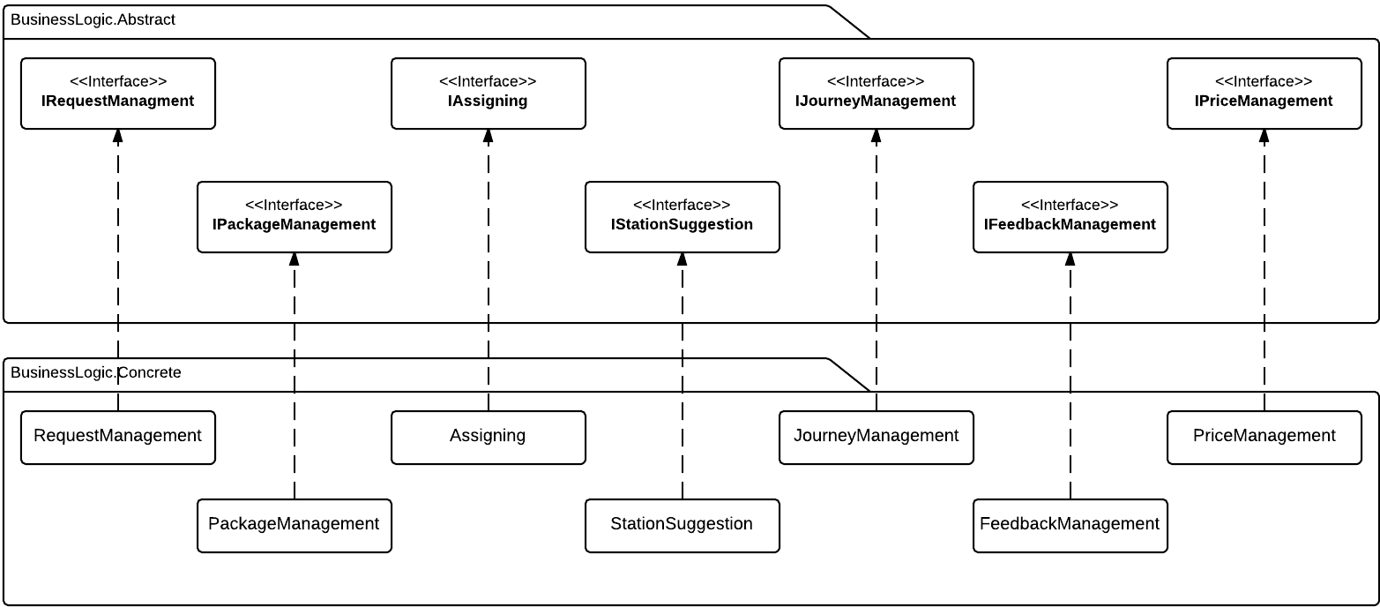

Diagram 7. Business Logic Class Diagram

#### IRequestManagement Interface

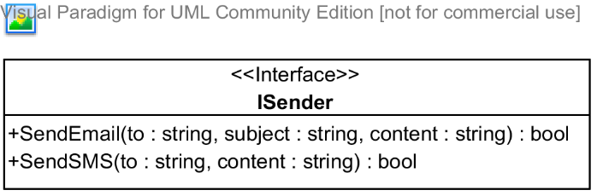

**Properties:** N/A

**Operations**

|  |  |  |
| --- | --- | --- |
| Signature: bool SendEmail(string to, string subject, string content)  Description: Sends an email to the address specified | | |
| Parameter | **Type** | **Description** |
| *to* | string | The email address to send to |
| *subject* | string | The subject of the email |
| *content* | string | The content of the email |

|  |  |  |
| --- | --- | --- |
| Signature: bool SendSMS(string to, string content)  Description: Sends an SMS message to the address specified | | |
| Parameter | **Type** | **Description** |
| *to* | string | The telephone number to send to |
| *content* | string | The content of the message |

#### IPackageManagement Interface

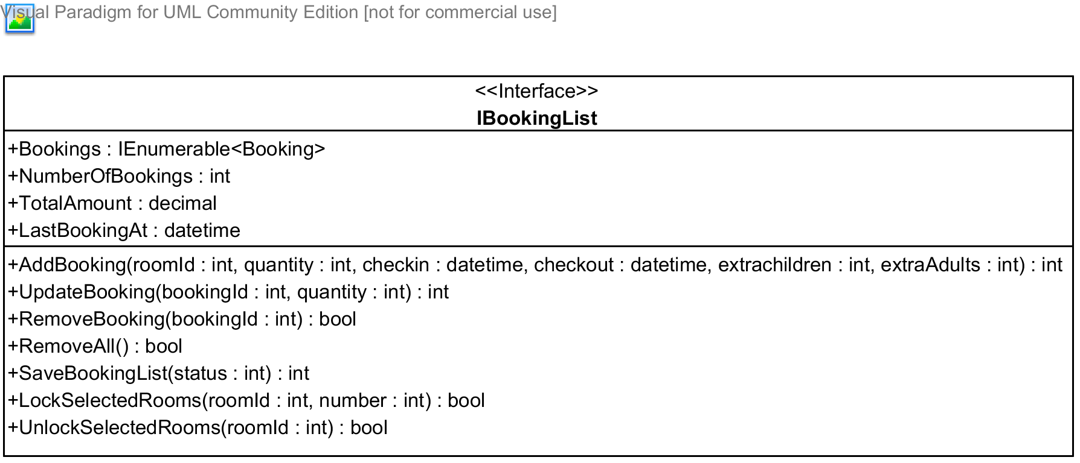

**Properties**

|  |  |  |  |
| --- | --- | --- | --- |
| Property name | Type | Visibility | Description |
| *Bookings* | IEnumerable<Booking> | public | A list of all bookings in the booking list for the current user |
| *NumberOfBooking* | int | public | Number of bookings in the booking list |
| *TotalAmount* | decimal | public | Total amount of all the booking |
| *LastBookingAt* | datetime | public | Time when the last booking was added to the booking list |

**Operations**

|  |  |  |
| --- | --- | --- |
| Signature: int AddBooking(int roomId, int quantity, datetime checkin, datetime checkout, int extraChildren, int extraAdults)  Description: Adds a bookings made by the current user to the booking list | | |
| Parameter | **Type** | **Description** |
| *roomId* | int | Id of room type being booked |
| *quantity* | int | Numbers of rooms needed |
| *checkin* | datetime | Check-in date |
| *checkout* | datetime | Check-out date |
| *extraChildren* | int | Number of extra children, if allowed by the hotel owner |
| *extraAdults* | int | Number of extra adults, if allowed by the hotel owner |

|  |  |  |
| --- | --- | --- |
| Signature: int UpdateBooking(int bookingId, int quantity)  Description: Update a booking in the booking list given its id | | |
| Parameter | **Type** | **Description** |
| *bookingId* | int | Id of the booking to be updated |
| *quantity* | int | Number of rooms to be updated |

|  |  |  |
| --- | --- | --- |
| Signature: bool RemoveBooking(int bookingId)  Description: Removed a booking in the booking list given its id | | |
| Parameter | **Type** | **Description** |
| *bookingId* | int | Id of the booking to be removed |

|  |  |  |
| --- | --- | --- |
| Signature: bool RemoveAll(int bookingId)  Description: Removed all the bookings int the booking list | | |
| Parameter | **Type** | **Description** |

|  |  |  |
| --- | --- | --- |
| Signature: bool SaveBookingList(int status)  Description: Saves the booking list to the database | | |
| Parameter | **Type** | **Description** |
| *status* | int | Status of the bookings to be saved |

|  |  |  |
| --- | --- | --- |
| Signature: bool LockSelectedRooms(int roomId, int number)  Description: Locks the rooms selected so that other user cannot book these rooms | | |
| Parameter | **Type** | **Description** |
| *roomId* | int | Id of the room type to be locked |
| *number* | int | Number of rooms to be locked for this type |

|  |  |  |
| --- | --- | --- |
| Signature: bool UnlockSelectedRooms(int roomId)  Description: Unlocks the rooms selected so that other user can book these rooms | | |
| Parameter | **Type** | **Description** |
| *roomId* | int | Id of the room type to be unlocked |

#### IAssigning Interface

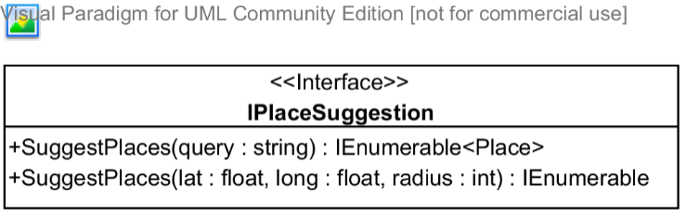

**Properties:** N/A

**Operations**

|  |  |  |
| --- | --- | --- |
| Signature: IEnumerable<Place> SuggestPlaces(string query)  Description: Suggests places(hotel address, provinces, and other type of places,...) given a query string | | |
| Parameter | **Type** | **Description** |
| *query* | string | A string that will be used to search and suggest places |

|  |  |  |
| --- | --- | --- |
| Signature: IEnumerable<Place> SuggestPlaces(float lat, float long, int radius)  Description: Suggests places(hotel address, provinces, and other type of places,...) given the center of the destination and the radius to be searched | | |
| Parameter | **Type** | **Description** |
| *lat* | float | Latitude of the destination center |
| *long* | float | Longitude of the destination center |
| *radius* | int | Radius to limit the searching |

#### IStationSuggestion Interface

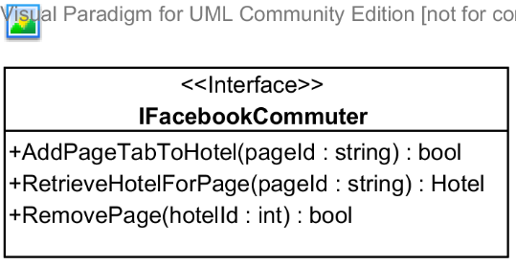

**Properties:** N/A

**Operations**

|  |  |  |
| --- | --- | --- |
| Signature: bool AddPageTabToHotel(string pageId, int hotelId)  Description: Adds a page tab to the hotel | | |
| Parameter | **Type** | **Description** |
| *pageId* | string | Id of the Facebook page to be added to the hotel |
| *hotelId* | int | Id of the hotel to be added |

|  |  |  |
| --- | --- | --- |
| Signature: Hotel RetrieveHotelForPage(string pageId)  Description: Retrieves a hotel given its pageId | | |
| Parameter | **Type** | **Description** |
| *pageId* | string | Facebook page id of the hotel to be retrieved |

|  |  |  |
| --- | --- | --- |
| Signature: bool RemovePage(int hotelId)  Description: Removes the Facebook page from the hotel given its id | | |
| Parameter | **Type** | **Description** |
| *hotelId* | int | Id of the hotel to remove the Facebook page |

#### IJourneyManagement

#### IFeedbackManagement

#### IPriceManagement Interface

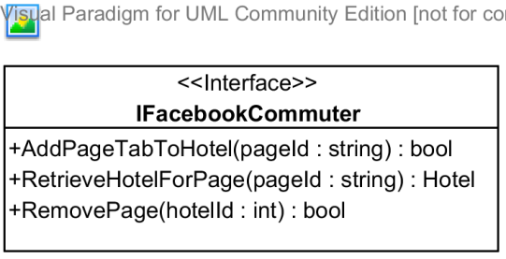

**Properties:** N/A

**Operations**

|  |  |  |
| --- | --- | --- |
| Signature: bool AddPageTabToHotel(string pageId, int hotelId)  Description: Adds a page tab to the hotel | | |
| Parameter | **Type** | **Description** |
| *pageId* | string | Id of the Facebook page to be added to the hotel |
| *hotelId* | int | Id of the hotel to be added |

|  |  |  |
| --- | --- | --- |
| Signature: Hotel RetrieveHotelForPage(string pageId)  Description: Retrieves a hotel given its pageId | | |
| Parameter | **Type** | **Description** |
| *pageId* | string | Facebook page id of the hotel to be retrieved |

|  |  |  |
| --- | --- | --- |
| Signature: bool RemovePage(int hotelId)  Description: Removes the Facebook page from the hotel given its id | | |
| Parameter | **Type** | **Description** |
| *hotelId* | int | Id of the hotel to remove the Facebook page |



## Behavioral Diagrams



### State Machine Diagram: Request Status Transition

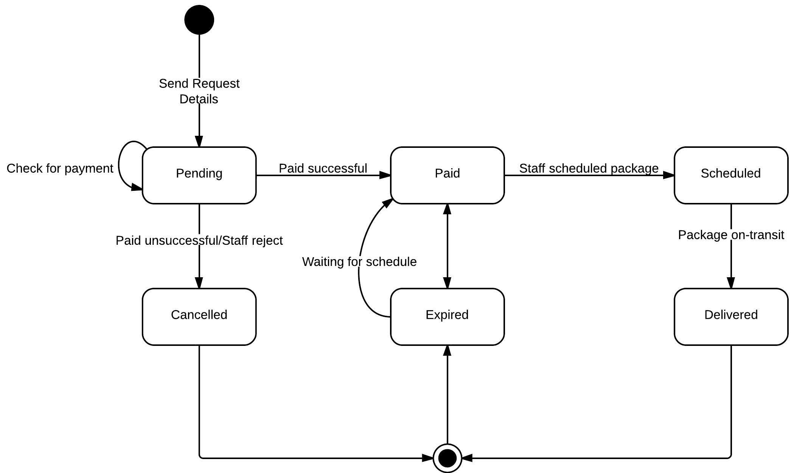

Diagram 8. State machine diagram: Request status transition

### State Machine Diagram: Package Status Transition

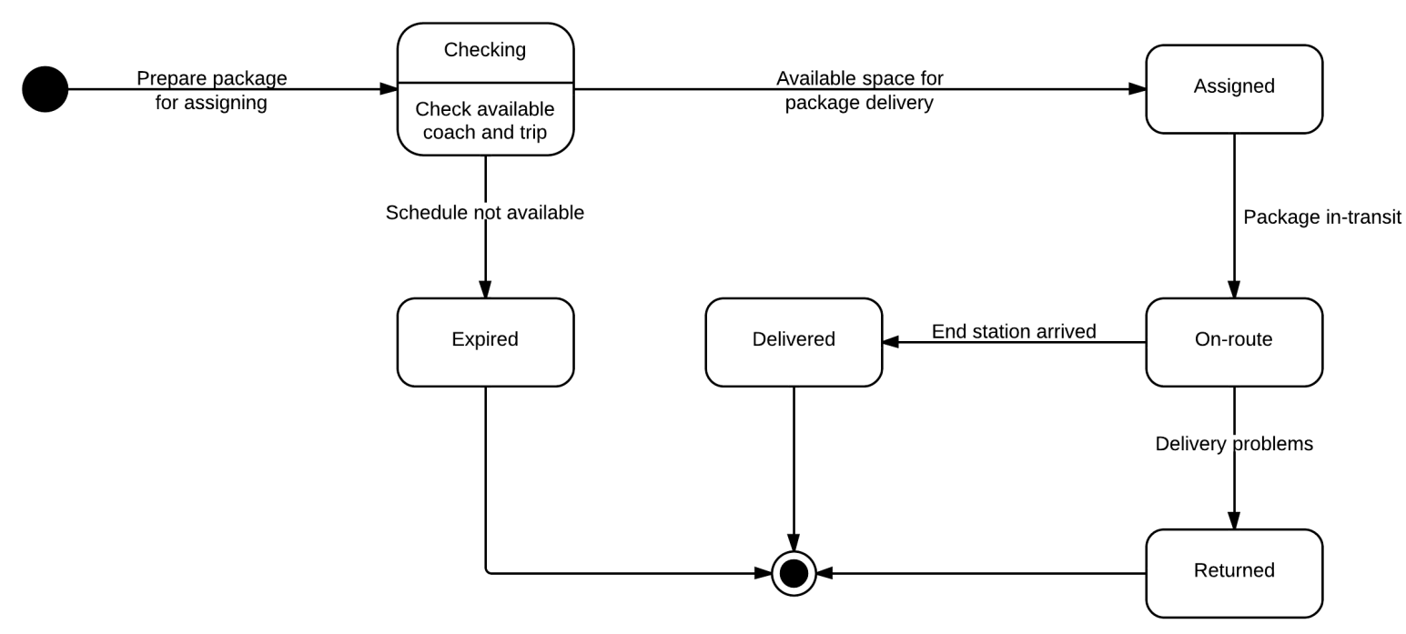

Diagram 9. State machine diagram: Package status transition

### Sequence Diagram: Post Delivery Requests

Diagram 10. Sequence diagram: Post delivery request

### Sequence Diagram: Approve Requests

Diagram 11. Sequence diagram: Approve Requests

### Sequence Diagram: Create a Trip

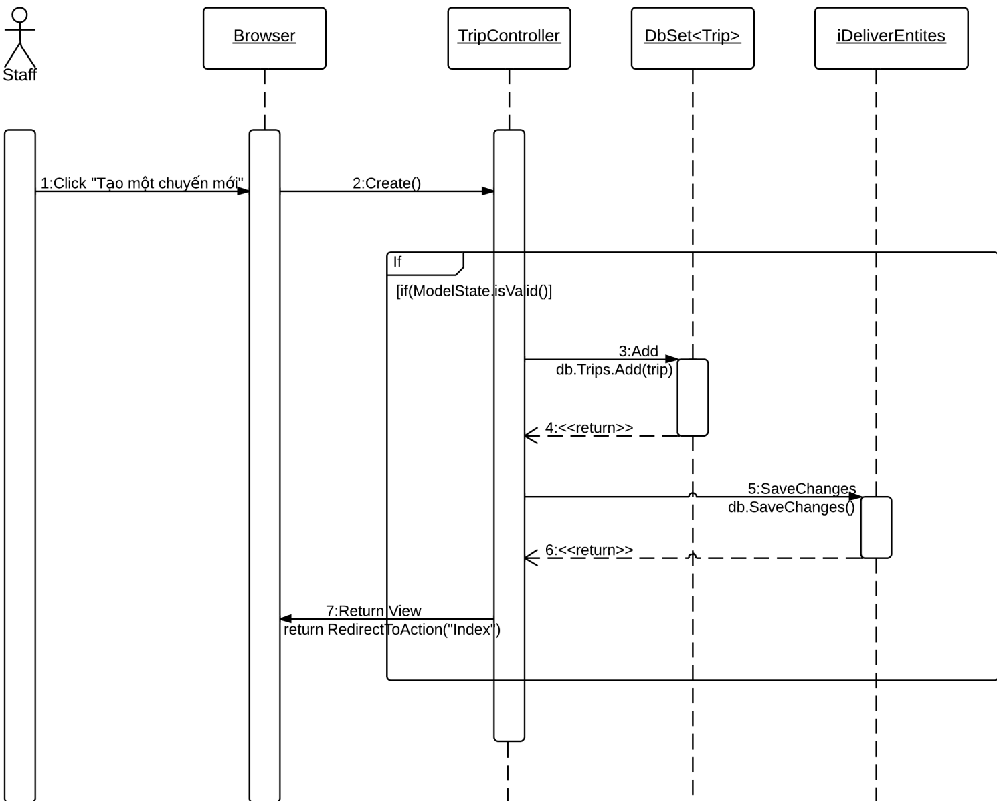

Diagram 12. Sequence diagram: Create a trip

### Sequence Diagram: Assign Package

Diagram 13. Sequence diagram: Assign package

### Sequence Diagram: Edit a Station

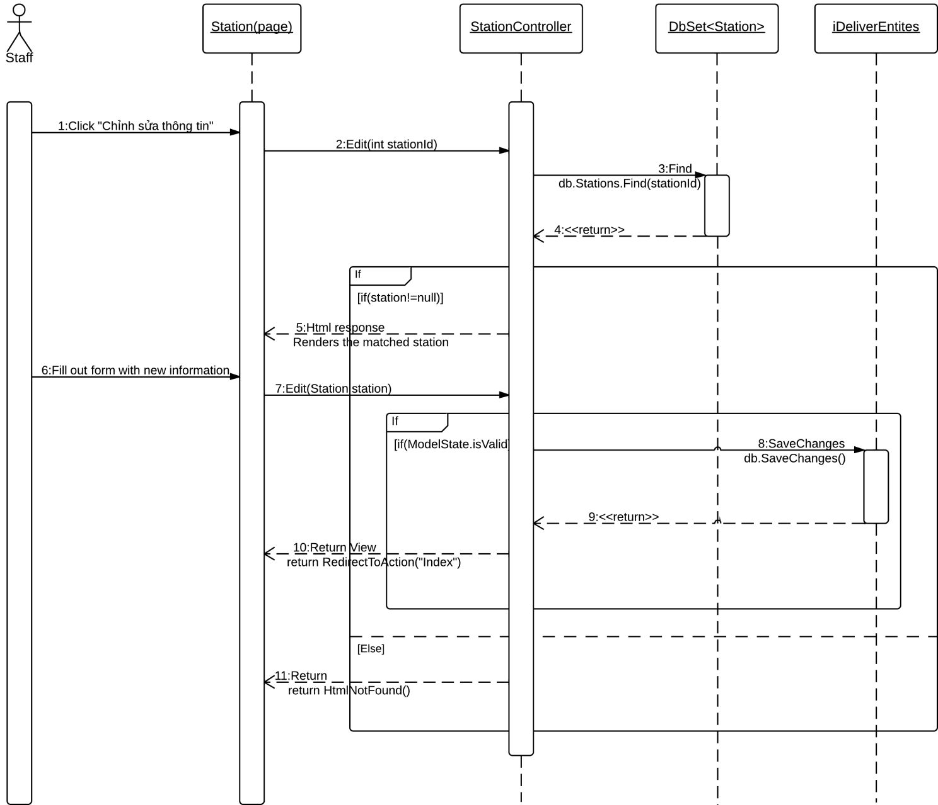

Diagram 14. Sequence diagram: Edit a station

### Sequence Diagram: Add a Price

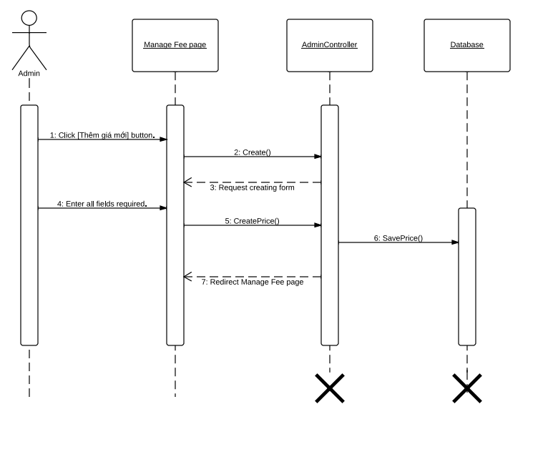

Diagram 15. Sequence diagram: Add a price

### Sequence Diagram: Create a Staff Account

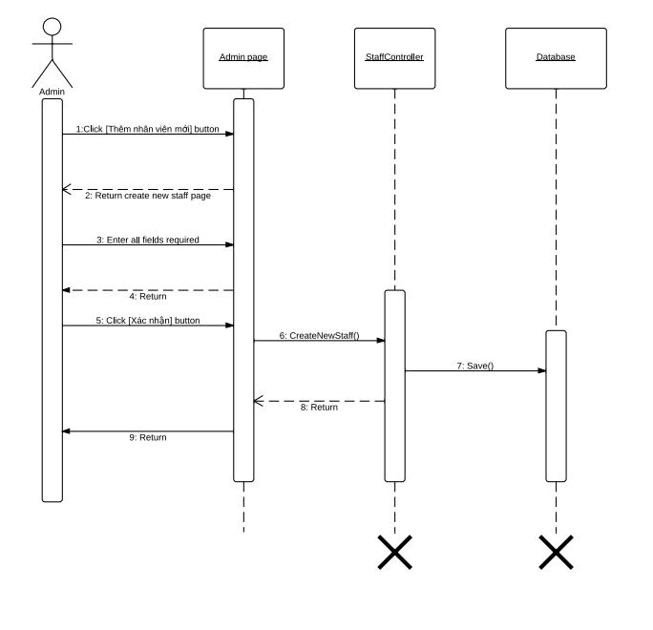

Diagram 16. Sequence diagram: Create a Staff Account

## User Interface Design

Below are some important screen designs for the i-Deliver systems.



### Home Page



### Post Delivery Request Page



### Online Payment Page

### Approve Request Page



### Assign Package Page

### Tracking Page

### Update Package Status Page

### Create Trip Page



### Feedback and Review Page



### Manage Fee Page



## Database Design



### Logical database design

#### User

|  |  |  |  |  |  |
| --- | --- | --- | --- | --- | --- |
| **Column Name** | **Type** | **Allow Null** | **Default Value** | **P/F Key** | **Description** |
| Username | int |  | - | PK | Username of user |
| Password | nvarchar(50) |  | - |  | Password of user |
| BackupPassword | nvarchar(50) |  | - |  | Backup password for user |
| Role | nvarchar(50) |  | - |  | Role of user in the system:  customer, admin or staff |
| Email | nvarchar(50) |  | - |  | Email of user |
| Phone | nvarchar(50) |  | - |  | Phone of user |
| BannedStatus | bit |  | - |  | User is banned or not |
| StationID | int |  | 11 | FK | The station of the staff belong to (just for staff account) |

Unique: Username.

Foreign key: StationID.

#### UserInfo

|  |  |  |  |  |  |
| --- | --- | --- | --- | --- | --- |
| **Column Name** | **Type** | **Allow Null** | **Default Value** | **P/F Key** | **Description** |
| Username | nvarchar(50) |  | - | FK | Username of user registerd to the system or the staff |
| Firstname | nvarchar(50) |  | - |  | Firstname of user registerd to the system or the staff |
| Lastname | nvarchar(50) |  | - |  | Lastname of user registerd to the system or the staff |
| Address | nvarchar(500) |  | - |  | Address of user registerd to the system or the staff |

Unique: Username.

Foreign key: N/A.

#### Coach

|  |  |  |  |  |  |
| --- | --- | --- | --- | --- | --- |
| **Column Name** | **Type** | **Allow Null** | **Default Value** | **P/F Key** | **Description** |
| CoachID | int |  | Auto generated | PK | Uniquely identifies of the coach |
| NumberPlate | nvarchar(50) |  | - |  | Number plate of coach |
| CoachTypeID | int |  | - | FK | The type of coach |

Unique: CoachID, NumberPlate.

Foreign key: CoachTypeID (table CoachType).

#### CoachType

|  |  |  |  |  |  |
| --- | --- | --- | --- | --- | --- |
| **Column Name** | **Type** | **Allow Null** | **Default Value** | **P/F Key** | **Description** |
| CoachTypeID | int |  | Auto generated | PK | Uniquely identifies of the coach |
| Seats | int |  | - |  | The number of seats of the coach, that define the type of coach |
| Capacity | float |  |  |  | The percentage of the cabin that coach can be serve. |

Unique: Seats.

Foreign key: N/A.

#### Route

|  |  |  |  |  |  |
| --- | --- | --- | --- | --- | --- |
| **Column Name** | **Type** | **Allow Null** | **Default Value** | **P/F Key** | **Description** |
| RouteID | int |  | Auto generated | PK | Uniquely identifies a route |
| RouteName | nvarchar(50) |  | - |  | The name of route |

Unique: RouteID.

Foreign key: StartPoint (table Station), EndPoint (table Station).

#### Trip

|  |  |  |  |  |  |
| --- | --- | --- | --- | --- | --- |
| **Column Name** | **Type** | **Allow Null** | **Default Value** | **P/F Key** | **Description** |
| TripID | int |  | Auto generated | PK | Uniquely identifies a route |
| EstimateDepartureTime | time |  | - |  | The estimate time for the trip departures in each day |
| RealDepartureTime | time |  | - |  | The real time that the trip departures in a specific day |
| EstimateArrivalTime | time |  | - |  | The estimate time for the trip departures in each day |
| RealArrivalTime | float |  |  |  | The real time for the trip arrival to the station in a specific day |
| AvailableVolume | float |  |  |  | The volume that the coach on this trip can deliver |
| Date | date |  |  |  | The date that trip start. |
| RouteID |  |  |  | FK | The route that the trip traveling on |
| CoachID |  |  |  | FK | The coach of this trip. |

Unique: RouteID.

Foreign key: RouteID (table Route), CoachID (table Coach).

#### Station

|  |  |  |  |  |  |
| --- | --- | --- | --- | --- | --- |
| **Column Name** | **Type** | **Allow Null** | **Default Value** | **P/F Key** | **Description** |
| StationID | int |  | Auto generated | PK | Uniquely identifies a route |
| StationName | nvarchar(50) |  | - |  | The name of the station |
| StationLocation | nvarchar(50 |  | - |  | The address of location |
| BreakTime | float |  | - |  | The default break time that for each trip come to this station |
| StationPhone | nvarchar(50) |  | - |  | The telephone number of this station |
| Description | nvarchar(500) |  | - |  | The desciption for this station |
| Longitude | float |  | - |  | The longitude of the station location |
| Latitude | float |  | - |  | The latitude of the station location |
| Province | nvarchar |  | - |  | The province of the statino location |

Unique: StationID.

Foreign key: N/A.

#### Schedule

|  |  |  |  |  |  |
| --- | --- | --- | --- | --- | --- |
| **Column Name** | **Type** | **Allow Null** | **Default Value** | **P/F Key** | **Description** |
| ScheduleID | int |  | Auto generated | PK | Uniquely identifies the volume |
| CoachID | Int |  | - |  | Uniquely identifies the coach used to scheduling |
| RouteID | Int |  | - |  | Uniquely identifies the route to be scheduled |
| EstimateDepartureTime | time |  | - |  | The minimum volume the coach can be deliver on the route |
| EstimateArrivalTime | time |  | - | FK | The route in this volume define |

Unique: N/A.

Foreign key: CoachID (table Coach), RouteID (table Route).

#### Request

|  |  |  |  |  |  |
| --- | --- | --- | --- | --- | --- |
| **Column Name** | **Type** | **Allow Null** | **Default Value** | **P/F Key** | **Description** |
| ScheduleID | int |  | Auto generated | PK | Uniquely identifies the volume |
| ArrangeID | float |  | - |  | The maximum volume the coach can be deliver on the route |
| EstimateDepartureTime | time |  | - |  | The minimum volume the coach can be deliver on the route |
| EstimateArrivalTime | time |  | - | FK | The route in this volume define |

Unique: N/A.

Foreign key: ArrangeID (table CoachArrangement).

#### DeliveryStatus

|  |  |  |  |  |  |
| --- | --- | --- | --- | --- | --- |
| **Column Name** | **Type** | **Allow Null** | **Default Value** | **P/F Key** | **Description** |
| DeliveryStatusID | Int |  | Auto generated | PK | Uniquely identifies the delivery status |
| StatusName | nvarchar(50) |  | - |  | The name of delivery status of the package |
| Note | nvarchar(500) | X | - |  | Some more description for the status |

Unique: DeliveryStatusID.

Foreign key: N/A.

#### Invoice

|  |  |  |  |  |  |
| --- | --- | --- | --- | --- | --- |
| **Column Name** | **Type** | **Allow Null** | **Default Value** | **P/F Key** | **Description** |
| InvoiceID | Int |  | Auto generated | PK | Uniquely identifies a invoice |
| Weight | float | X | - |  | Weight of package |
| Volume | int | X | - |  | Volume of package |
| Price | float |  | - |  | Price of delivery service |
| RequestID | int |  | - | FK | The request that the invoice point to |

Unique: InvoiceID.

Foreign key: RequestID (table Request).

#### ManageFee

|  |  |  |  |  |  |
| --- | --- | --- | --- | --- | --- |
| **Column Name** | **Type** | **Allow Null** | **Default Value** | **P/F Key** | **Description** |
| FeeID | int |  | Auto generated | PK | Uniquely identifies a fee rule |
| Fee | float |  | - |  | The fee of this weight and volume range |
| MinWeight | float |  | - |  | The minimum weight of the weight range |
| MaxWeight | float |  | - |  | The maximum weight of the weight range |
| MinVolume | float |  | - |  | The minimum volume of the volume range |
| MaxVolume | float |  | - |  | The maximum volume of the volume range |

Unique: FeeID.

Foreign key: N/A.

#### Comment

|  |  |  |  |  |  |
| --- | --- | --- | --- | --- | --- |
| **Column Name** | **Type** | **Allow Null** | **Default Value** | **P/F Key** | **Description** |
| CommentID | int |  | Auto generated | PK | Uniquely identifies the comment |
| Username | nvarchar(50) |  | - | FK | The user post comment |
| CommentContent | nvarchar(4000) |  | - |  | Content of comment |
| DatePost | date |  | - |  | Date that user post the comment |
| Status | bit |  | - |  | Approve or reject the comment |
| StationID | int |  | - | FK | The station that customer comment for |

Unique: CommentID.

Foreign key: Username (table User), StationID (table Station).

#### Rating

|  |  |  |  |  |  |
| --- | --- | --- | --- | --- | --- |
| **Column Name** | **Type** | **Allow Null** | **Default Value** | **P/F Key** | **Description** |
| RatingID | int |  | Auto generated | PK | Uniquely identifies the rating |
| Username | nvarchar(50) |  | - | FK | The user post comment |
| RateLevel | int |  | - |  | The level of rate: from 1 to 5 |
| StationID | int |  | - | FK | The station that user rating for |

Unique: RatingID.

Foreign key: Username (table User), StationID (table Station).

#### Assigning

|  |  |  |  |  |  |
| --- | --- | --- | --- | --- | --- |
| **Column Name** | **Type** | **Allow Null** | **Default Value** | **P/F Key** | **Description** |
| CoachID | int |  | - | PK | The ID of coach for the specific request |
| RequestID | int |  | - | The ID of request |
| IndicateOrder | int |  | - |  | The indicated order of the assigning the package of this request |

Unique: (CoachID, RequestID).

Foreign key: N/A.

#### Stage

|  |  |  |  |  |  |
| --- | --- | --- | --- | --- | --- |
| **Column Name** | **Type** | **Allow Null** | **Default Value** | **P/F Key** | **Description** |
| CoachID | int |  | - | PK | The ID of coach |
| StartPoint | int |  | - | FK | The start position (station) of the stage |
| EndPoint | int |  | - | FK | The end position (station) of the stage |
| Duration | float |  | - |  | The estimate duration (in hours) for moving on this route |
| Distance | float |  | - |  | The estimate distance (in km) between start and end location |
| Container | float |  | - |  | The percentage of coach that allow to travel on the stage |
| Price | float |  | - |  | The fee for traval on the stage |

Unique: N/A.

Foreign key: StartPoint, EndPoint.

#### RouteStage

|  |  |  |  |  |  |
| --- | --- | --- | --- | --- | --- |
| **Column Name** | **Type** | **Allow Null** | **Default Value** | **P/F Key** | **Description** |
| RouteID | int |  | - | PK | The ID of route |
| StageID | int |  | - | The ID of stage |
| StageIndex | int |  | - |  | The index of stage in the list stage of the route |

Unique: N/A.

Foreign key: N/A.

#### Notification

|  |  |  |  |  |  |
| --- | --- | --- | --- | --- | --- |
| **Column Name** | **Type** | **Allow Null** | **Default Value** | **P/F Key** | **Description** |
| ID | int |  | **-** | PK | The index of notification |
| Username | Int |  | - |  | Username of user |
| StationID | int |  | - |  | The ID of station the user manges |
| isView | bit |  | - |  | Status of notification, it is seen by user or not. |

Unique: N/A.

Foreign key: StationID, Username.

#### Province

|  |  |  |  |  |  |
| --- | --- | --- | --- | --- | --- |
| **Column Name** | **Type** | **Allow Null** | **Default Value** | **P/F Key** | **Description** |
| ProvinceID | int |  | **-** | PK | The index of province |
| ProvinceName | nvarchar(50) |  | - |  | Name of province |

Unique: N/A.

Foreign key: N/A.

### Physical database design



Diagram 17. Physical database design

# Software Test Document



## Introduction



### System Overview

From the perspective of a user, the i-Deliver system operates in the following order

### Test Approach

The system will be tested following the normal testing approach for a software project, including for major stages: Unit testing, Integration testing, System testing, and Acceptance testing.

Firstly, each member will be responsible for *unit testing* all the modules he or she developed. The other team members will later approve of the modules developed by verifying that they comply with the detailed designs.

Secondly, the team leader will perform *integration testing* for the whole application with the assistance of the other team members.

Next, all of the team members will conduct *system testing* to make sure that the system is consistent with the requirements initially specified.

Finally, the supervisor of the project will be accountable for a*cceptance testing*, with the assistance of all team members.

## Test Plan



### Features to be tested

The following features will be system-tested and the results are specified in this test document. The order of the tested features is listed in the system main flow.

|  |  |  |  |
| --- | --- | --- | --- |
| No. | Feature | Description | Assigned |
| 1. | Post new package delivery request | Test if the customers can post new package delivery request easily | TungNT |
| 2. | Online payment | Test if the dashboard page for staffs and administrators is displayed correctly | LongDB |
| 3. | Tracking packages | Test if the customers can track delivery status of packages | TungNT |
| 4. | Feedback | Test if the customers can write reviews for stations | DucNT |
| 5. | Approve package delivery request | Test if the staffs can approve package delivery request issued by a customer | TungNT |
| 6. | Assign packages |  |  |
| 7. | Prepare for packages return | Test if the customers can search routes information. | TungNT |
| 8. | Create a trip |  |  |
| 9. | Create a schedule | Test if a packages can be returned if it can’t be delivered to receiver | LongDB |
| 10. | Monitor price/fee | Test if the delivery fee can be easily and accurately monitored | LuLP |

### Features not to be tested

The following features will not be tested.

* For guests and travelers: Change password, Update account information, View past requests.
* For staffs and system admins: Add a coach, Edit a coach, Delete a coach, Add a coach type, Edit a coach type, Delete a coach type, Add a station, Edit a station, Delete a station, Add a route, Edit a route, Delete a route, Add a schedule, Edit a schedule, Delete a schedule, Add a stage, Edit a stage, Delete a stage, Delete a comment, Clear station rating.
* For system administrators: Manage staff accounts

## System Test Cases



### Post new delivery request

|  |  |  |  |  |  |  |  |
| --- | --- | --- | --- | --- | --- | --- | --- |
| Test case ID | Test Case Description | Test Case Procedure | Expected Output | Inter-Test Case Dependence | Result | Test Date | Note |
|  | **Main Steps: 1.** Click on the button “Đăng nhập” at the top of the home page.  **2.** Enter the username in the “Tên đăng nhập” textbox, and the password in the “Mật khẩu” textbox.  **3.** Click the “Đăng nhập” button. | | | | | | |
| [LG-1] | Loginwith an activated account | * Fill an authentic username in the “Tên đăng nhập” textbox; * Fill the correct password in the “Mật khẩu” textbox; * Click the “Đăng nhập” button. | The user is logged in with the account and redirected to the page he or she is browsing if the user is a traveler, or to the admin dashboard page if the user is a hotel owner or a system admin. |  | Passed | 15/11/2013 |  |
| [LG-2] | Loginwith empty username and password | * Leaves the username and password box empty; * Click the “Đăng nhập” button. | The message “Tên đăng nhập không được bỏ trống” will be shown next to the “Tên đăng nhập” textbox;  The message “Mật khẩu không được bỏ trống” will be shown next to the “Mật khẩu” textbox. |  | Passed | 15/11/2013 |  |
| [LG-3] | Loginwith a wrong account | * Fill in the “Tên đăng nhập” textbox with an the existing username; * Fill a wrong password in the “Mật khẩu” textbox; * Click the “Đăng nhập” button. | The user will be redirected back to the log in page, with the message “Tên đăng nhập hoặc mật khẩu không chính xác” displayed at the top part. |  | Passed | 15/11/2013 |  |
| [LG-4] | Loginwith a wrong account | * Fill in the “Tên đăng nhập” textbox with an the non-existing username; * Fill a ramdom password in the “Mật khẩu” textbox; * Click the “Đăng nhập” button. | The user will be redirected back to the log in page, with the message “Tên đăng nhập hoặc mật khẩu không chính xác” displayed at the top part. |  | Passed | 15/11/2013 |  |
| [LG-5] | Loginwith a deactivated account | * Fill in the “Tên đăng nhập” textbox with the username of a deactivated account; * Fill the correct password in the “Mật khẩu” textbox; * Click the “Đăng nhập” button. | The user will be redirected back to the log in page, with the message “Tài khoản này đã bị khóa, vui lòng thử đăng nhập với một tài khoản khác” displayed at the top part. |  | Passed | 15/11/2013 |  |

### Online payment

|  |  |  |  |  |  |  |  |
| --- | --- | --- | --- | --- | --- | --- | --- |
| Test case ID | Test Case Description | Test Case Procedure | Expected Output | Inter-Test Case Dependence | Result | Test Date | Note |
|  | **Main Steps: 1.** Log in with Hotel Owner or System Admin role.  **2.** Click on the “Khách sạn” link in the menu bar if the log in form does not redirect you to this page.  All the hotels under your management is on the dashboard. | | | | | | |
| [VD-1] | View hotels under your management | * Click on the “Khách sạn” link in the menu bar | The dashboard display a list of hotels you are managing. Each item in the list includes the following information:   * Name and address of the hotel; * Number of new bookings; * Which hotel owner manages it. |  | Passed | 17/11/2013 |  |
| [VD-2] | View hotels with filters | * Click on the “Khách sạn” link in the menu bar * Click the “Tự quản lý” or “I-DELIVER quản lý” button on the section “Lọc theo” | The list of hotels is filtered limited to hotels owned by a local hotel owner or hotels provided by an external hotel data provider. |  | Passed | 17/11/2013 |  |
| [VD-3] | View hotels with sorting order | * Click on the “Khách sạn” link in the menu bar * Click “Mới cập nhật” or “Mới đặt phòng” button on the section “Sắp xếp theo” | The list of hotel is ordered by the last time it was updated or the last booking it has |  | Passed | 17/11/2013 |  |

### Tracking package

|  |  |  |  |  |  |  |  |
| --- | --- | --- | --- | --- | --- | --- | --- |
| Test case ID | Test Case Description | Test Case Procedure | Expected Output | Inter-Test Case Dependence | Result | Test Date | Note |
|  | **Main Steps: 1.** Log in the system with Hotel Owner role  **2.** Click on the “Khách sạn” link in the menu bar  **3.** Click on “Tạo khách sạn mới” button  **4.** Provide the necessary information about the hotel  **5.** Click the “Lưu và tiếp tục” button. | | | | | | |
| [CH-1] | Try to save a hotel with errorneous input | * Make one or more validation errors when entering the information for the hotel. Because there too many validation error types, please refer to the use case “Create a hotel” for more information. | The corresponding message will be shown next to the fields that have errorneous input. |  | Passed | 15/11/2013 |  |
| [CH-2] | Save a hotel with validated input | * Fill in all fields with validated input; * Select some features for the hotel in the “Các dịch vụ của khách sạn” tab * Click the “Lưu và tiếp tục” button. | The hotel is saved into the database. A hotel opening request is issued waiting for a System Admin to approve of it. The user is redirected to the dashboard page. |  | Passed | 15/11/2013 |  |

### Feedback

|  |  |  |  |  |  |  |  |
| --- | --- | --- | --- | --- | --- | --- | --- |
| Test case ID | Test Case Description | Test Case Procedure | Expected Output | Inter-Test Case Dependence | Result | Test Date | Note |
|  | **Main Steps: 1.** Log in the system with System Admin role.  **2.** Click on a hotel marked “Chưa xác nhận”  **3.** Press the “Xác nhận khách sạn” button | | | | | | |
| [AH-1] | Approve a hotel successfully | * In the dash board page, click on a hotel that was marked “Chưa xác nhận”. The user will be redirected to the hotel management page of that hotel. * Verify the information provided by the hotel owner. * Press the “Xác nhận khách sạn” button to approve of and allow the hotel to operate on the I-DELIVER system. | The hotel will be marked as “Activated” on the I-DELIVER system. In the hotel dashboard page the hotel will be displayed as an activated hotel. The system now allows its hotel owner to provide additional information. |  |  |  |  |

### Approve delivery requests

|  |  |  |  |  |  |  |  |
| --- | --- | --- | --- | --- | --- | --- | --- |
| Test case ID | Test Case Description | Test Case Procedure | Expected Output | Inter-Test Case Dependence | Result | Test Date | Note |
|  | **Main Steps: 1.** Click on the “Giá phòng” link on room type you want to monitor prices to see the price calendar.  **2.** Drag, drop, resize, and click on the price bars to updates it information. | | | | | | |
| [MP-1] | View the price bar successfully | * Click on the “Giá phòng” link on room type you want to monitor prices to see the price calendar | A price calendar for the selected room type will be display. In the calendar there are three types of price bars:   * Gray price bars represent the prices in the past; * Blue price bars represent the prices in the future; * Violet price bars represent the prices crossing from the past to the future (including system current date);   In each price bar contains the price itself and the number of rooms available for the period it spans on |  | Passed | 24/11/2013 |  |
| [MP-2] | Try to drag a price bar in the past | * Drag a gray price bar and drop it somewhere. | The notification “Không thể cập nhật giá trong quá khứ” is shown. |  | Passed | 24/11/2013 |  |
| [MP-3] | Try to drag a price bar in the future to the past | * Drag a blue price bar and drop it on to a date in the past. | The notification “Không thể cập nhật giá trong quá khứ” is shown. |  | Passed | 24/11/2013 |  |
| [MP-4] | Try to drag a price bar crossing from the past to the future | * Drag a violet price bar and drop somewhere. * Choose “OK” to confirm the action of splitting the price bar * Drag the second price bar and drag it somewhere in the future. | A message box asks the user to confirm the action “Một phần của giá này nằm trong quá khứ nên bạn không thể cập nhật được. Bạn có muốn cập nhật phần còn lại không?”  The price bar is split into two smaller bars: one in the past and one in the future (including the system current date)  The corresponding price is updated and the price calendar is refreshed. |  | Passed | 24/11/2013 |  |
| [MP-5] | Try to resize a price bar in the past | * Holds the edge of a gray price bar and drags it to another position | The notification “Không thể cập nhật giá trong quá khứ” is shown. |  | Passed | 24/11/2013 |  |
| [MP-6] | Try to resize a price bar with start date exceeding end date | * Holds the edge of a blue price bar and drags it to another position so that start date exceeds end date | The notification “Ngày bắt đầu của giá không được lớn hơn ngày kết thúc” is shown. |  | Passed | 24/11/2013 |  |
| [MP-6] | Try to edit the number of available rooms less than the number of rooms booked | * Click on a blue price bar. A popup will be display to edit the price * Reduce the number of rooms to less than the number of rooms booked on the date which the price bar covers. | The notification “Vào ngày X đã có Y đặt phòng, bạn không thể giảm số lượng phòng trống xuống thấp hơn mức đó”, where X is the date and Y is the number of rooms booked, is shown. |  | Passed | 24/11/2013 |  |

### Assign packages

|  |  |  |  |  |  |  |  |
| --- | --- | --- | --- | --- | --- | --- | --- |
| Test case ID | Test Case Description | Test Case Procedure | Expected Output | Inter-Test Case Dependence | Result | Test Date | Note |
|  | **Main Steps: 1.** Log in to the system with System Admin role.  **2.** Click the link “Kết nối với Bookee” on the menu pane.  **3.** Click the button “Đồng bộ dữ liệu” | | | | | | |
| [SW-1] | Successfully connects and synchronize the hotel data. | * Click the link “Kết nối với Bookee” on the menu pane. * Click the button “Đồng bộ dữ liệu”. | The two system begins to synchronize data about hotels, features, room types, and prices together. Once the synchronization process is complete, a log of all the events that occurred during the process will be shown to the user. |  | Passed | 28/11/2013 |  |
| [SW-2] | Cannot connect and synchronize data | * Your internet connection is lost to prevent access to the internet. * Click the link “Kết nối với Bookee” on the menu pane. * Click the button “Đồng bộ dữ liệu”. | The notification “Không thể kết nối đến hện thống Bookee. Vui lòng liên hệ kỹ thuật để được hỗ trợ” is shown. |  | Passed | 28/11/2013 |  |

### Prepare for packages return

|  |  |  |  |  |  |  |  |
| --- | --- | --- | --- | --- | --- | --- | --- |
| Test case ID | Test Case Description | Test Case Procedure | Expected Output | Inter-Test Case Dependence | Result | Test Date | Note |
|  | **Main Steps: 1.** Go to the “Khách sạn” tab on the home page.  **2.** Provide the destination, check-in and check-out dates, searching radius, and sorting order of the results.  **3.** Click the “Tìm ngay” button.  **4.** (Optional) Apply filters on the results. | | | | | | |
| [SH-1] | Search for hotels by criteria such as user’s destination, check-in and check-out dates, searching radius, and sorting order of the results | * Fill in the “Điểm đến của bạn” textbox with the place name or the hotel name you want to search. A list of suggestions, inluding hotels and places is displayed. * Choose a place name in the suggestion list; * Specify a valid check-in date and check-out date; * Choose the searching radius in the “Bán kính tìm kiếm” dropdown list; * Choose the order of the results in the “Sắp xếp theo” dropdown list; * Click the “Tìm ngay” button. | A list of all hotels that sastisfy the searching criteria is shown without refeshing the page. Each item in the list represents a hotel found and should include the following information:   * Basic information: name, star, address, email, phone, website, check-in time, check-out time, features, images, and introduction article; * Distance from the hotel to the center of the searched place; * Average rating points by user; * Last time a booking was made; * Cheapest room for the period specified.   The google map section will automatically update the locations of all the hotels found. |  | Passed | 17/11/2013 |  |
| [SH-2] | Search hotels without filling any information | * Leaves all the fields empty; * Click the “Tìm ngay” button. | The notification “Vui lòng chọn địa điểm, ngày nhận phòng, ngày trả phòng trước khi tiếp tục” is shown. |  | Passed | 17/11/2013 |  |
| [SH-3] | Search hotels with only place name | * Fill in the “Điểm đến của bạn” textbox with the place name or the hotel name you want to search. A list of suggestions, inluding hotels and places is displayed. * Click the “Tìm ngay” button. | The notification “Vui lòng chọn ngày nhận phòng, ngày trả phòng trước khi tiếp tục” is shown. |  | Passed | 17/11/2013 |  |
| [SH-4] | Search hotels with check-in date exceeding checkout date | * Fill in the “Ngày đặt phòng” textbox with a date that exceeds the date in the “Ngày trả phòng” textbox. * Click the “Tìm ngay” button. | The notification “Ngày nhận phòng không được vượt quá ngày trả phòng” is shown. |  | Passed | 17/11/2013 |  |
| [SH-5] | Search hotels with the period between the check-in and checkout date exceeding 30 days | * Fill in the “Ngày đặt phòng” textbox and “Ngày trả phòng” textbox with two dates that span more than 30 days. * Click the “Tìm ngay” button. | The notification “Vui lòng giới hạn số ngày ở khách sạn dưới 30 ngày trước khi tiếp tục” is shown. |  | Passed | 17/11/2013 |  |
| [SH-6] | Filter the results by star quality and user rating average point | * Perform test procedure [SH-1] again to get the results; * Check / uncheck some star qualities (from 1 to 5 stars) in the “Lọc kết quả” pane; * Check / uncheck some user rating average points (from 1 to 5 points) in the “Lọc kết quả” pane; * Click the “Lọc kết quả” button. | The list of found hotels is filtered by the criteria you specified and shown immediately without refreshing the page.  The google map section will automatically update the locations of all the hotels filtered. |  | Passed | 17/11/2013 |  |
| [SH-7] | Filter the results by with no criteria | * Perform test procedure [SH-1] again to get the results; * Uncheck all star qualities in the “Lọc kết quả” pane; * Uncheck all user rating average points in the “Lọc kết quả” pane; * Click the “Lọc kết quả” button. | The notification “Vui lòng chọn ít nhất một tiêu chuẩn để lọc kết quả tìm kiếm” is shown. |  | Passed | 17/11/2013 |  |

### Create the trip

|  |  |  |  |  |  |  |  |
| --- | --- | --- | --- | --- | --- | --- | --- |
| Test case ID | Test Case Description | Test Case Procedure | Expected Output | Inter-Test Case Dependence | Result | Test Date | Note |
|  | **Main Steps: 1.** Go to the “Khách sạn” page and select one hotel to view its details.  **2.** Fill in the “Ngày nhận phòng” textbox with the check-in date and the “Ngày trả phòng” textbox with the check-out date.  **3.** Click the “Kiểm tra giá” button. | | | | | | |
| [SR-1] | Search available rooms in a specific period | * Fill in the “Ngày nhận phòng” textbox with the check-in date; * Fill in the “Ngày trả phòng” textbox with the check-out date; * Click the “Kiểm tra giá” button. | A list of all room types that are avaible in the specified period is shown without refeshing the page. Each item in the list represents a room types found and should include the following information:   * Basic information: name, description, number of persons who can stay, extra persons allowed or not, refundable or not; * A grid that displays all the prices in that period. Each price include the date it becomes active, the date it becomes inactive, the price itself, the price for an extra child or adult, if any; * A dropdown list named “Số phòng bạn cần đặt” and a button named “Đặt phòng”. |  | Passed | 15/11/2013 |  |
| [SR-2] | Search available rooms in a specific period but no available rooms are found. | * Fill in the “Ngày nhận phòng” textbox with the check-in date; * Fill in the “Ngày trả phòng” textbox with the check-out date; * Click the “Kiểm tra giá” button. | The notification “Không tìm thấy phòng trống nào trong thời gian bạn đưa ra. Vui lòng thay đổi hoặc giới hạn ngày nhận và trả phòng để tìm được nhiều kết quả hơn” is shown. |  | Passed | 15/11/2013 |  |
| [SR-3] | Search available rooms with empty check-in and check-out dates. | * Leave one of the “Ngày nhận phòng” and “Ngày trả phòng” textboxes empty; * Click the “Kiểm tra giá” button. | The notification “Vui lòng chọn ngày nhận phòng, ngày trả phòng trước khi tiếp tục” is shown. |  | Passed | 15/11/2013 |  |

### Create schedules

|  |  |  |  |  |  |  |  |
| --- | --- | --- | --- | --- | --- | --- | --- |
| Test case ID | Test Case Description | Test Case Procedure | Expected Output | Inter-Test Case Dependence | Result | Test Date | Note |
|  | **Main Steps: 1.** Perform Test Procedure [SR-1] to check available rooms of a hotel in a specific period.  **2.** Choose number of rooms you need and click the “Đặt phòng” button.  **3.** Fill in the information form with your personal information.  **4.** Pay for the rooms booked. | | | | | | |
| [BR-1] | Book a room type in a specific period | * Navigate to a room type that is available in the searching period; * Choose number of rooms you need in the dropdown list named “Số phòng bạn cần đặt”; * Click the “Đặt phòng” button. | The booking is added to the booking list. The user is redirected to the booking detail page. |  | Passed | 15/11/2013 |  |
| [BR-2] | Fail book a room type in a specific period | * Choose number of rooms you need in the dropdown list named “Số phòng bạn cần đặt”; * In the mean time, another user performs Test Procedure [BR-1] to book a number of rooms of this time so that the number of rooms left is less than the selected number; * Click the “Đặt phòng” button. | The notification “Hiện tại khách sạn không còn đủ số lượng phòng bạn muốn đặt, vui lòng tải lại trang hoặc giảm số lượng phòng xuống” is shown. |  | Passed | 15/11/2013 |  |
| [BR-3] | Fail add a booking to the booking list | * Perform Test Procedure [BR-1] 5 times to add 5 bookings into the booking list; * Perform Test Procedure [BR-1] again. | The notification “Vui lòng thanh toán hóa đơn hoặc bỏ bớt phòng trong danh sách đặt phòng trước khi tiếp tục” is shown. |  | Passed | 15/11/2013 |  |
| [BR-4] | Fail add a booking to the booking list | * Perform Test Procedure [BR-1] to book a room type in a specific period. * Perform Test Procedure [BR-1] again to book the same room type in the same period so that the total number of rooms is greater than 10. | The notification “Bạn chỉ có thể đặt tối đa 10 phòng của cùng một loại phòng trong một khoảng thời gian” is shown. |  | Passed | 15/11/2013 |  |
| [BR-5] | Fail add a booking to the booking list | * Perform Test Procedure [BR-1] to book a room type in a specific period. * Perform Test Procedure [BR-1] to book a room type in a different hotel. | The notification “Bạn có thể đặt nhiều phòng nhưng các phòng phải ở cùng một khách sạn” is shown. |  | Passed | 15/11/2013 |  |
| [BR-6] | Successfully book rooms | * Perform Test Procedure [BR-1] to book a room type in a specific period. * Fill in the information form with your personal information. * Click the “Thanh toán” button. * Pay for the room on Ngân Lượng. | An email of the booking details is sent to the user’s email.  An SMS message containing the booking code is sent to the user’s number.  A booking success page is shown to the user. Basic information includes:   * The booking code; * Personal information of the user; * Details of the booking. |  | Passed | 15/11/2013 |  |
| [BR-7] | Fail to validate the user’s information | * Perform Test Procedure [BR-1] to book a room type in a specific period.   Make at least one of the following errors:   * Leave the textbox “Họ và tên” empty. * Fill the textbox “Họ và tên” with a value less than 5 or more than 100 characters in length * Leave the textbox “Địa chỉ” empty. * Fill the textbox “Địa chỉ” with a value less than 5 or more than 200 characters in length. * Leave the textbox “Ngày sinh” empty. * Leave the textbox “Email” empty. * Fill the textbox “Email” with an invalid email format. * Leave the textbox “Số điện thoại” empty. * Fill the textbox “Số điện thoại” with an invalid telephone number format. | The corresponding message will be shown next to the fields that have errorneous input.   * The message “Họ và tên không được để trống, tối thiểu là 5 kí tự, tối đa là 100 kí tự” is shown; * The message “Họ và tên tối thiểu là 5 kí tự, tối đa là 100 kí tự.” is shown; * The message “Địa chỉ không được để trống, tối thiểu là 5 kí tự, tối đa là 200 kí tự.” is shown; * The message “Địa chỉ tối thiểu là 5 kí tự, tối đa là 200 kí tự.” is shown; * The message “Ngày sinh không được để trống” is shown * The message “Email không được để trống” is shown * The message “Email không hợp lệ.” is shown; * The message “Số điện thoại không được để trống” is shown; * The message “Số điện thoại không hợp lệ.” is shown. |  | Passed | 15/11/2013 |  |
| [BR-8] | Fail to pay for a booking list | * Perform Test Procedure [BR-1] to book a room type in a specific period. * Enter valid personal information. * Open the booking detail page in a new tab and remove all the bookings by clicking the “X” button. * Return to the original booking detail page. * Click the “Thanh toán” button. | The notification “Bạn chưa đặt phòng nào. Vui lòng đặt ít nhất một phòng để tiếp tục” is shown. |  | Passed | 15/11/2013 |  |
| [BR-9] | The booking list is emptied after 15 minutes | * Perform Test Procedure [BR-1] to book a room type in a specific period. * Waits for more than 15 minutes | The booking detail is refreshed with no bookings waiting to be paid in the booking list. |  | Passed | 15/11/2013 |  |

### Monitor price/fee

|  |  |  |  |  |  |  |  |
| --- | --- | --- | --- | --- | --- | --- | --- |
| Test case ID | Test Case Description | Test Case Procedure | Expected Output | Inter-Test Case Dependence | Result | Test Date | Note |
|  | **Main Steps: 1.** Go the the “Hủy đặt phòng” link.  **2.** Choose a booking you have made or enter your booking code in the “Mã xác nhận” box.  **3.** Click the “Gửi yêu cầu hủy phòng” button. | | | | | | |
| [RR-1] | Successfully request for a refund | * Fill the generated code of booking that has been approved, not expired and not refunded before in the “Mã xác nhận” box. * Click the “Gửi yêu cầu hủy phòng” button. | The message “Bạn đã gởi yêu cầu thành công, chúng tôi sẽ xử lí và thông báo trong email cho bạn trong thời gian sớm nhất. Vui lòng kiểm tra e-mail để xác nhận.” is displayed. |  | Passed | 19/11/2013 |  |
| [RR-2] | Fail to request for a refund | * Fill the generated code of a booking that has been refunded before or expired in the “Mã xác nhận” box. * Click the “Gửi yêu cầu hủy phòng” button. | The message “Thông tin bạn nhập không chính xác, đã tồn tại hoặc đã quá hạn. Vui lòng thử lại.” is displayed. |  | Passed | 19/11/2013 |  |
| [RR-3] | Fail to request for a refund | * Leave the “Mã xác nhận” textbox empty. * Click the “Gửi yêu cầu hủy phòng” button. | The message box “Mã xác nhận phải là kí tự chữ hoặc số có 6 kí tự” is displayed. |  | Passed | 19/11/2013 |  |

## Checklists



### Checklist of Validation

|  |  |  |  |  |
| --- | --- | --- | --- | --- |
| Question | | Yes | No | N/A |
| 1 | Does a failure of validation on every field cause a sensible user error message? | 🗹 |  |  |
| 2 | Is the user required to fix entries which have failed validation tests? | 🗹 |  |  |
| 3 | Have any fields got multiple validation rules and if so are all rules being applied? | 🗹 |  |  |
| 4 | If the user enters an invalid value and clicks on the OK button (i.e. does not TAB off the field) is the invalid entry identified and highlighted correctly with an error message? |  | 🗹 |  |
| 5 | Is validation consistently applied at screen level unless specifically required at field level? |  | 🗹 |  |
| 6 | For all numeric fields check whether negative numbers can and should be able to be entered. | 🗹 |  |  |
| 7 | For all numeric fields check the minimum and maximum values and also some mid-range values allowable? | 🗹 |  |  |
| 8 | For all character/alphanumeric fields check the field to ensure that there is a character limit specified and that this limit is exactly correct for the specified database size? |  | 🗹 |  |
| 9 | Do all mandatory fields require user input? | 🗹 |  |  |
| 10 | If any of the database columns don’t allow null values then the corresponding screen fields must be mandatory. (If any field which initially was mandatory has become optional then check whether null values are allowed in this field.) | 🗹 |  |  |

### Submission Checklist

|  |  |  |  |  |
| --- | --- | --- | --- | --- |
| Question | | Yes | No | N/A |
| TABLES AND FIGURES | | | | |
| 1 | Does every table column, including the stub column, have a heading? | 🗹 |  |  |
| 2 | Are all tables referred to in text? |  | 🗹 |  |
| 3 | Are the elements in the figures large enough to remain legible after the figure has been reduced to the width of a journal column or page? |  | 🗹 |  |
| 4 | Is lettering in a figure no smaller than 8 points and no larger than 14 points? |  | 🗹 |  |
| 5 | Are the figures being submitted in a file format acceptable to the publisher? |  | 🗹 |  |
| 6 | Has the figure been prepared at a resolution sufficient to produce a high-quality image? |  | 🗹 |  |
| 7 | Are all figures numbered consecutively with Arabic numerals? | 🗹 |  |  |
| 8 | Are all figures and tables mentioned in the text and numbered in the order in which they are mentioned? | 🗹 |  |  |
| REFERENCES | | | | |
| 1 | Are references cited both in text and in the reference list? |  | 🗹 |  |
| 2 | Do the text citations and reference list entries agree both in spelling and in date? |  | 🗹 |  |
| 3 | Are journal titles in the reference list spelled out fully? | 🗹 |  |  |
| 4 | Are the references (both in the parenthetical text citations and in the reference list) ordered alphabetically by the authors’ surnames? |  | 🗹 |  |
| 5 | Are inclusive page numbers for all articles or chapters in books provided in the reference list? |  | 🗹 |  |
| 6 | Are references to studies included in your meta-analysis preceded by an asterisk? |  | 🗹 |  |
| FORMAT | | | | |
| 1 | Have you checked the journal’s website for instructions to authors regarding specific formatting requirements for submission? | 🗹 |  |  |
| 2 | Is the entire manuscript—including quotations, references, author note, content footnotes, and figure captions—double-spaced? Is the manuscript neatly prepared? |  | 🗹 |  |
| 3 | Are the margins at least 1 in. (2.54 cm)? |  | 🗹 |  |
| 4 | Are the title pages, abstracts, references, appendices, content footnotes, tables, and figures on separate pages (with only one table or figure per page)? Are the figure captions on the same page as the figures? Are manuscript elements ordered in sequence, with the text pages between the abstract and the references? | 🗹 |  |  |
| 5 | Are all pages numbered in sequence, starting with the title page? | 🗹 |  |  |
| PARAGRAPHS AND HEADINGS | | | | |
| 1 | Is each paragraph longer than a single sentence but not longer than one manuscript page? | 🗹 |  |  |
| 2 | Do the levels of headings accurately reflect the organization of the paper? | 🗹 |  |  |
| 3 | Do all headings of the same level appear in the same format? | 🗹 |  |  |

# Software User’s Manual



## Installation Guide

### Prerequisites

Before we install the application and throw it into operation, the preconditions about the environment and tools specified below must be satisfied.

Firstly, system requirements for the i-Deliver application to run on top of are specified below:

* Personal computers for the minimum configuration: 2 Gb of RAM, 50Gb of hard disk, Core 2 Duo 2.0 Ghz;
* Microsoft Windows 7 or higher.
* At least 100MB for the application resources, and another 100MB for data storage.

Secondly, these tools must be installed in advance and run without errors:

* IIS Express 7.0 or higher
* SQL Server 2008 or higher,
* .NET Framework 4.5,
* WebDeploy 3.5

### Installation procedures

The following installation guides are composed using IIS Express 8.0, SQL Server 2018, .NET Framework 4.5 and WebDeploy 3.5. If you are using another version of these tools, the installation procedures might be a little bit different.

**Step** 1. Prepare the deployment package

Extract the deployment package to a folder on the server, for example, D:\Capstone Project\I-DELIVER.

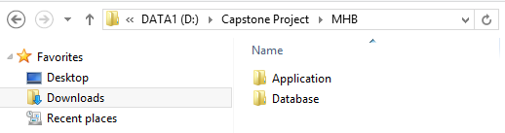

**Step 2. Create the database**

Open the file “DB1.0.sql” in the folder “Database” of the deployment package by Microsoft SQL Server Management Studio (MSSQL).

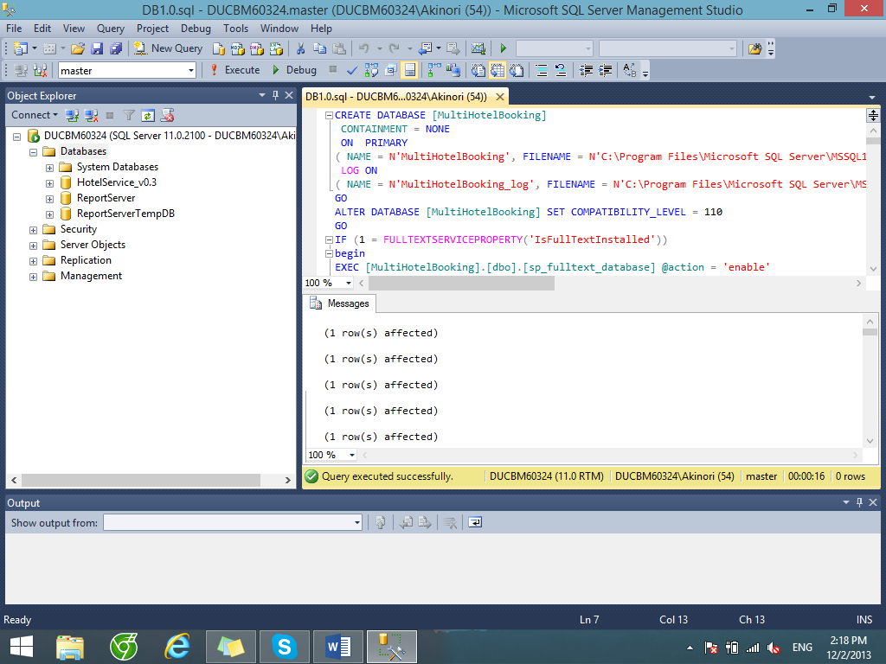

Change the paths of the SQL server where the databases are stored. Usually this file path has the form “C:\Program Files\Microsoft SQL Server\***<SQLServerInstanceName>***\MSSQL\DATA”.

Next, press F5 or the Execute button to run the database script. If the database is created successfully, continue to the next step.

**Step 3. Install the application**

Open the IIS Manager by typing its name into the search box in the start menu in Windows 7 or the charm bar in Windows 8.



Expand the Sites folder and then right click on Default Web Site. Select “Add Application…” to open Add Application window. In the “Add application” window, fill the field “Alias” with the name of the website.

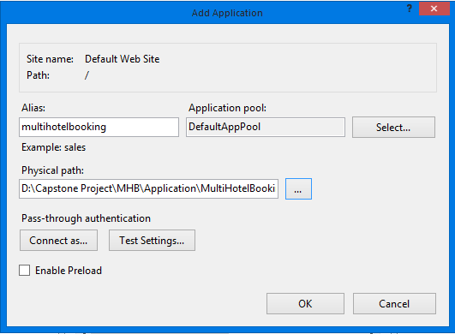

Click the “…” button to browse to the folder that contains the deployment package. Select the “Website” folder in the “MultiHotelBooking” folder, in the “Application” folder and click OK.

Verify that the MultiHotelBooking Website has been added to “Default Web Site” of IIS Express by right-clicking the website’s name, choosing “Manage Application” and then “Browse”.

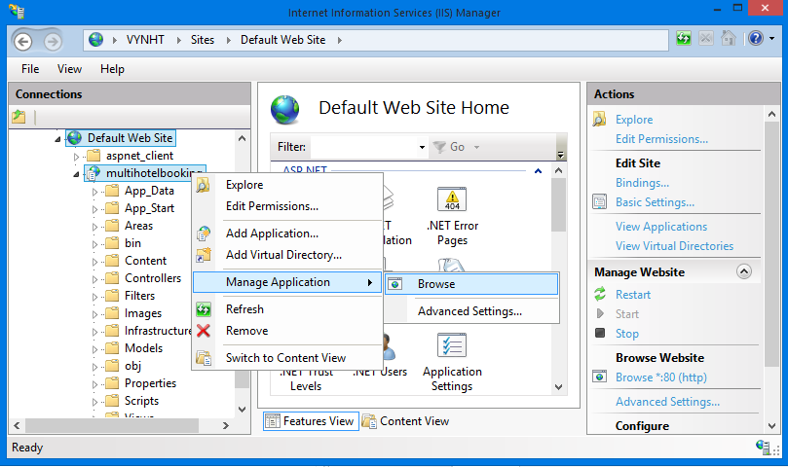

Note that at this step, you will see an error connecting to the database, because you didn’t change the database connection configuration. We will solve it shorly.

**[Optional] Step 4**. **Create a new Self Signed Certificate**

This step is to enable SSL browsing to your application when it is installed on Facebook.

Certificates are managed in IIS by clicking the root machine node in the left-hand tree-view explorer, and then selecting the "Server Certificates" icon in the feature pane on the right:

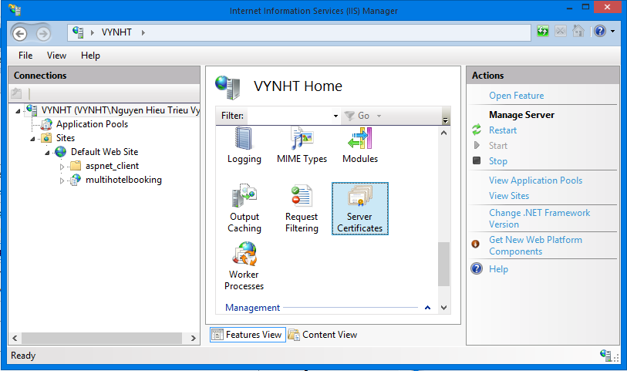

This will then list all certificates registered on the machine, and allow you to optionally import and/or create new ones.

You could optionally go to a certificate authority like Verisign and purchase a certificate to import using this admin UI. Alternatively, you can create a “self-signed certificate” which is a test certificate that I can use during the development and testing of my site. To do this, click the “Create Self-Signed Certificate” link on the right-hand side of the admin tool:

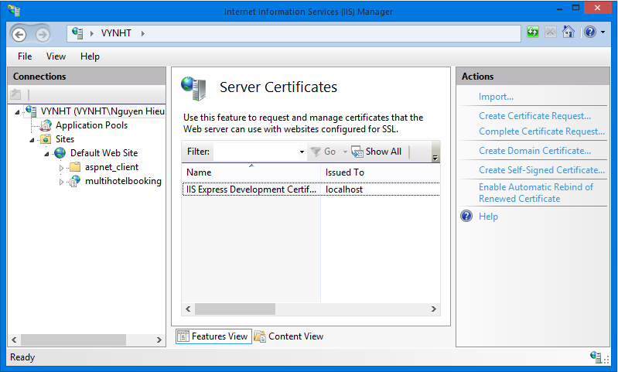

Enter a name to use for the certificate (for example: "test") and hit ok. IIS will then automatically create a new self-signed crypto certificate for you and register it on the machine:

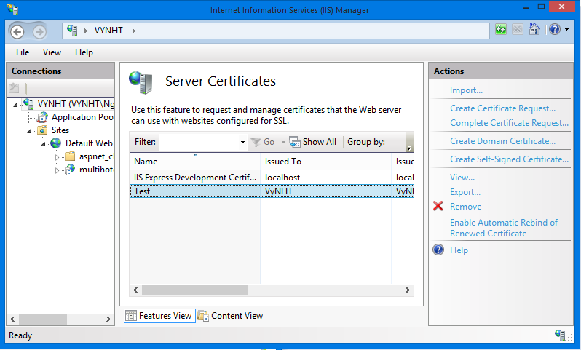

To SSL enable the web-site we created earlier, select the web-site node in the left-hand tree-view, and the click the “Bindings” link in its “actions” pane on the right-hand side of the screen:

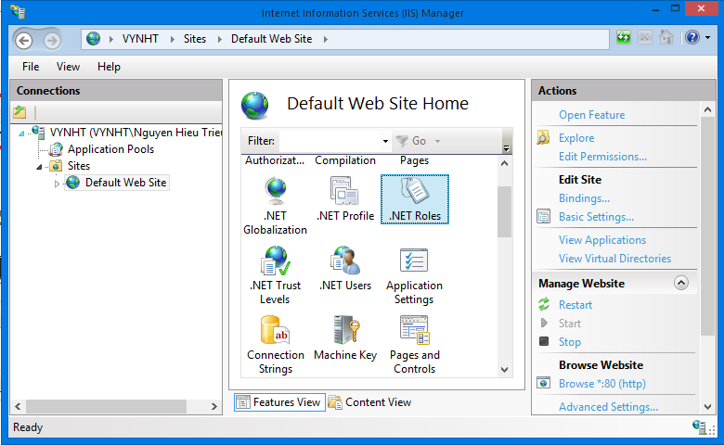

This will then bring up a dialog that lists all of the binding rules that direct traffic to this site (meaning the host-header/IP address/port combinations for the site):

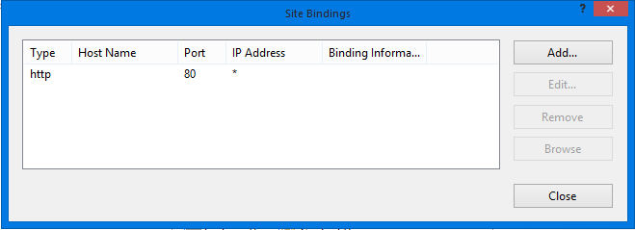

To enable SSL for the site, we'll want to click the “Add” button. This will bring up an “add binding” dialog that we can use to add HTTPS protocol support. We can select the self-signed certificate we created earlier from the SSL certificate dropdownlist in the dialog, and in doing so indicate that we want to use that certificate when encrypting content over SSL:

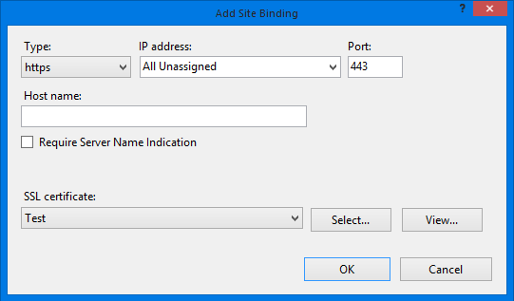

Click “OK”, and we now have SSL enabled for our site.

**Step 5. Configure database connection string**

In the “Application\MultiHotelBooking\Website” folder of the deployment package, find and open the file Web.config using Notepad or any other text editor.

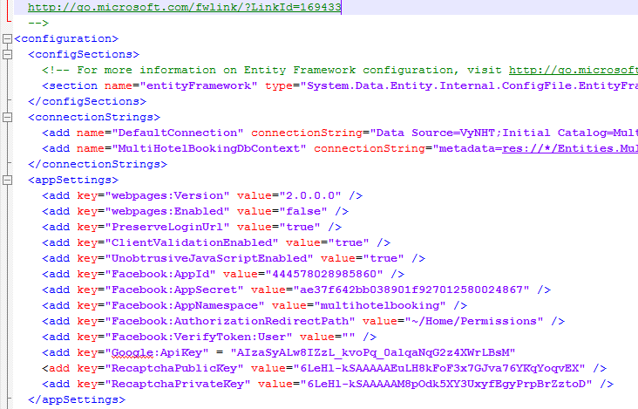

In the connectionStrings tag, change the Data Source of the connection strings to the SQLServer instance where you installed the database. Also, update the password to access the SQLServer instance in the connection strings.

**Step 6. Configure Facebook app**

Go to your Facebook app at <https://developers.facebook.com/apps/> (if you don’t have one, here is how to create one <https://developers.facebook.com/docs/opengraph/getting-started/>).

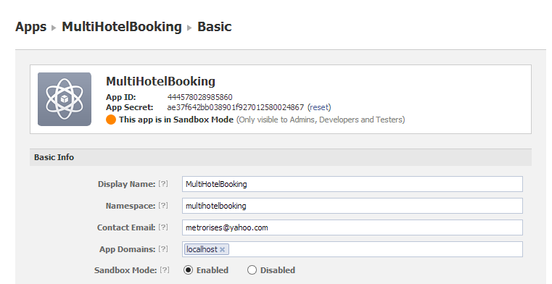

Update the App Id, App Secret, and Namespace for the app in the web.config file.

**Step 6**. **Configure the Facebook app as follows.**

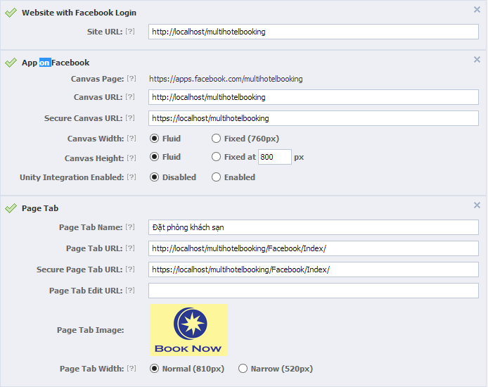

In the configuration below, “multihotelbooking” is the name of the website (Alias) you’ve just installed on IIS.

|  |  |
| --- | --- |
| Field Name | Value |
| *Site Url* | <http://localhost/multihotelbooking> |
| *Canvas Url* | <http://localhost/multihotelbooking> |
| *Secure Canvas Url* | <https://localhost/multihotelbooking> |
| *Page Tab Name* | The name of the app displayed on the fan pages |
| *Page Tab Url* | <http://localhost/multihotelbooking/Facebook/Index> |
| *Secure Page Ta Url* | <https://localhost/multihotelbooking/Facebook/Index> |
| *Page Tab Image* | An image for the app |

You can also update your own Google API Key and Recaptcha public and private keys if you would like to. Now go to [**http://localhost/multihotelbooking**](http://localhost/multihotelbooking) and [**https://localhost/multihotelbooking**](https://localhost/multihotelbooking) and enjoy the website**.**

## User’s Guide



### Guides for Customer



#### Log in to the system

This function allows a user with a registered account to log in to the i-Deliver system.

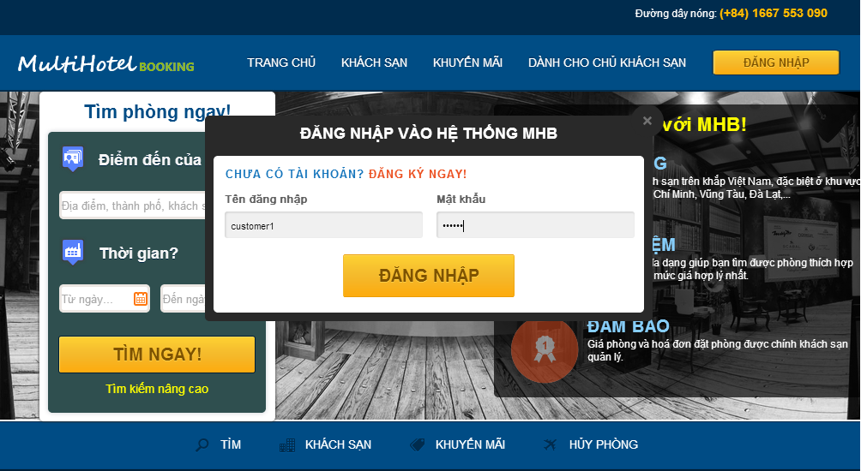

1

3

2

4

4

Screen 1. Login screen

|  |  |
| --- | --- |
| Step | Instruction |
| 1. | Click the “Đăng nhập” button on the menu bar of the “Trang chủ” page. |
| 2. | Fill the registered account in the “Tên đăng nhập” field |
| 3. | Fill the password in the “Mật khẩu” field |
| 4. | Click the “Đăng nhập” button to log in to the system. You will be redirected to the page you are viewing |

#### Log out of the system

This function allows the user to log out of the system after he or she finishes browsing the website.

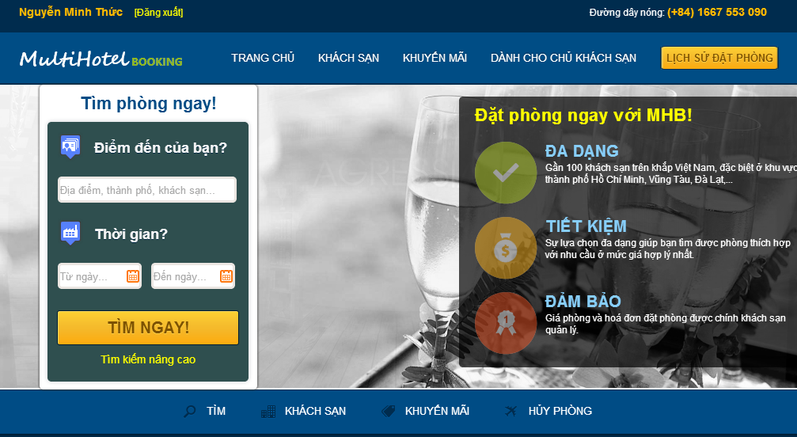

1

Screen 2. Logout screen

|  |  |
| --- | --- |
| Step | Instruction |
| 1. | Click the “Đăng nhập” button on the menu bar of the “Trang chủ” page. You will be redirected to the page you are viewing if this page allows guests to access, or the “Trang chủ” page otherwise. |

#### Register an account with Customer role

This function allows the user to register a new account with Customer role in the i-Deliver system.

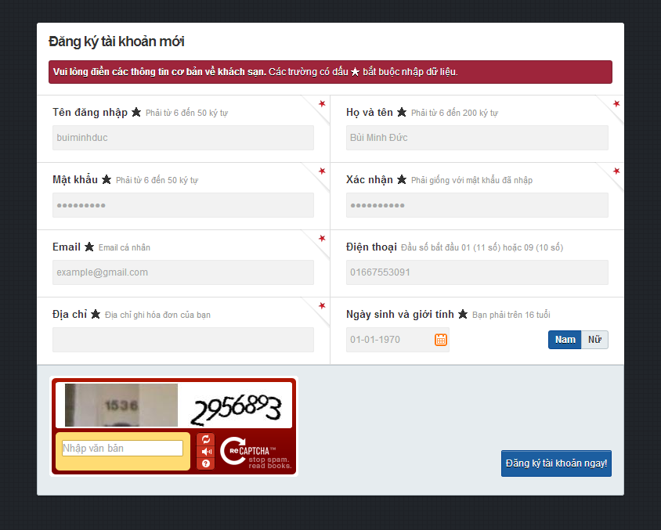

3

4

5

Screen 3. Register screen

|  |  |
| --- | --- |
| Step | Instruction |
| 1. | Click the “Đăng nhập” button on the menu bar of the “Trang chủ” page. |
| 2. | Click “Đăng ký ngay” on the “Đăng nhập” popup (Screen 2). The system will redirect you to “Đăng ký” page. |
| 3. | Fill in the fields “Tên đăng nhập”, “Họ và tên”, “Mật khẩu”, “Xác nhận”, “Email” “Điện thoại”, “Địa chỉ”, “Ngày sinh”, and “Giới tính” with your username, full name, password, password, email address, phone number, address line, date of birth, and gender.  Your input will be validated as you type. Please make sure that all the values that you provide are validated. |
| 4. | Fill in the “Nhập văn bản” field with the numbers or characters in the captcha image. |
| 5. | Click the button “Đăng ký tài khoản ngay” to proceed to register your account with Traveler role.  If registered successfully, you will be redirected to the “Đăng nhập” page to login with the newly created account. |

#### Sent a delivery request

This function allows the user to sent a delivery request to the i-Deliver system.

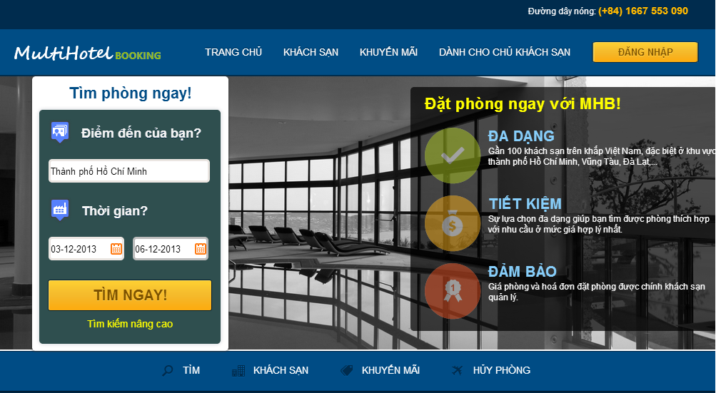

2

3

1

Screen 4. Home page screen

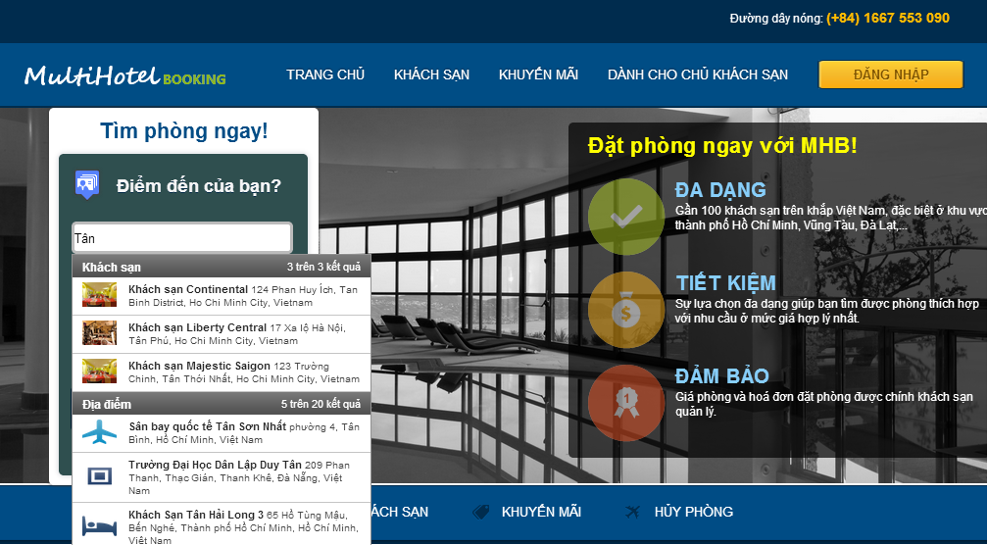

Screen 5. Places suggestion screen

|  |  |
| --- | --- |
| Step | Instruction |
| 1. | Fill in the textbox “Điểm đến của bạn?” with a place, city, or hotel name.  A list of suggestions will appear as you type. Select one item of the suggestions to specify the place of your destination. |
| 2. | Pick a date for checking in and a date for checking out. Your input will be validated as you picked a date. |
| 3. | Click the button “Tìm ngay”. You will be redirected to the hotel search page. |

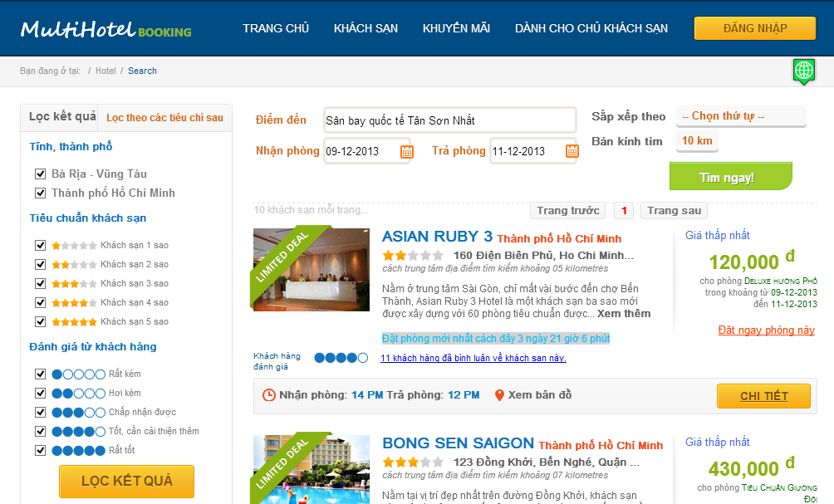

7

4

6

5

Screen 6. Search hotel screen

|  |  |
| --- | --- |
| Step | Instruction |
| 4. | You can change your searching criteria to limit or expand the results. The website will behave as when you search in the home page. |
| 5. | Specify some filters on the results by   * Checking or unchecking cities in “Tỉnh, thành phố” section; * Checking or unchecking hotel’s stars in “Tiêu chuẩn khách sạn” section; * Checking or unchecking average rating point of customers in “Đánh giá từ khách hàng” section. |
| 6. | Click the “Lọc kết quả” button. The system will filter the results without refreshing the page. |
| 7. | You can view all the searched and filtered hotels on the Google map by clicking the button marked 7 in the search hotel screen. The hotels are numbered as in the result list. |

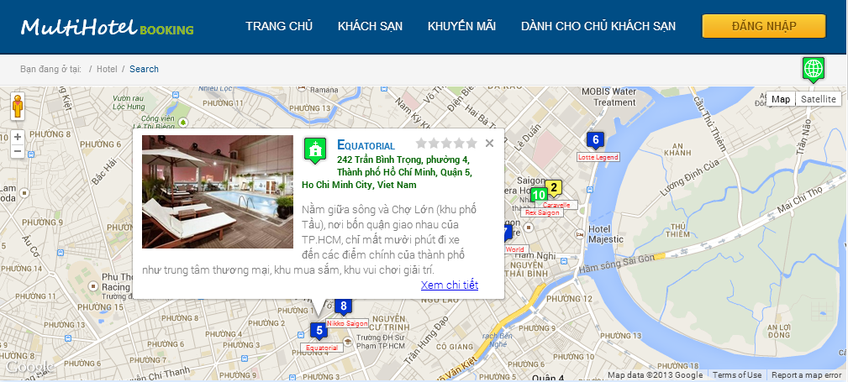

Screen 7. Hotels on google map screen

#### View station details, rate, and comment

This function allows the customer to view details of a station information, review, and rate the station.



1

Screen 8. Search results screen

2

3

4

|  |  |
| --- | --- |
| Step | Instruction |
| 1. | Click the “Chi tiết” button in the result list of the hotel search page. You will be redirected to the hotel details page of the selected hotel. |

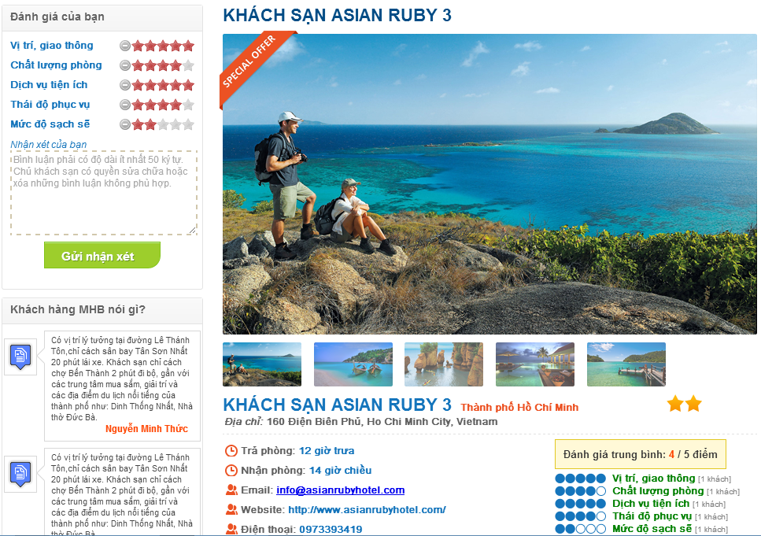

Screen . Hotel details screen

|  |  |
| --- | --- |
| Step | Instruction |
| 2. | (Optional) Rate the hotel by different critiaria like location and traffic, room quality, hotel services, staff attitude, cleanliness by checking the number of stars for each criterion in “Đánh giá của bạn” |
| 3. | (Optional) Fill your review about the hotel in the box “Nhận xét của bạn”. The content of the review can be your opinion on the hotel services, your personal experience, and what needs to be improved. |
| 4. | (Optional) Press the button “Gửi nhận xét” in order to submit a review for the hotel. |

#### Online payment

This function allows the customer make a payment online via PayPal.

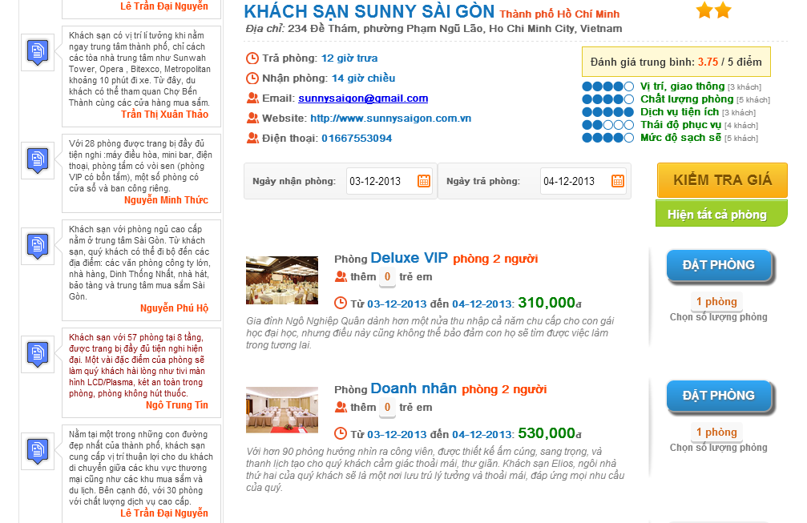

**1**

**2**

**4**

**3**

**5**

Screen 10. Room details screen

|  |  |
| --- | --- |
| Step | Instruction |
| 1. | Pick a date for checking in to fill the textbox “Ngày nhận phòng” and a date for checking out to fill the textbox “Ngày trả phòng”. Your dates will be validated before you continue. |
| 2. | Click the “Kiểm tra giá” button to check for room availability and prices. If there are available rooms in the specified period, the system will list their information and prices in the list below. |
| 3. | (Optional) Choose number of rooms in the rectangular under “Đặt phòng” button. The default value for number of rooms is 1. |
| 4. | (Optional) Choose number of extra children or adults, if allowed by the hotel. |
| 5. | Click the “Đặt phòng” button. The system will drive you to Booking Details Page. |

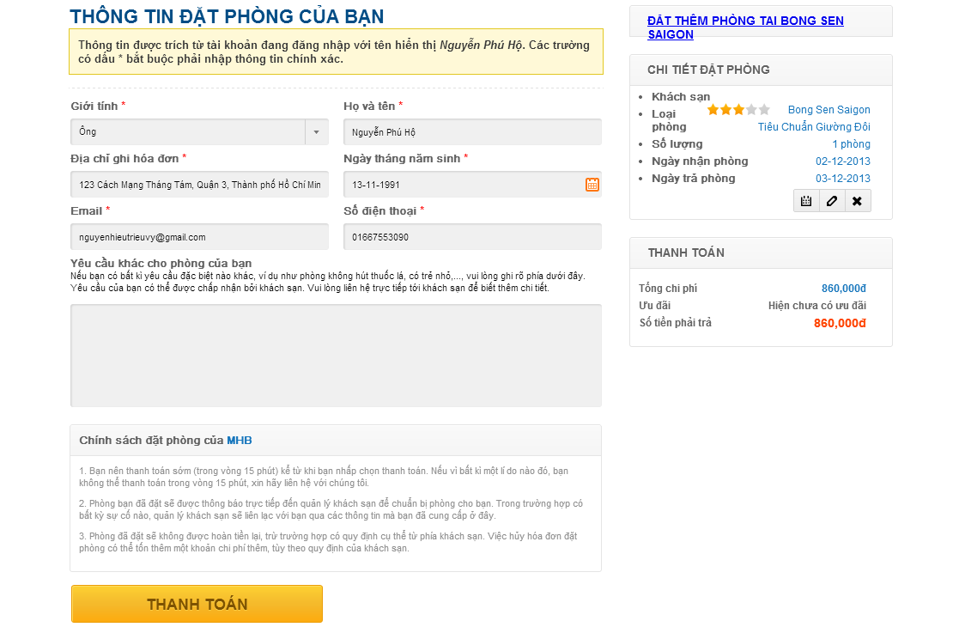

**8**

**6**

**7**

Screen 11. Booking details screen

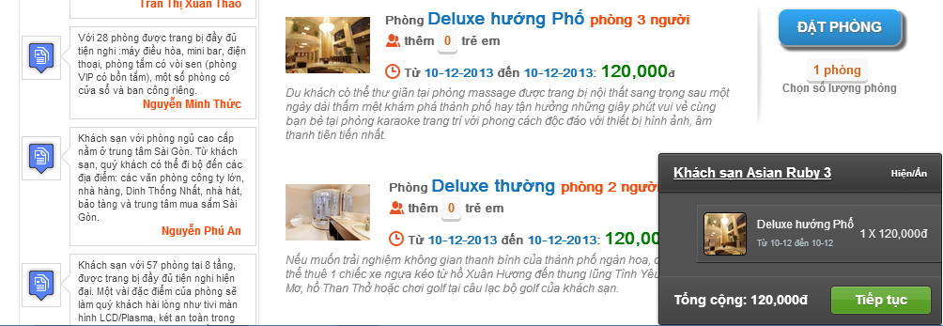

Screen 12. Book more rooms screen

|  |  |
| --- | --- |
| Step | Instruction |
| 6. | (Optional) Click on the link “Đặt thêm phòng tại khách sạn X”, where X is the name of the selected hotel to book more rooms of this hotel. Repeat the steps from 1 to 5 to add more rooms to the booking list. |
| 7. | Fill in the customer information form. If you are already logged in the website, the details of your account will be automatically filled in the form.  Provide us your real gender, full name, address, date of birth, email, phone number and specify any request you want to send to the hotel owner. Your input will be validated as you type and will be used for the hotel owner to verify your booking when you check in the hotel, so please make sure you enter accurate information. |
| 8. | Click the button “Thanh toán”. You will be redirected to “Ngân Lượng” payment service. |

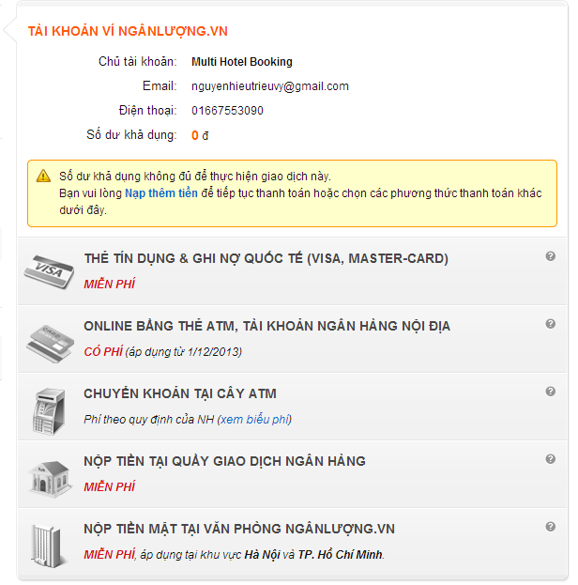

**9**

Screen 13. Ngân Lượng payment screen

|  |  |
| --- | --- |
| Step | Instruction |
| 9. | Pay for the rooms using your “Ngân Lượng” account. If the payment was made successfully, you will be redirected to the booking success page. |
| 10. | An email of the booking details will be sent to your email address. An SMS message containing your booking code will be sent to your phone number. Use this booking code and your personal information to verify with the hotel when you check in. |
| 11. | The booking success page shows your booking details and your booking code. Record this code to use to verify with the hotel when you check in. |

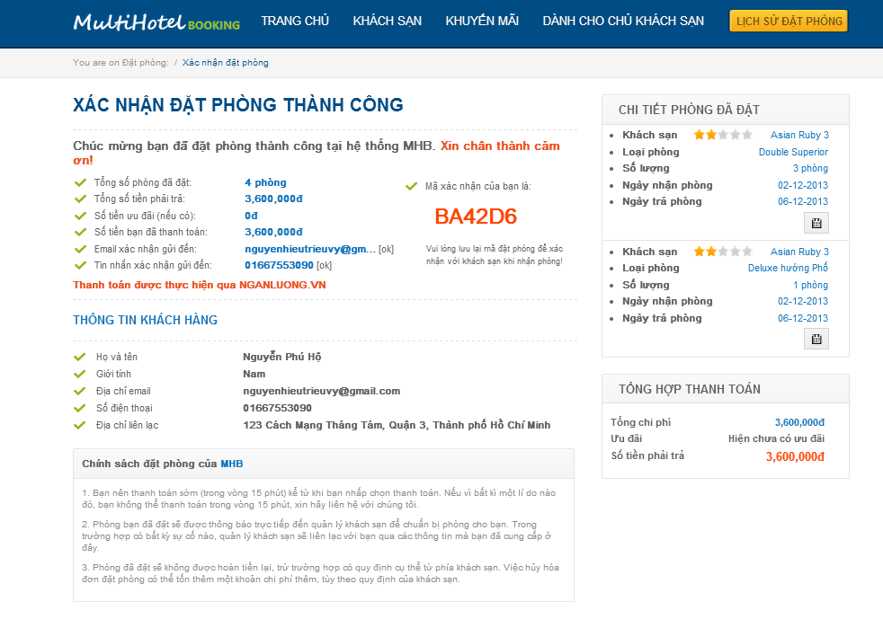

**11**

Screen 14. Booking success screen

#### Tracking package(s)

### Guides for Staffs and System Admins



#### Approve pending requests

This function allows the staff to view all pending requests, input invoice for each request by click “Nhập hóa đơn” button then approve it after confirm payment for request by click “Xác nhận thanh toán” button.

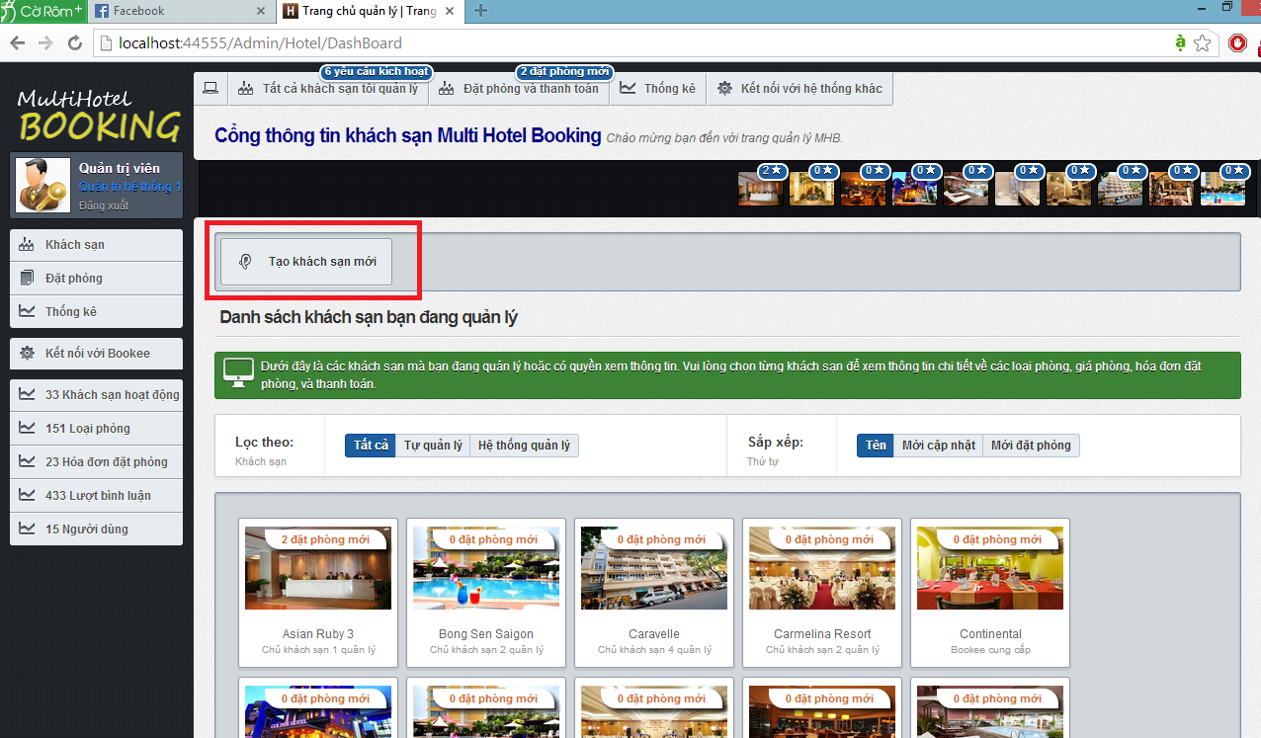

**7**

**6**

Screen . Admin dashboard screen

**5**

**4**

**3**

**2**

**1**

|  |  |
| --- | --- |
| Section | Description |
| 1. | The number of hotel opening request by hotel owner. This section is only available to System Admins. |
| 2. | The number of new bookings that need to be approved. |
| 3. | Ten hotels under your management that have the most new bookings. |
| 4. | Filters on local and external hotel. |
| 5. | Orders in which the hotels under your management should be displayed |
| 6. | All the hotels under your management |
| 7. | The menu bar that contains links to other pages. |

#### Create a trip

This function allows the user to insert a new hotel to the system and send a hotel opening request to System Admin.

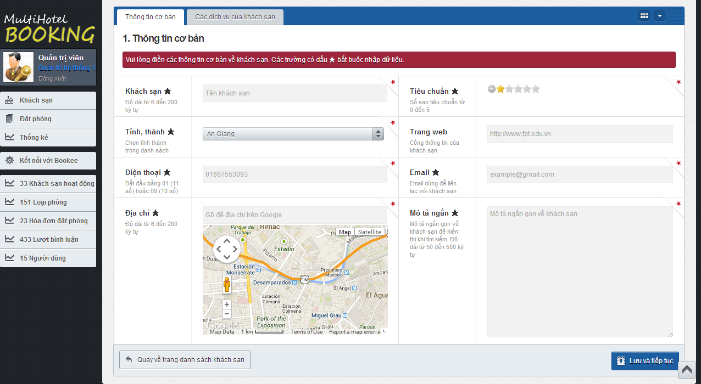

**3**

**2**

Screen 16. Create a hotel screen

|  |  |
| --- | --- |
| Step | Instruction |
| 1. | Click the “Tạo khách sạn mới” button on the hotel dashboard. |
| 2. | Provide necessary information for the hotel.   * Fill the hotel name in the “Khách sạn” textbox; * Choose the province where the hotel is located in in “Tỉnh, thành” dropdown list; * Fill the address line of the hotel in “Địa chỉ”. * Check the hotel’s star quality, ranging from 0 to 5. * Fill the hotel’s website in the “Website” textbox. * Fill the hotel’s email in the “Email” textbox. * Fill a short introduction about the hotel in the box “Mô tả ngắn”.   In the “Các dịch vụ của khách sạn” tab, tick the services that the hotel has and provide some custom description for them.  Your input will be validated as you type. Because the hotel you create will have to be approved by System Admin before it is set as activated, the information you provide must be accurate. |
| 3. | Click the “Lưu và tiếp tục” button. The system saves the hotel and continues to the Resource page of the hotel. |

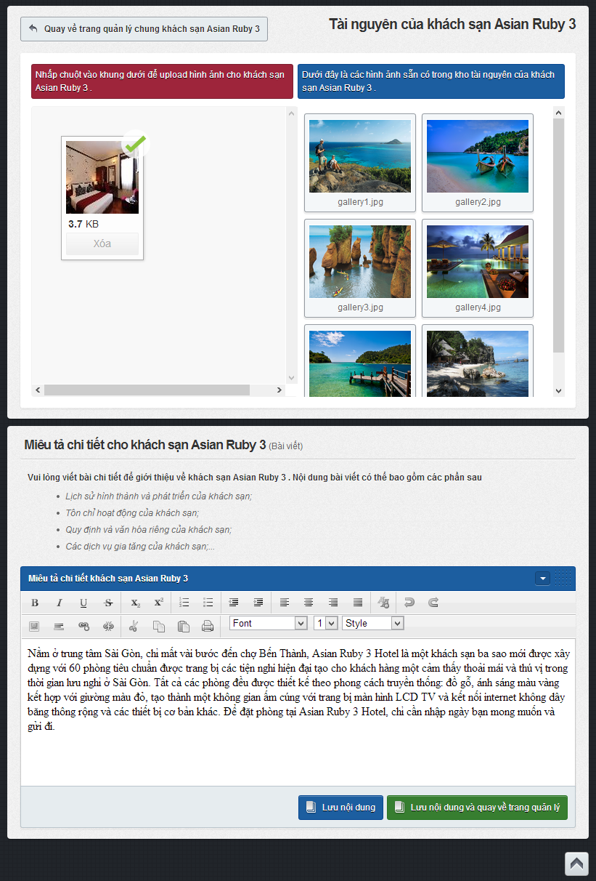

**6**

**5**

**4**

|  |  |
| --- | --- |
| Step | Instruction |
| 4. | Click the big plus button to add images to the hotel. A popup will appear to let you choose the hotel’s images. Choose the images you want to add and click Open.  The website will automatically upload all the images you selected. |
| 5. | Fill the detailed description for the hotel in the text editor “Miêu tả chi tiết khách sạn”. This description will be used as an article to introduce about your hotel on the I-DELIVER system. |
| 6. | Click the “Lưu nội dung” button or “Lưu nội dung rồi quay về trang quản lý” button. |

#### Assign package(s)

This function allows the user to delete a hotel under your management from the system. All the information related to this hotel (room types, prices, features, images…) will be deleted too.

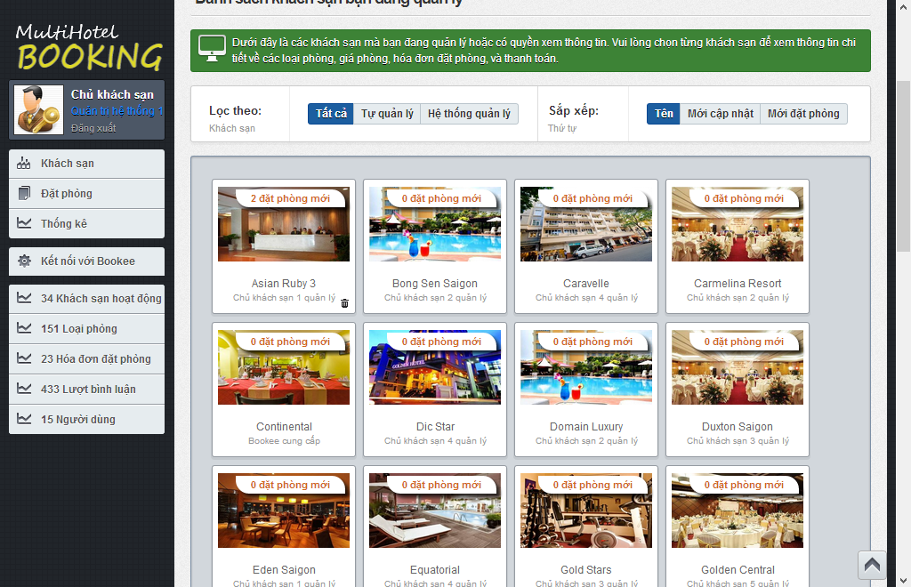

**1**

Screen 17. Delete a hotel screen

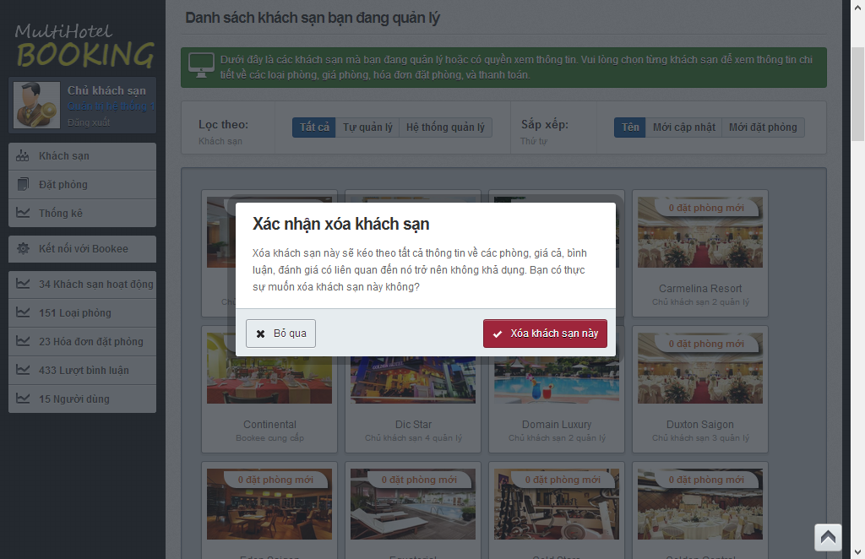

**2**

|  |  |
| --- | --- |
| Step | Instruction |
| 1. | Hover your mouse over a hotel and click  button. A pop up will be displayed to ask you to confirm if you really want to delete the hotel. |
| 2. | Click “Bỏ qua” button if you don’t to delete this hotel; or  Click “Xóa khách sạn này” button if you want to delete this hotel. |

#### Confirm package(s) departed from start-station

This function allows the user to add a new room type for an existing hotel.

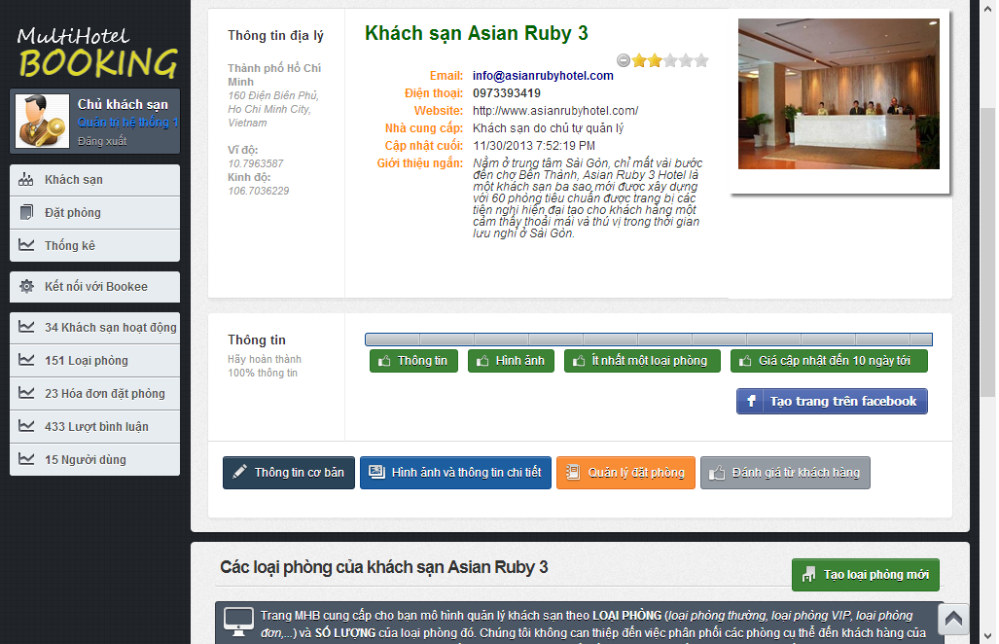

**1**

Screen 18. Hotel Details screen

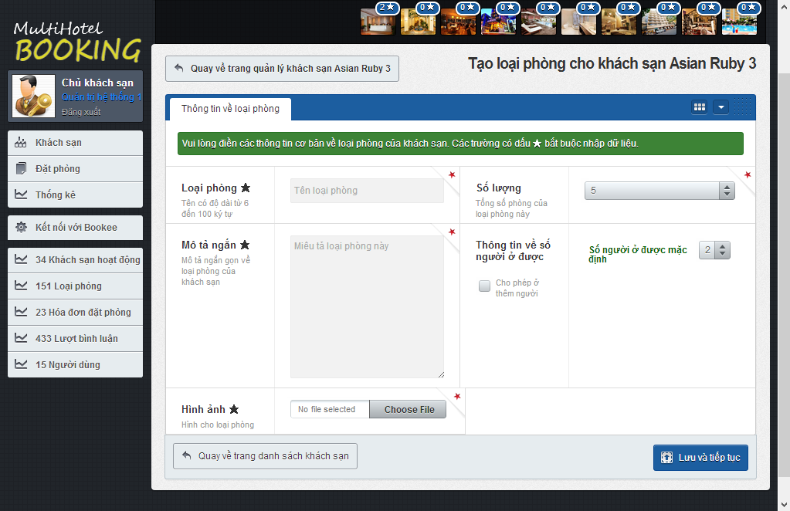

**3**

**2**

Screen 19. Add a room type screen

|  |  |
| --- | --- |
| Step | Instruction |
| 1. | Click the button “Tạo loại phòng mới” button in Hotel details page of the hotel you want to create a new room type. |
| 2. | Provide necessary information for the room type.   * Fill the name of the room type in the “Loại phòng” textbox; * Choose the number of rooms of this type in the “Số lượng” dropdownlist; * Fill a short description about this room type in the box “Mô tả ngắn” * Choose default number of persons who can stay in this room in the “Số người ở được mặc định” dropdown list and check/uncheck “Cho phép ở thêm người” to allow or not allow extra persons. * Choose room’s picture in “Hình ảnh” textbox by click “Choose file” button then choose a picture file and click Open. |
| 4. | Click the “Lưu và tiếp tục” button. The system will save the room type and redirect you back to the hotel management page of the room type newly added. |

#### Confirm package(s) arrived in end-station

This function allows the user to delete a room type of a hotel under your management from the system. All the information related to this room type will be deleted too.

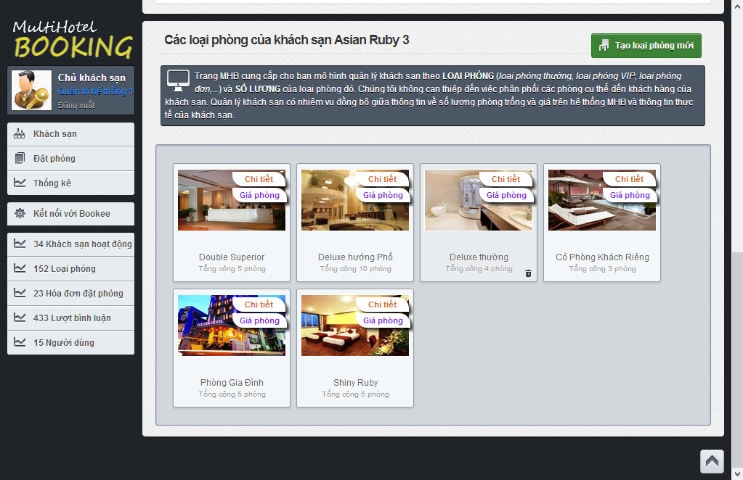

1

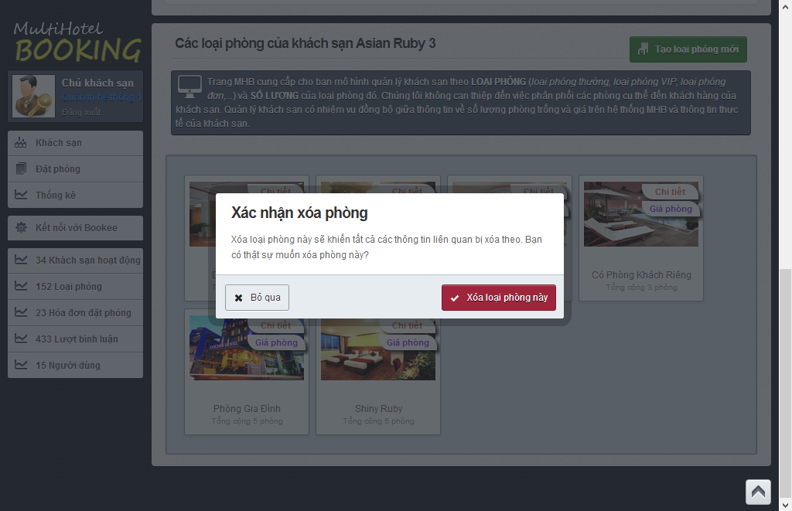

2

Screen 20. Delete a room type screen

|  |  |
| --- | --- |
| Step | Instruction |
| 1. | Hover your mouse over a room type and click  button. A pop up will be displayed to ask you to confirm if you really want to delete the room type. |
| 2. | Click “Bỏ qua” button if you don’t to delete this room type; or  Click “Xóa khách sạn này” button if you want to room type this hotel. |

#### Confirm package(s) delivered

This function allows a hotel owner to easily update the start date and end date of a price.

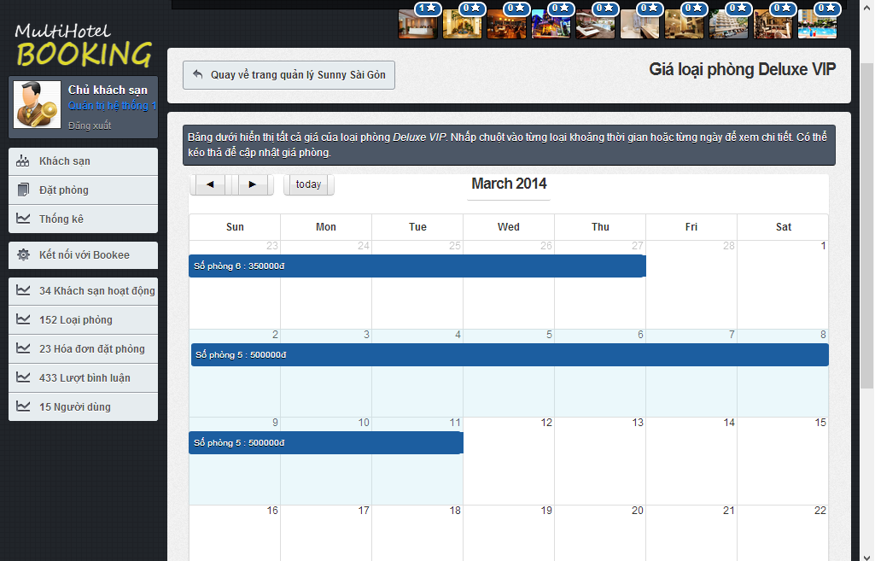

2

1

Screen 21. Resize a price screen

|  |  |
| --- | --- |
| Step | Instruction |
| 1. | **(**Optional) Click and hold the edge of a price bar you want to resize and drag it to your desired position in the price calendar. Release the mouse to update the price to the new position in calendar. |
| 2. | (Optional) Click and hold a price bar in the price calendar, then drag it to new position in the calendar. Release the mouse to drop the price to the new position in calendar. |

#### Prepare package(s) for return

This function allows the user to verify that he or she has approved of a booking made by a customer.

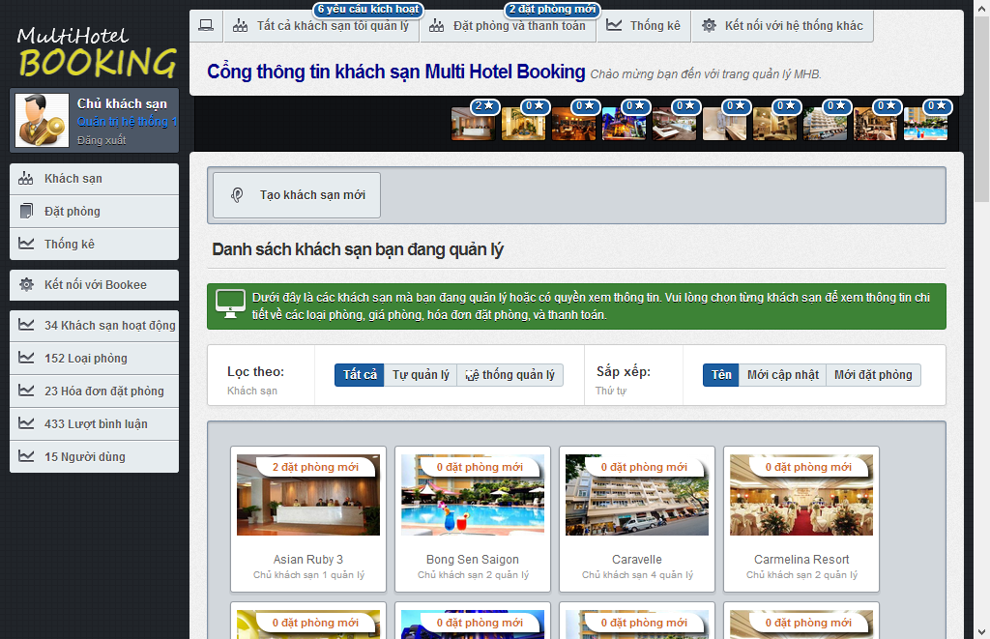

1

1

Screen 22. Dashboard screen

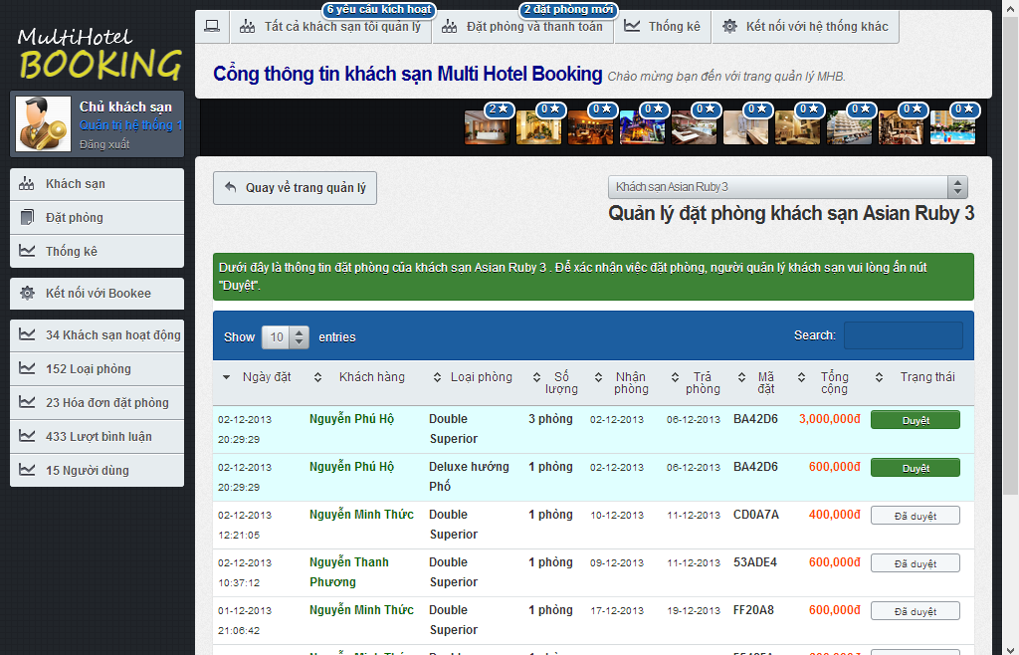

2

|  |  |
| --- | --- |
| Step | Instruction |
| 1. | In hotel dashboard page, click the notification bar of a hotel that has new bookings ade by customers; or click on the list of ten hotels that have the most new bookings at the top of the dashboard page. |
| 2. | Check the new booking, allocate the necessary rooms and services in your hotel, and click the button “Duyệt” to verify that you have approved of a booking. A notification is shown to you to notify that the booking was approved successfully.  Note that once you have “approved” of a booking, you cannot restore it back. |

#### Extend due-date for online payment

This function allows a system admin to approve of a hotel opening request made by a hotel owner.

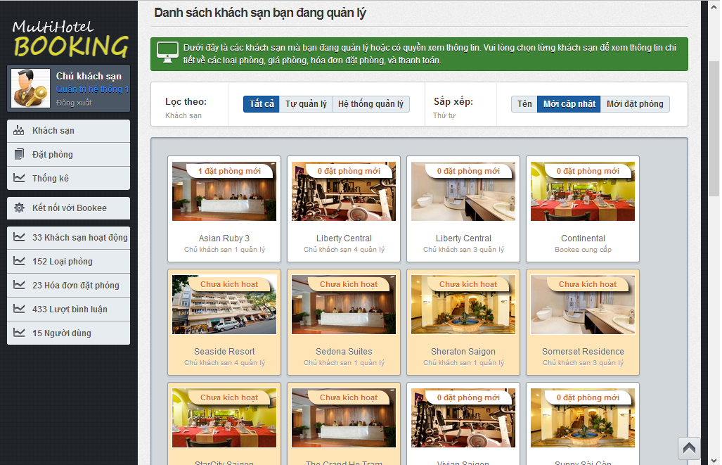

1

Screen 23. Hotel opening request screen

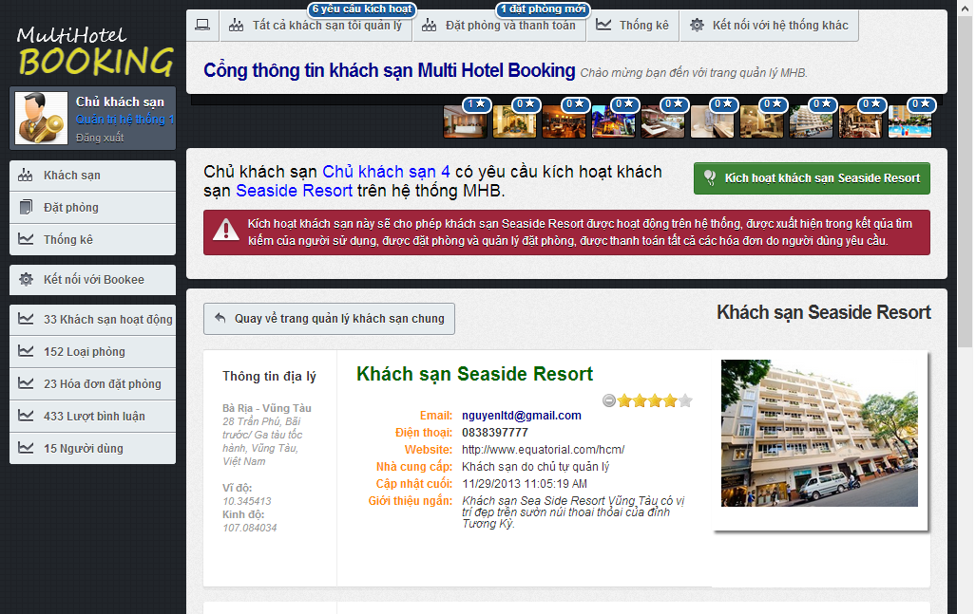

2

Screen 24. Approve hotel opening request screen

|  |  |
| --- | --- |
| Step | Instruction |
| 1. | Click on a hotel which is not approved by System Admin yet. You will be redirected to the hotel details page. At the top of this page is the content of the request. |
| 2. | Check the hotel information, make necessary contact with the hotel owner to verify the information. If the hotel is valid and can be put into operation on the I-DELIVER system, click the “Kích hoạt Khách sạn X” button, where X is the name of the hotel, to approve this hotel.  After the hotel is approved, you will be redirected back to the dashboard page. |

#### Statistics

This function allows a system admin to manually synchronize information about hotels provided by an external hotel provider (BMT in this case).

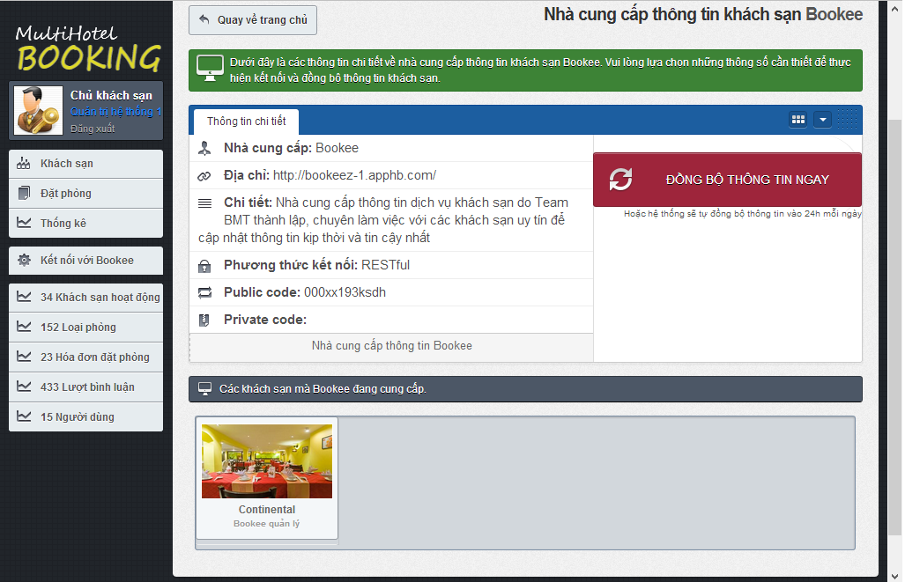

3

2

ĐỒNG BỘ GIÁ

ĐỒNG BỘ THÔNG TIN

1

|  |  |
| --- | --- |
| Step | Instruction |
| 1. | Click the “Kết nối với Bookee” link in the menu bar. You will be redirected to the data synchronization page for this provider. |
| 2., 3. | Click the button “Đồng bộ thông tin” or “Đồng bộ giá” to synchronize data with provider. After you clicked this button, it will takes a while to synchronize the data between the two systems. If you don’t want to wait, you can go to another page, because the synchronization will still continue.  Once the data is completely synchronized, the page will refresh and show a log of the synchronization process. |

#### Add a price

This function allows a hotel owner to add a new price for the selected room type.

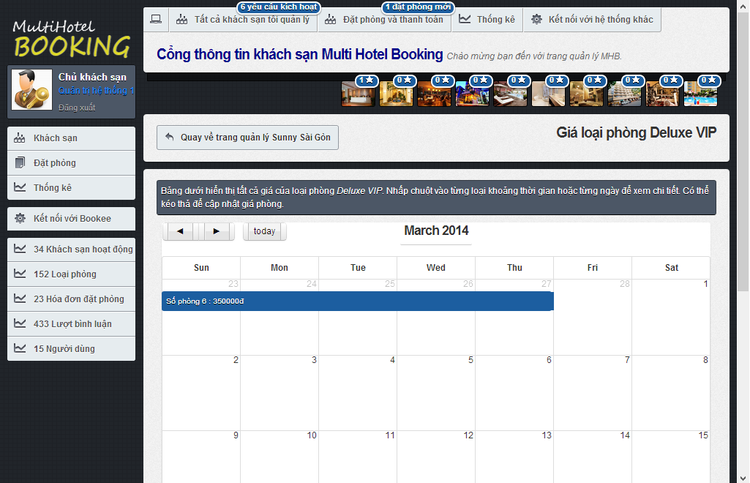

1

Screen 25. Price calendar screen

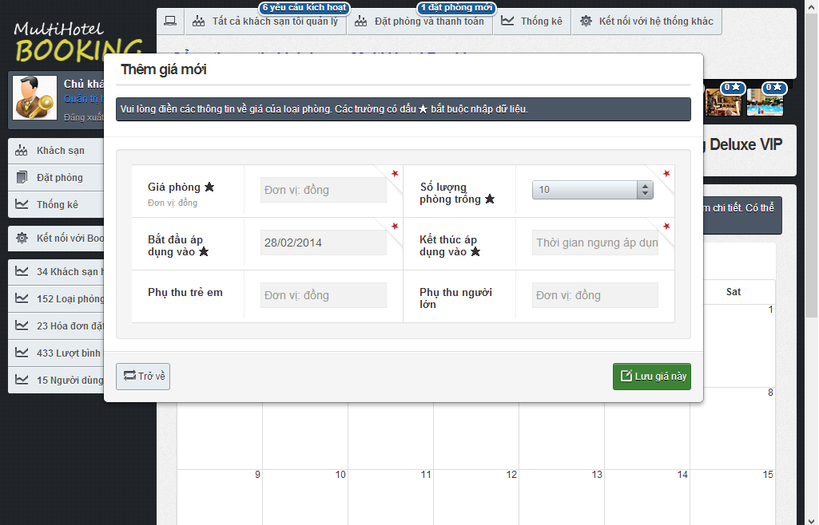

3

2

Screen 26. Add a price screen

|  |  |
| --- | --- |
| Step | Instruction |
| 1. | Click on an empty date you want to add new price in the price calendar for the selected room. A popup window will be displayed to add a new price for the date. |
| 2. | Provide necessary information about the new price:   * Fill the price in Vietnam Dong in the “Giá phòng” textbox; * Choose the number of rooms available for the period in the “Số lượng phòng trống” dropdown list; * Choose the start date and end date of the price; * Fill the price for extra children in “Phụ thu trẻ em”, if any; * Fill the price for extra adults in “Phụ thu người lớn”, if any.   Your input will be validated as you type. |
| 3. | Click the “Lưu giá này” button. The price will be saved and added to the calendar. |

#### Monitor prices

This function allow a hotel owner to monitor the prices of a room type in a hotel under his or her management. In addition, the screen also allows to see the bookings made on a specific day for a room type.

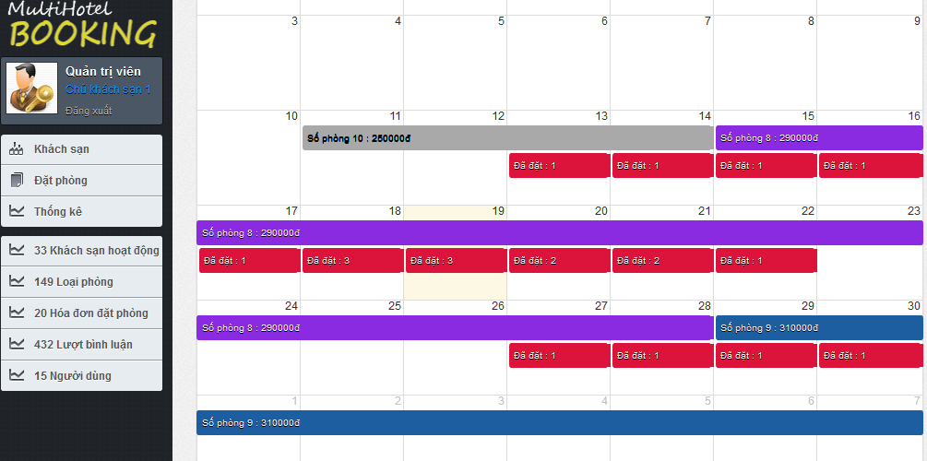

4

3

2

1

Screen 27. Price calendar screen

|  |  |
| --- | --- |
| Section | Description |
| 1. | A price bar (in gray) that represents a price in the past. You cannot drag, drop, or resize the price bar because the price is no longer active for the room type. |
| 2. | A price bar (in violet) that represents a price crossing from the past to the future (including the current system date). You can drag, drop, and resize the future part of the price bar to update the price in the future. |
| 3. | A price bar (in blue) that represents a price in the future. You can drag, drop, and resize this price bar to update the price in the future. |
| 4. | The number of bookings made on a specific day for the selected room type. |

# Appendix

## Reference

<http://en.wikipedia.org/wiki/Model-view-controller>

<http://www.visual-paradigm.com/product/vpuml/tutorials/>

<http://www.packtpub.com/mastering-ninject-for-dependency-injection/book>

<http://en.wikipedia.org/wiki/Waterfall_model>

<http://www.asp.net/mvc/tutorials/mvc-4>

<http://msdn.microsoft.com/en-us/library/vstudio/ff926074.aspx>

<http://www.csharpfriends.com/articles/getarticle.aspx?articleid=336>

<http://www.uml-diagrams.org/>

<http://en.wikipedia.org/wiki/Database_design>